EAGLE RIVER PRESBYTERIAN CHURCH

Earthquake Repairs and Renovation

Request for Quote

REMOVE CARPET

NAME: Remove Carpet
RFQ Number: 103
Owner: Eagle River Presbyterian Church
Address: 12836 Old Glenn Highway
Eagle River, Alaska 99577
Phone ERPC Secretary: (907) 694-5753
Phone Project Manager, Chuck Homan: (907) 862-6116
Email: homan@remodelalaska.com.

Description. Eagle River Presbyterian Church (ERPC) is soliciting a quote to remove and dispose of approximately 3,200 SF of glued down carpet for a firm fixed price contract. To be considered for contract, the attached bid/quote form for the specified Scope of Work must be completed and received by email at homan@remodelalaska.com or hand-delivered to Eagle River Presbyterian Church, 12836 Old Glenn Highway, Eagle River, Alaska 99577, on-or-before, 1:00 PM local time, on Friday, January 10, 2020. It is anticipated work can begin on January 15, 2019. All work must be completed prior to 4:00 PM on Saturday, January 25, 2019. The Contractor shall schedule and make a site visit prior to Wednesday, January 8, 2020. A Sample Contract will be provided at the conclusion of the site visit. The Final Contract the Offeror will sign will be substantially similar to the Sample Contract.
Note - A Pre-Bid Site Visit is required.

- GENERAL INFORMATION

  - Bid/Quote Submittal: Fill out and submit the attached QUOTE SUBMITTAL FORM.

  - Contractor Minimum Qualification. The Offeror/Contractor shall have a minimum of three (3) years of documented experience in providing related services of this scope and complexity. The Contractor be a duly licensed general contractor in good standing, with a State of Alaska license number. The Contractor shall have Commercial General Liability (including Personal Injury) with limits of liability not less than $1,000,000 {minimum amount of general liability insurance] for each occurrence, and Workers’ Compensation Insurance with statutory limits for the State of Alaska. Insurance requirements are further defined in the Sample Contract.

  - Site Visit (Required). All Offerors submitting bids/quotes shall visit the site and walk through the building to observe conditions, take measurements, ask questions, etc. An ERPC representative will conduct the site visit. The Offeror shall coordinate with ERPC to arrange and establish a mutual agreed upon date and time for the site visit. It is the Offerors responsibility to initiate contact in writing via email to homan@remodelalaska.com. and to ensure the site visit is completed prior to submitting a proposal.

  - Permits. The Contractor shall be responsible for determining the permits necessary to perform the contract work. The Contractor shall include the cost for permits in the proposal, and shall obtain the permits prior to beginning work. Permits shall be posted where directed by the permitting agency and/or ERPC.

  - Ongoing Activities at ERPC and Coordination. Multiple Organizations, Groups, Tenants, and Individuals, utilize and operate within ERPC and will continue their activities to the greatest extent possible while the contractor is performing the specified SOW. ERPC is responsible for communicating with the various entities utilizing the ERPC Building and performing any required coordination to facilitate the Contractors approved schedule. The Contractors adherence to the approved schedule, and updating the schedule as work progresses, is very important to ERPC.

  - Schedule. ERPC is issuing multiple contracts for the earthquake related repairs. Each Contract will be phased to avoid conflicts between the contracts and other Contractors to the greatest extent possible. Work on this contract shall start at a mutually agreed upon date and time when the Contract is signed and shall be completed prior to 4:00 PM on Saturday, January 25, 2019. The Contractor may work Monday through Sunday, seven (7) days per week including holidays. Except, no works shall be scheduled between 5:00 AM and 1:00 PM on any Sunday, and the Sanctuary and Narthex shall have all pews and furniture restored to its “start of contract” location and the area shall be clean and fully useable by 5:00 AM on any Sunday.

- SCOPE OF WORK. The Contractor shall perform the following work (reference attached Building Room Plan / Layout):

  - Remove Molding: There is a combination of wood molding and rubber mop-board coving in the areas where carpet is to be removed. Remove the molding/coving taking care to not damage the drywall and painted surface. Dispose of all molding/coving.

  - Move Equipment and Furniture: The Sanctuary and rooms contains pews, piano, moveable platforms, and other furniture (see photos). The Contractor shall remove carpet from areas, then move equipment and furniture to the “removed” area to remove carpet under the equipment and furniture. Following removal of the carpet the equipment and furniture shall be placed back in its original location.

  - Remove Carpet: The carpet in the Sanctuary is glued down and well adhered to the concrete floor. Dispose of all carpet and other removed materials as specified in the sample contract. Removal areas:

      - Narthex Area A has approximately 225 square feet of carpet to remove.
      - Sanctuary Area A has approximately 1950 square feet of carpet to remove.
      - Narthex Area F has approximately 175 square feet of carpet to remove.
      - Sanctuary Area F has approximately 650 square feet of carpet to remove.
      - Room 18 Area F has approximately 170 square feet of carpet to remove.
      - Room 22 Area F has approximately 180 square feet of carpet to remove.

Note1 – The Sanctuary and Narthex are divided into Area A and F because there are different funding sources for the work.

Note2 – The raised area on the right side of photo 3 is comprised of carpet covered moveable platforms. Move the platforms, then remove the carpet from the floor under the platforms. Leave the carpet on the surface and sides of the moveable platforms; it is not in the contract.

  - Finish Surface: All components of the carpet and carpet mesh shall be removed. Glue remnants that attach to the concrete floor can remain but should be smooth surface.

  - Labor and Equipment. The Contractor shall provide all labor, equipment, hand tools, materials and supervision required to move or reposition and protect office equipment, furniture, or appurtenances. The Contractor shall provide all labor, materials, equipment, work-lighting, etc., and supervision for the specified work.

- SELECTION AWARD OF CONTRACT. The RFQ is written as a performance specification. A contract will be awarded to the “Best Value” Offer as determined by ERPC. Price is of most importance, but experience and schedule will factor into the final selection for award. Selection will be by the ERPC Moderator of Trustees.

  - Sample Contract. A Sample Contract will be provided at the conclusion of a site visit. The Final Contract the Offeror will sign will be substantially similar to the Sample Contract. The Offeror shall read and be familiar with the Sample Contract prior to preparation of a Quote as it may have impact on the manner work is conducted and the proposed price. The provisions and requirements will become binding upon signature of the Contract.

  - Contract Requirements. The successful Offeror/Contractor shall comply with all instructions and shall perform services in a manner commensurate with the highest professional standards by qualified and experienced personnel. The successful Contractor shall follow 2 CFR 200.326, 2 CFR Part 200, Contract Addendum 1 and all Regulatory Codes & Standards required by the Federal Government, State of Alaska and the Municipality of Anchorage, and obtain all required Permits and Business License(s). The successful Contractor shall follow Federal Procurement Standards including purchases.

ERPC Room Plan / Layout

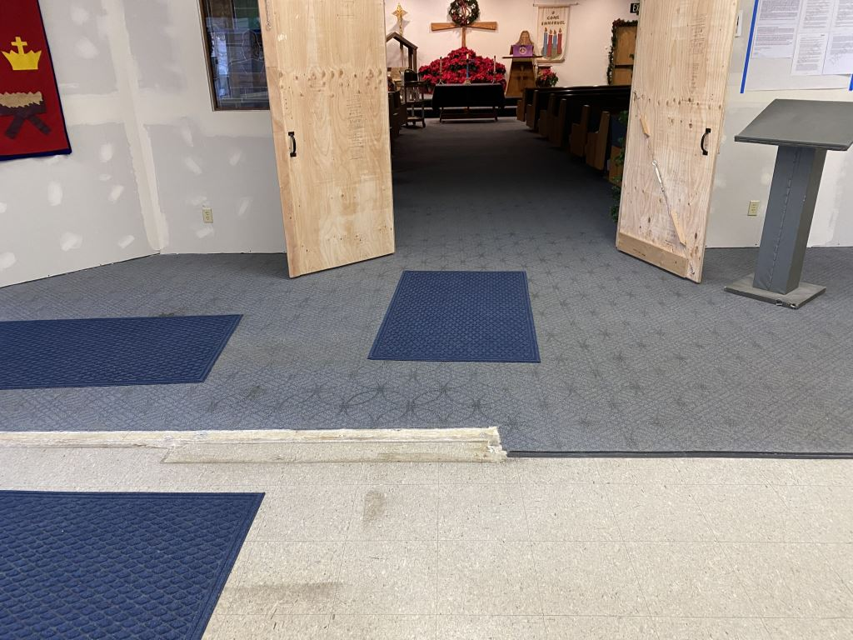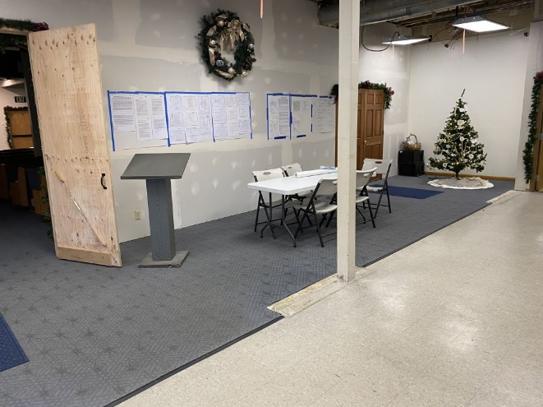
Photo 1 -View from Narthex into Sanctuary Photo 2 -Narthex Area
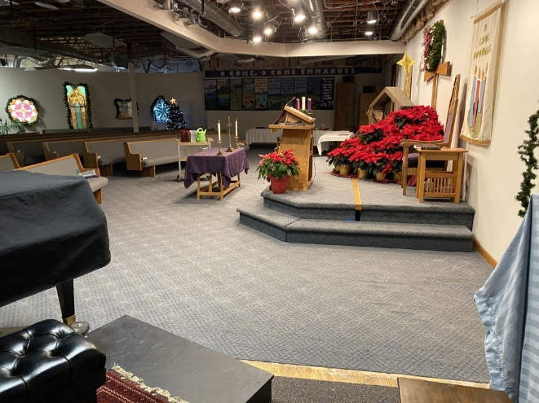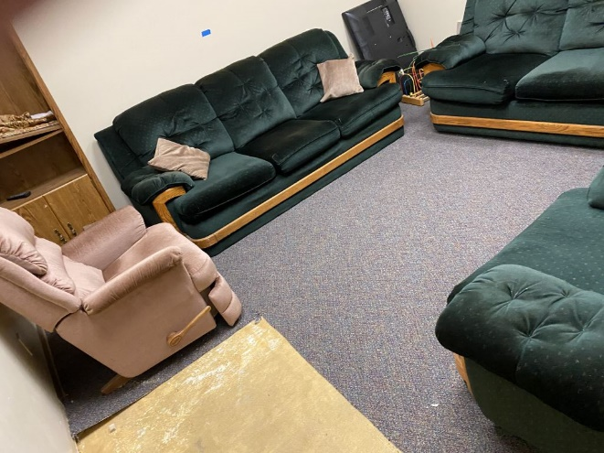
Photo 3 -Front of Sanctuary Photo 4 -Room 18

QUOTE SUBMITTAL FORM

CONTRACTOR INFORMATION:

Date: [Enter a date]
[Your Company Name]
[Street Address]
[City, ST ZIP Code]
[Phone]
[e-mail]

REQUESTOR INFORMATION:
Owner: Eagle River Presbyterian Church
Address: 12836 Old Glenn Highway
Eagle River, Alaska 99577
Phone ERPC Secretary: (907) 694-5753
Phone Project Manager, Chuck Homan: (907) 862-6116
Email: homan@remodelalaska.com.
RFQ NAME: Remove Carpet from ERPC Building
RFQ Number: 103

QUOTE INFORMATION:

State of Alaska Contractors License Number: ______________________
Contractor has required Insurance ( Yes / No ) note-proof is required at contract signing
Contractor has required Experience ( Yes / No ) attach proof to this submittal.
Contractor Equipment. Attach a brief description of the equipment to be used to remove carpet.
Contractor’s preferred: start date_______________ finish date_______________.
Price/Quote: AREA A $_________________ AREA F $_________________
Price/Quote (Total all Work): $_________________
(the total price quote offered shall be inclusive of all RFQ scope of work items, including disposal, submittal preparation, warranty, visits, call-back, touch-up, repairs of faulty workmanship, incidentals, or any other required repairs or work.)

Signature ___________________________________ Date ____________________
Of a corporate officer or other Company Official who has the authority to bind the Firm/Company.

