**EAGLE RIVER PRESBYTERIAN CHURCH**

**Earthquake Repairs and Renovation**

**REQUEST FOR PROPOSAL**

**Upgrade Fire Sprinkler System**

**Owner:** **Eagle River Presbyterian Church**

Address: 12836 Old Glenn Highway

Eagle River, Alaska 99577

Phone ERPC Secretary: (907) 694-5753

Phone Project Manager, Chuck Homan: (907) 862-6116

Email: [homan@remodelalaska.com](mailto:homan@remodelalaska.com).

**RFP Name:** Upgrade Fire Sprinkler System

**RFP Number:** 107

**Description/Directions**. Eagle River Presbyterian Church (ERPC) is soliciting a Proposal to replace existing sprinkler heads and drop pipes with new heads on flexible drops in areas of suspended ceiling. Hard ceiling areas will require new heads and adjustment. Award will be made to an Offeror meeting minimum qualifications with the lowest price if a mutually agreed upon schedule can be developed. To submit a proposal, fill out the submittal form in Attachment 2.

**Note 1 -** A Pre-Bid Site Visit is required.

**TABLE OF CONTENTS**

TITLE PAGE ……………………………………………………………….1

TABLE OF CONTENTS ……………………………………………………….2

1. CONTRACTOR MINIMUM QUALIFICATION .………...….…………2
2. SITE VISIT .…………………………………………...……….…………2
3. GENERAL INFORMATION ...………………………………………….….2
4. SCOPE OF WORK .…………...………………………………………….4
5. SCHEDULE ...…….……………………………………………………….5
6. PAYMENT ...…….……………………………………………………….6
7. SAMPLE CONTRACT ……………………………………………….6
8. AWARD OF CONTRACT ……………………………………………….6

ATTACHMENT 1 DRAWINGS, TABLES, PHOTOS, MISC......….….……...8

ATTACHMENT 2 PROPOSAL SUBMITTAL FORM .……….….….15

ATTACHMENT 3 SAMPLE CONTRACT ...…….………….…………...17

CONTRACT ADDENDUM 1 – Federal Requirements…....…...…...….….25

CONTRACT ADDENDUM 2 – Final RFP ……….…………………...…28

CONTRACT ADDENDUM 3 – Final Proposal …….……………...…29

CONTRACT EXHIBIT A Certificate of Insurance ...………….…30

CONTRACT EXHIBIT B Sample Change Order …...……….…31

1. **CONTRACTOR MINIMUM QUALIFICATION**. The Offeror/Contractor shall have a minimum of five (5) years of documented experience in providing services with similar scope and complexity as required for this Contract. The Offeror shall have all certification and documentation required by The National Fire Protection Association (NFPA), The Municipality of Anchorage, and the State of Alaska. to perform work on fire protection systems in buildings. The Offeror shall be able to perform the required work within the specified schedule requirements.
2. **SITE VISIT** (Required). All Offerors submitting proposals shall visit the site and walk through the building to observe conditions, take measurements, ask questions, etc. An ERPC representative will conduct the site visit. The Offeror shall coordinate with ERPC to arrange and establish a mutual agreed upon date and time for the site visit. It is the Offerors responsibility to initiate contact in writing via email to [homan@remodelalaska.com](mailto:homan@remodelalaska.com). and to ensure the site visit is completed prior to submitting a proposal.
3. **GENERAL INFORMATION**

* 1. **Proposals**. Eagle River Presbyterian Church (ERPC) is soliciting proposals for the specified work from qualified firms for a firm fixed price contract. To be considered for contract, proposals for the specified Scope of Work must be received by the Eagle River Presbyterian Church either by email at [homan@remodelalaska.com](mailto:homan@remodelalaska.com) or hard copy delivered to 12836 Old Glenn Highway, Eagle River, Alaska 99577, on-or-before, 1:00 PM local time, on Thursday, February 27, 2020. The timeliness of Proposal receipt is the responsibility of the Offeror.
  2. **Funding**. Funding for the work is from a variety of sources, including ERPC’s Insurance Company and Federal Agencies. The funding sources have specific requirements and require special price/cost breakouts for their portion of the repairs. These requirements are specified in the RFP. Fill out and submit the bid schedule/breakdown in in Attachment 2.
  3. **Conflict and Discrepancy**. Should the Offeror discover any ambiguity, conflict, discrepancy, omission or other error in the RFP, The Offeror shall immediately notify ERPC in writing and request modification or clarification prior to submitting its proposal/bid. The Offeror shall be responsible for requesting clarification from ERPC of any known ambiguity, conflict, discrepancy, omission or other error in the RFP prior to bid. In the absence of such request, the resolution action determined by ERPC to be within the bounds of the contract shall be binding and shall be accomplished by the Offeror at no cost to ERPC.
  4. **Ongoing Activities at ERPC and Coordination**. Multiple Organizations, Groups, Tenants, and Individuals, utilize and operate within ERPC and will continue their activities to the greatest extent possible while the contractor is performing the specified SOW. ERPC is responsible for communicating with the various entities utilizing the ERPC Building and performing any required coordination to facilitate the Contractors approved schedule. The Contractors adherence to the approved schedule, and updating the schedule as work progresses, is very important to ERPC.
  5. **Background and Damage**. The building was originally constructed in 1982-83 and extensively remodeled in 1990-91. The building experienced non-structural damage during the earthquake on 30 November 2018. The majority of the building is structurally supported by steel columns and beams which did not appear to experience vertical movement or damage from the earthquake. The fire sprinkler piping is attached to roof joist/truss which rest on the steel beams of the structure. Sprinkler piping and the sprinkler heads are generally believed to have remained at pre-earthquake elevations. The building floor is concrete slab-on-grade, and as-built drawings show it to be isolated from both the columns and column footings by control joints cut into the finish slab. The concrete floor did experience differential movement from the earthquake. Interior partition walls which rest on the concrete floor show the effect of differential vertical movement of the floor slab. The most visible evidence is seen in the suspended ceiling grid. The ceiling grid is attached to the interior walls, and where the grid has not been removed to reduce hazard, shows significant differential movement. The most visible indicator of movement are the sprinkler heads that are now located slightly above/below the ceiling tile at various locations within the building. As-built drawings indicate the finish floor elevation of the building to be 277.56. Several Contracts: to raise the floor slab (1-inch or less is typical); to repair cracks in drywall and paint walls; to demolish the existing suspended ceiling and install a new ceiling grid, will be completed prior to the start of physical work on this Contract.
  6. **Questions**. Questions related to the RFP shall be emailed to [homan@remodelalaska.com](mailto:homan@remodelalaska.com).

1. **SCOPE OF WORK** 
   1. **Codes and Requirements**: For all work in this RFP the Contractor shall meet or exceed the codes, specifications or requirements of: The State of Alaska; The Municipality of Anchorage; NFPA 13, Standard for the Installation of Sprinkler Systems; or other appropriate NFPA Standards that govern the work.
   2. **Phase 1 - Review and Analysis.**

Background. The walls of two rooms in the Sanctuary were demolished to increase the area of the Sanctuary. The wall between the Narthex and the Sanctuary was demolished and a new wall constructed to increase the area of the Narthex. A new wall was constructed to create Office 1 (which decreased he overall area of Entry 1). A partial wall (ceiling area) was constructed to define the Chancel area of the Sanctuary (see Photo’s in Attachment 1). The Plans for this remodel work were submitted to the Fire Marshal and approved (see Certificate in Attachment 1)

Work Required. Review and analyze the existing layout of piping and sprinklers in the area comprised of Office 1, Entry 1, Kitchen 1 and 2, Narthex, Sanctuary, and Chancel, and determine whether relocation of sprinklers is necessary. See Attachment 1 for Ceiling Plan and Room Layout Drawing.

* 1. **Phase 1 - Drawings and Sketches**: Create and provide adequate drawings or sketches if relocation of existing sprinklers or additional new sprinklers are required. The drawings or sketches, with appropriate certification or professional stamps, as required by the State of Alaska Fire Marshal, shall be prepared and submitted to Fire Marshal for review and approval.
  2. **Phase 1 - Permits**. The Contractor shall be responsible for submitting proper documentation to the proper agency or authority having jurisdiction, to obtain the permits necessary to perform the specified work. The Contractor shall include the cost for permits in their proposal, and shall obtain approvals and permits prior to beginning physical work on fire systems. Permits and approvals shall be posted where directed by the permitting agency and/or ERPC.
  3. **Phase 2 - New Flexible Sprinkler Drops**. Reference Table 1 and the Ceiling Plan and Room Layout Drawing in Attachment 1. In all areas with suspended acoustic ceilings the Contractor shall remove existing hard pipe drops and install a new flexible sprinkler drop assembly. The assembly shall include new flexible drops, sprinkler heads, and all necessary brackets, supports, escutcheons, such that all equipment and materials needed from top of flexible drop to final placement in the suspended ceiling tile is new and complete. Table 1 indicates there are 100 sprinklers that require this modification. The intent is to have all sprinklers in the rooms in Table 1 that have suspended ceilings to be upgraded with a flexible drop assembly. If Review and Analysis results in additional sprinklers being required, the total number in excess of 100 shall be added to the contract by change order.
  4. **Phase 2 - Sprinkler Drops, Hard Ceiling Areas**: The contractor shall remove the 26 sprinkler heads as shown in Table 1 and replace with new heads, including all necessary new hardware for the work. The Contractor shall adjust sprinkler head height and location in the ceiling as necessary to meet NFPA requirements. Install new oversized fire sprinkler head escutcheons on all 26 Sprinkler heads. The intent is to have all sprinkler heads in the hard ceiling areas in Table 1 have new heads and be adjusted.
  5. **Materials**: The Contractor shall supply all materials for the work.
  6. **Labor and Equipment**. The Contractor shall provide all labor, materials, equipment, work-lighting, etc., and supervision for the specified work. There are a number of awkward or heavy pieces of furniture (pews, piano, organ, desks, shelving and racks of food, etc.) in the rooms or areas. It is the intent of ERPC to move these items from the work area to an adjacent room prior to the contractor’s work (this will be discussed, and the final schedule adjusted accordingly, prior to the signing of a contract). Incidental movement of furniture, equipment or appurtenances may be required and the Contractor shall provide all labor, equipment, hand tools, materials and supervision required to move or reposition or, protect office equipment, furniture, or appurtenances.

1. **SCHEDULE**. ERPC is issuing multiple contracts for the earthquake related repairs. Each Contract will be phased to avoid conflicts between the contracts and other Contractors to the greatest extent possible.
   1. **Start Date, Notice to Proceed (NTP), Duration** (in calendar days). ERPC will advertise the RFP, receive and evaluate proposals, and award a contract. It is anticipated Award of the Contract will occur in early-March, 2020. ERPC will issue NTP soon thereafter. Should the Offeror believe the specified NTP, start date, or duration to complete work or other schedule requirement is inadequate or unacceptable for the work, the Offeror shall provide alternates in the Proposal.

**Phase 1** (items 4.2, 4.3, and 4.4) shall be completed within 14 days of NTP unless another mutually agreed upon date is established.

**Phase 2**. Physical work on the sprinkler system is not expected to be able to begin before May 1, 2020 because of other contracted work schedules. Mutually agreed upon dates shall be established as more schedule information is known.

* 1. **Work Areas and Sequence of Work**. The Scope of Work in rooms and areas shown in Attachment 1 are prioritized to accommodate Sunday services and multiple users and activities within the building. The final schedule shall accommodate the listed requirements and priority:

Priority 1 - Sanctuary, Narthex, Entry 1 Corridor, Kitchen 1-2, and Nursery. These areas experience heavy use on Sunday’s. Work shall be scheduled to be completed in the shortest time possible. These Rooms and Areas shall be clean and fully useable on any Sunday.

Priority 2 - Pastor’s Office, Office 1, Entry 2, and Room AA. These areas experience heavy use on multiple days of the week. Work shall be completed in the shortest time possible.

Priority 3 - Food Pantry Rooms, FP1-4. Work shall be scheduled for any Wednesday-Thursday or Saturday-Sunday time period. These Rooms and Areas shall be clean and fully useable on any Monday, Tuesday, and Friday.

Priority 4 - Rooms 12 through 22 and other rooms or areas not specifically called out. These rooms are not heavily used but should be scheduled to minimize the time each room or area is out of service.

* 1. **Allowed Work Days and Work Hours**. The Contractor may work Monday through Sunday, seven (7) days per week including holidays. Except, no works shall be scheduled between 5:00 AM and 1:00 PM on any Sunday.

1. **PAYMENT**. Payment will be made for each Phase of work, in accordance with the provisions specified in the Sample Contract. The Contractor may also request payment for received materials. All payment agreements that differ from that specified in the Sample Contract, shall be written and attached to the Contract as addendums at the time the Contract is signed. Verbal agreements that are not addendums to the contract are not valid and will be considered void.
2. **SAMPLE CONTRACT**. A Sample Contract is provided in Attachment 3. The Final Contract the Offeror will sign will be substantially similar to the Sample Contract. the general provisions and requirements of the RFP are contained in the Sample Contract. The Offeror shall read and be familiar with the Sample Contract and these requirements, as they are likely to have impact on the manner work is conducted and the proposed price. The provisions and requirements will become binding upon signature of the Contract.
3. **AWARD OF CONTRACT**. The successful Offeror shall have the opportunity to be awarded the Contract to perform the work stated in the RFP. It is the intent of ERPC to award the contract to the Proposal with the lowest price, provided the Offeror meets minimum qualifications and a mutually agreed upon schedule can be developed
   1. **Schedule**. A schedule that is mutually agreeable to ERPC and the Offeror must be developed prior to the award and signing of a contract, or the proposal will be rejected.
   2. **Rejection of Proposal**. ERPC reserves the right to reject any or all proposals, to waive any informality in any proposal, to act as sole judge of the merit of each response submitted, and to select a Contractor based on the criteria stated.
   3. **Contract Requirements**. The successful Offeror/Contractor shall comply with all instructions and shall perform services in a manner commensurate with the highest professional standards by qualified and experienced personnel. The successful Contractor shall follow 2 CFR 200.326, 2 CFR Part 200, Contract Addendum 1 and all Regulatory Codes & Standards required by the Federal Government, State of Alaska and the Municipality of Anchorage, and obtain all required Permits and Business License(s). The successful Contractor shall follow Federal Procurement Standards including purchases.

**ATTACHMENT 1 DRAWINGS, TABLES, PHOTOS, MISC.**



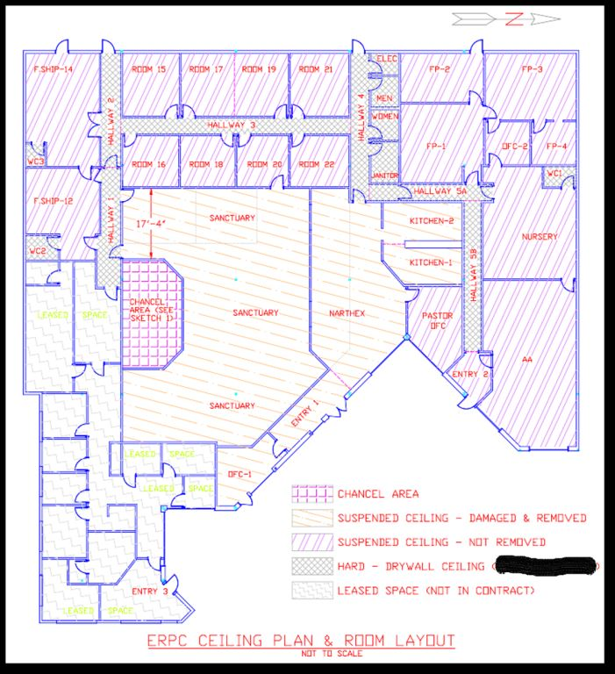

**DRAWING 1 – ERPC New Ceiling Plan & Room Layout (new wall shown, old walls shown as faint lines)**

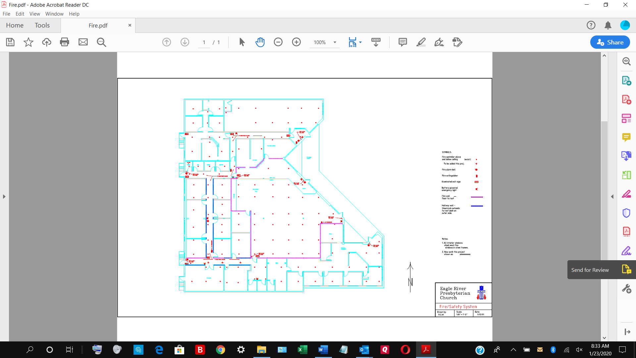

**DRAWING 2 – ERPC Fire Safety System (current location of sprinklers with old wall location are shown this drawing. New walls are shown on Drawing 1)**

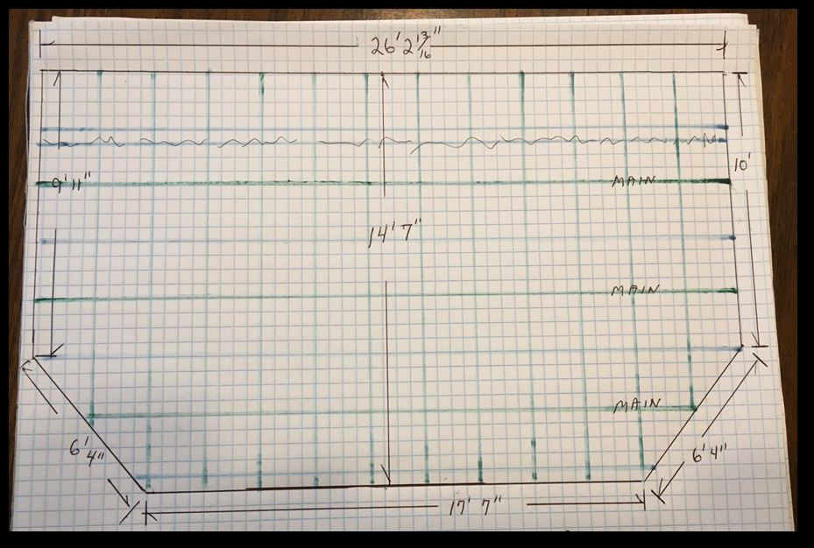

**SKETCH 1: Chancel Area Dimensions**

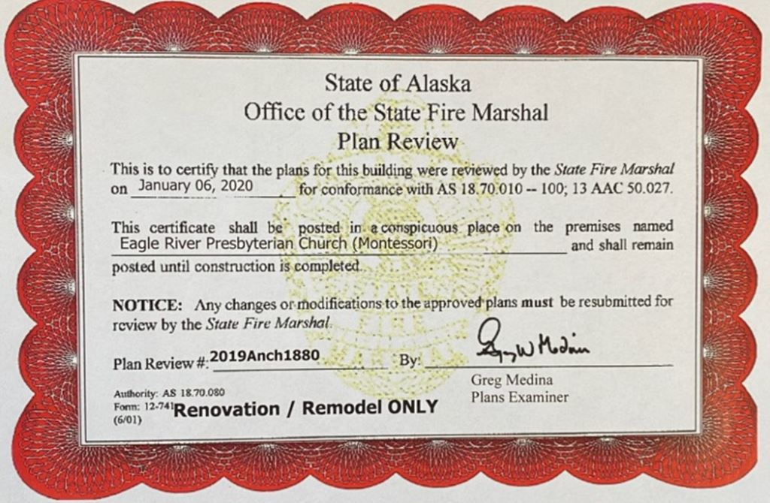

PLAN REVIEW APPROVAL

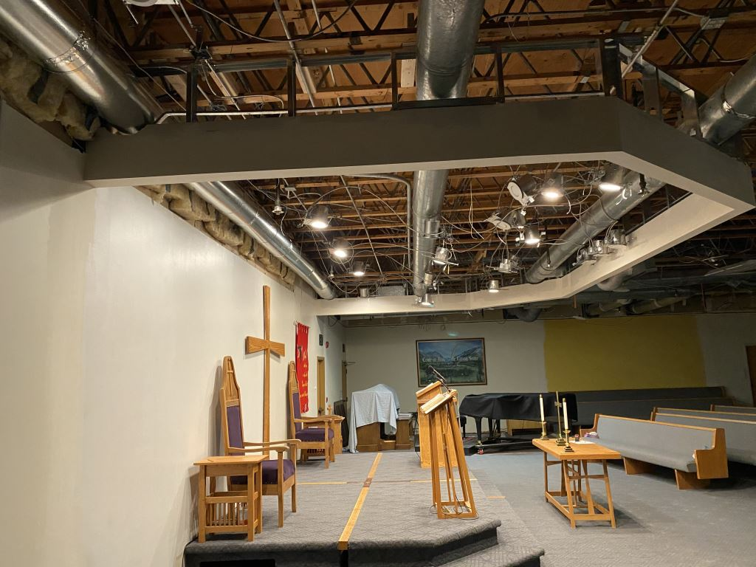

**Chancel Ceiling Area (looking to the West)**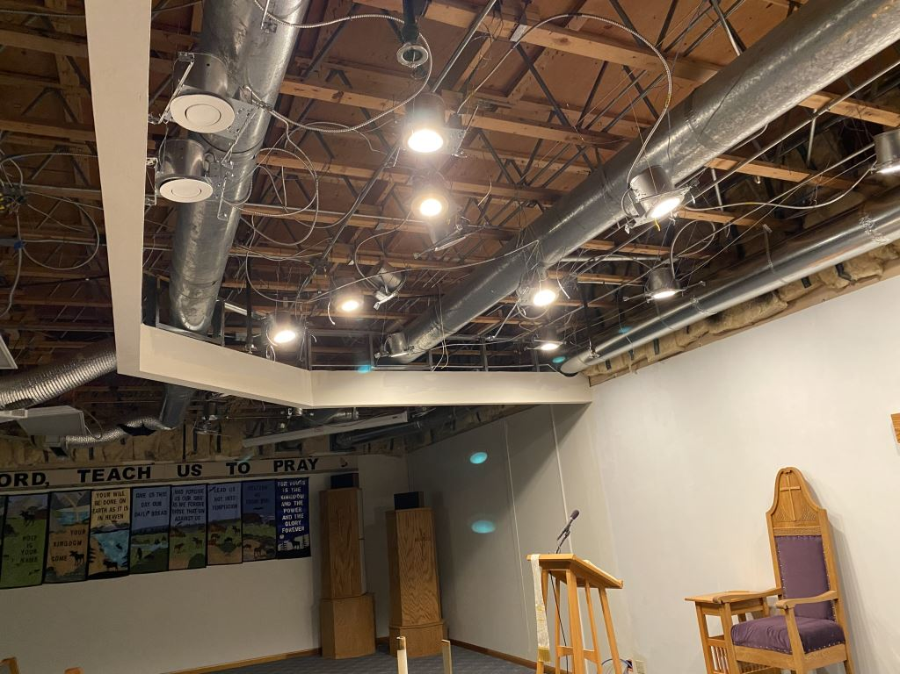

**Chancel Ceiling Area (looking to the East)**

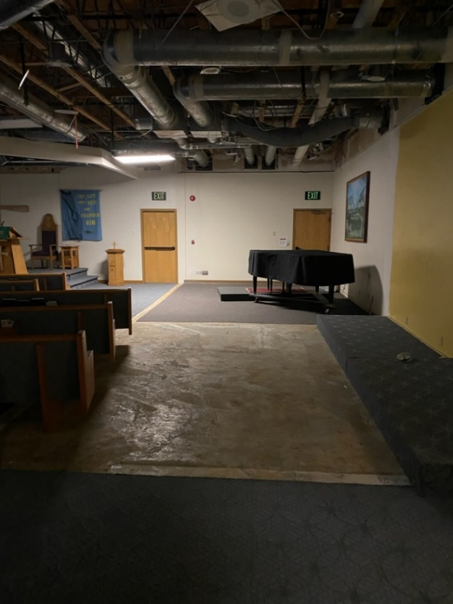

**Demolished Wall Area S.W. Sanctuary**

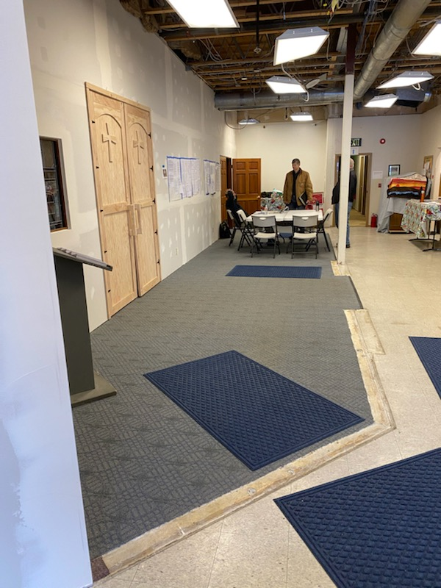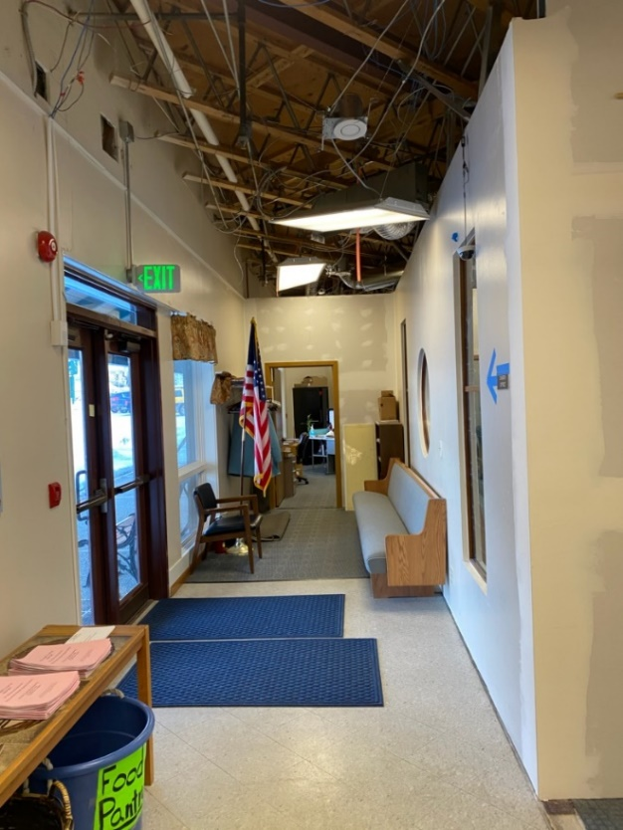

**New & Demolished Wall Sanctuary/Narthex Entry 1 with New Office (in background)**

**ATTACHMENT 2 - PROPOSAL SUBMITTAL FORM (Page 1)**

**CONTRACTOR INFORMATION:**

Date: [Enter a date]

[Your Company Name]

[Street Address]

[City, ST ZIP Code]

[Phone]

[e-mail]

**REQUESTOR INFORMATION:**

Owner: Eagle River Presbyterian Church

Address: 12836 Old Glenn Highway

Eagle River, Alaska 99577

Phone ERPC Secretary: (907) 694-5753

Phone Project Manager, Chuck Homan: (907) 862-6116

Email: [homan@remodelalaska.com](mailto:homan@remodelalaska.com).

RFP Name: Upgrade Fire Sprinkler System

RFP Number: 107

**PROPOSAL INFORMATION:**

State of Alaska Contractors License Number: ______________________

Contractor has required Insurance ( **Yes / No** ) Note-proof is required at contract signing

Contractor made the scheduled Site Visit ( **Yes / No** ). Site Visit Date_________________ Name of Person __________________________________________ Title _______________.

1. State the number of years you have performed work on fire sprinkler systems in commercial buildings work similar to that required by this RFP. Years ____ .

**Signature ___________________________________Date ____________________**

Corporate Officer or other Company Official who has the authority to bind the Firm/Company

**ATTACHMENT 2 - PROPOSAL SUBMITTAL FORM (Page 2)**

**PRICE.** Fill in the bid schedule below. Any supplemental price information submitted should be attached to this page.

Federal Agencies may provide part of the funding to ERPC for this work. They require the cost/price breakout of certain items as shown in the bid schedule. The Contractor may submit a bid breakout that is more comprehensive and in greater detail than required below, but as a minimum, you shall include a price for each item listed below

The Contract shall be firm fixed price and the final total price offered shall be inclusive of all RFP scope of work items, including proposal preparation, warranty, visits, call-back, touch-up, repairs of faulty workmanship, incidentals, or any other required repairs or work.

|  |  |  |
| --- | --- | --- |
| **PROPOSAL BID SCHEDULE** | | |
| **Item** | **Item Description** | **Price** |
| 1 | Review, Analysis, Drawings, Sketches, Plan Approval, Permits. |  |
| 2 | New “hard pipe” work to relocate or add new sprinklers |  |
| 3 | 100 Flexible Sprinkler drops in Suspended Ceiling |  |
| 4 | 26 Sprinkler heads and Adjustments in Hard Ceiling Areas |  |
| 5 | Miscellaneous Interior Work |  |
|  | **Total Price: Items 1, 2, 3, 4 and 5** |  |
| **A** | Additional Flexible drop for each new Sprinkler |  |

Bid Schedule Notes:

* Item 1 shall be the price to complete all work related to Scope of Work Items 4.1, 4.2, and 4.3 and 4.4.
* Item 2 shall be the price to complete all physical installation to revise, relocate, or add new hard pipe for new or relocated sprinklers.
* Item 3 shall be the price to complete all work to remove 100 existing sprinkler hard pipe drops and the complete install of a new flexible drop sprinkler in areas with a suspended ceiling.
* Item 4 shall be the price to remove existing heads, install and adjust new heads in areas with hard ceilings.
* Item 5 shall be the price for any work not listed in Items 1 through 5. Provide an itemized listing of the work and associated price for anything included in this item.
* Item A shall be the price for a complete flexible drop assembly and all work to install, should additional sprinklers be needed.

Note- should the actual number of sprinklers be different than shown in Table 1, the difference shall be addressed by change order.

**ATTACHMENT 3**

**SAMPLE CONTRACT**

|  |  |
| --- | --- |
|  |  |
| **CONSTRUCTION CONTRACT AGREEMENT** | |

This Construction Contract Agreement (this “Agreement”) is made as of the dd day of Month, 2019 by Eagle River Presbyterian Church, (“Owner”) and ____________________________, address____________________________, ph. ___________ ("Contractor"). Owner and Contractor may each be referred to in this Agreement individually as a “Party” and collectively as the “Parties.”

WHEREAS, Contractor is a duly licensed general contractor in good standing, with Contractor’s State of Alaska license number ___________; and

WHEREAS, Owner owns the property located at 12836 Old Glenn Highway, Eagle River, Alaska 99577 (the “Property”) and desires to have specified work performed by Contractor at the Property.

NOW THEREFORE, in consideration of the mutual promises and for other good and valuable consideration exchanged by the Parties as set forth in this Agreement, the Parties, intending to be legally bound, hereby mutually agrees as follows:

**OWNER CONTACT INFORMATION:**

**Owner: Eagle River Presbyterian Church**

Address: 12836 Old Glenn Highway

Eagle River, Alaska 99577

Phone ERPC Secretary: (907) 694-5753

Phone Project Manager, Chuck Homan: (907) 862-6116

Email: [homan@remodelalaska.com](mailto:homan@remodelalaska.com).

**REQUEST FOR PROPOSAL (RFP)**. The Contractor shall review the RFP and ensure that all information is correct prior to signing the Contract. The Request for Proposal will then become Addendum 2 to this Contract. The Contractor agrees to, and shall perform, all provisions and requirements as described, specified, or stated in the Request for Proposal.

**PROPOSAL**. The Contractor shall review their submitted Proposal and ensure that all information is correct prior to signing the Contract. The Contractor’s Proposal will become Addendum 3 to this Contract. The Contractor shall perform in full, all elements, provisions, promises, and statements made in the Proposal.

**ORDER OF PRECEDENCE**. Following the signing of the contract, should, there be conflict or discrepancy between the Contract, RFP, or Proposal, then in all cases or situations, the Contract shall take precedence over the RFP, and both Contract and RFP shall take precedence over the Proposal.

1. **Description of Work.** Contractor shall perform the work described in Addendum 2 in accordance with Owner’s contract plans and specifications. This Agreement and any Change Order, as defined herein, (collectively, the "Contract Documents") at the Property.
2. **Contract Price and Payments.** Owner agrees to pay Contractor the total amount of $__________ (the “Contract Price”) for the Work. Payment of this amount is subject to additions or deductions in accordance with any mutually agreed to changes and/or modifications in the Work, and the other documents to which this Agreement is subject. Payment for the Work will be 85% at substantial completion, and 15% at final completion unless other arrangements are made in writing, prior to signing of the Contract. Contractor, by accepting final payment, waives all claims except those previously made in writing, and which remain unsettled at the time of Final Completion.
3. Final Inspection: When work is substantially completed, the Contractor shall notify ERPC that a final inspection is requested. ERPC will coordinate with the Contractor to develop a mutually acceptable date and time for the final inspection (usually within two (2) working days). ERPC will inspect, develop a punch list, and determine whether the work is substantially complete.
4. Substantial Completion shall be defined as the stage of a construction where the building project, or a designated portion of the project, is at least 95% completed and sufficiently complete that the owner may use or occupy the building project or designated portion thereof for the intended purpose.
5. Final Completion shall be defined as all work completed, all punch list items are corrected and signed off, and all equipment and materials have been removed from ERPC property.
6. Payment: at the Final Inspection ERPC will inspect, develop a punch list, and determine whether the work is substantially completed. The contractor may request payment of 85% of the substantially completed work. The final 15% of the contract will be paid after all deficiencies are cleared in all areas and the contractor has performed final cleanup and demobilized.
7. **Materials and Labor.** Contractor shall provide and pay for all labor and equipment, including tools, construction equipment, machinery, transportation and all other facilities and services, and all materials as described in the RFP necessary for the completion of the Work. All materials shall be good quality and new, unless the Contract Documents require or permit otherwise. Contractor may substitute materials only with the prior written approval of Owner.
8. **Instructions.** The Owner’s designated representative, the Moderator of Trustees, will give all instructions to Contractor, and will furnish all necessary correspondence for the Work. The Moderator of Trustees, by written direction to the Contractor, may appoint an alternate representative. The written direction will include the limits of authority assigned to the alternate representative. All instructions from ERPC to the Contractor shall be in written form. Instructions, which either the Moderator of Trustees, or the Contractor, believe will affect contract scope of work or contract price shall not be implemented, nor any related work performed, until a signed Change Order is made to the Contract.

1. **Start and Completion Dates.** The Work under this Agreement shall begin as stated in Contract Addendum 2 and further defined in Contract Addendum 3.
2. **Timeliness.** All times stated in this Agreement or in the Contract Documents are of the essence. Contractor agrees that such times are reasonable for performing and completing the Work.
3. **Liability for Damages**. In all cases, Contractor accepts liability for all damages, including but not limited to, loss of business, physical property damage, bodily injury, etc., resulting from failure of Contractor to abide by any of the terms of this Contract. Contractor shall indemnify and hold harmless Owner and Manager its agents and employees to the fullest extent permitted by law, from and against all claims, damages, losses and expenses, including, but not limited to attorney's fees, arising out of or resulting from the performance of work.
4. **Contractor’s Insurance**. Contractor agrees to maintain at its own expense during the entire period of construction at the Property:

A. **Commercial General Liability** (including Personal Injury) Insurance. Commercial General Liability includes coverage Premises-Operations, Products/Completed Operations Hazard, Contractual Liability, Broad Form property Damage, Independent Contractors and Personal Injury Liability. Such general liability insurance as will protect Contractor from claims for property damage and bodily injury, with limits of liability not less than $1,000,000 {minimum amount of general liability insurance] for each occurrence.

B. **Workers’ Compensation Insurance**. Workers Compensation Insurance with statutory limits for the State of Alaska.

Contractor shall maintain and keep in force insurance in amounts and types specified above, and shall provide an appropriate Certificate of Insurance evidencing the insurance coverage. Contractor shall name Owner as an additional insured. Any Subcontractor used by Contractor on RFP required work shall have similar insurance and the Contractor is required to collect and forward to the ERPC Office Certificates from all Subcontractors. The Certificate of Insurance shall be on file in the ERPC Office prior to commencement of any work. Proof of such insurance shall be filed by Contractor with Owner within a reasonable time after execution of this Agreement and prior to the start of any physical on-site work. See Contract Exhibit A for an example of a Certificate of Insurance

1. **Subcontracts.** Contractor shall furnish to Owner a list of names of subcontractors proposed to perform principal portions of the Work. Contractor shall not employ any subcontractor to whom Owner reasonably objects. A subcontractor, for the purposes of this Agreement, shall be a person with whom Contractor has a direct contract for work at the Property. All contracts between Contractor and subcontractor shall be in accordance with the terms of this Agreement and the Contract Documents.
2. **Change Orders.** All changes to specified requirements and work shall be authorized in a written “Change Order” signed by Owner and Contractor, which shall be incorporated by reference herein. Verbal discussion, comments, or direction shall have no validity until a written change order is signed by both parties. Owner reserves the right to order changes to the Work in the nature of additions, deletions or modifications, without invalidating this Agreement, and agrees to make corresponding adjustments in the Contract Price and time of termination if applicable. The Contractor is cautioned that any statements made by Owner staff or advisors that materially change any portion of the Contract document are NOT binding on Owner, and shall not be relied upon unless ratified by written and signed “Change Order”. See Contract Exhibit B for an example of a Change Order Form.
3. **Permits and Licenses.** Contractor shall obtain all licenses, permits, and inspections necessary for proper completion of the Work except that Owner will be responsible for obtaining the Building Permit from the Fire Marshall. Contractor is responsible for the cost of any necessary permits, licenses, or inspections.
4. **Laws and Regulations.** Contractor shall perform the Work in a workmanlike manner. Contractor shall comply with all applicable federal, state, and local laws, regulations and ordinances, and any safety requirements of Owner in the performance of the Work. Contractor shall promptly notify Owner upon discovery of any variance between the various regulations and the Construction Documents.
5. **Supervision of Construction.** Contractor shall be solely responsible for, and shall supervise and direct all work, construction, or services under this Agreement. Contractor shall provide competent and suitable personnel to perform the Work and shall at all times maintain good discipline and order at the Property. Contractor will at all times take all reasonable precautions for the safety of its employees and the public at the Property. Contractor agrees to assume full responsibility for the acts, negligence, and/or omissions of its employees and any subcontractors and their employees.
6. **Maintain Condition of Property.** The Contractor shall adhere to all EHP (Environmental, Historic and Preservation) guidelines. Contractor agrees to keep the Property and adjoining driveways free and clear of waste material and rubbish. Contractor shall confine the storage of materials and equipment and the operations of employees to the Property, and shall not unreasonably encumber the Property with materials or equipment. Contractor shall be fully responsible for any damage to the Property or areas contiguous thereto resulting from the performance of the Work. At the completion of the Work, Contractor shall remove all waste materials, rubbish and debris from and about the Property as well as all tools, appliances, construction equipment and machinery, and surplus materials, and shall leave the Property clean and ready for occupancy by Owner.
7. **Protect Existing Property and Features**. Contractor shall protect all surrounding furniture, surfaces (mechanical, electrical, computer hardware, etc.) and other sensitive components from sanding dust, paint splatter, spills and/or overspray. Use sufficient drop cloths and protective coverings for the protection of floors, furnishings and adjacent surfaces. Contractor shall be responsible for providing and for the placement of barricades, drop cloths, tarps, plastic, flag tape and any other safety equipment required to protect the public and employees in the work area. Contractor shall be responsible for the security of his or her equipment and materials.
8. **Contractor Clean-Up and Disposal of Waste**. Contractor is responsible for the cleanliness of the work area at all times and while work is being performed. The Contractor shall perform a final clean-up at the end of each day and upon completion of each activity of the work. Clean up shall comply with all applicable Federal, State, and local laws and regulations. Contractor shall, at all times, keep the site free from accumulation of waste materials, debris or rubbish caused by his or her employees at work. Contractor shall remove from the site all tools, surplus materials, debris or rubbish and shall leave the site and the work in a neat and orderly fashion at the completion of the work. Whenever possible, clean up shall be conducted with water or water-based agents. Contractors may not utilize in-building or on-site trash receptacles.
9. **Free Access to Worksite.** Eagle River Presbyterian Church will allow free access to work areas for workers and vehicles, and will allow areas for the storage of materials and debris. Driveways shall be kept clear for the movement of vehicles during work hours. The Contractor shall make reasonable efforts to protect driveways, lawns, shrubs, and other vegetation. The Contractor also agrees to keep the Worksite clean and orderly and to remove all debris as needed during the hours of work in order to maintain work conditions which do not cause health or safety hazards.

1. **Contractor Staging and Parking Area.** The contractor shall be assigned an area of the graveled parking area nearest the Old Glenn Highway for Contractors use. The Contractor shall not park vehicles or equipment or locate connex (or other storage units), trailers, dumpster or trash receptacles etc. except in this designated area. The Contractor may contact ERPC to arrange for loading and unloading of materials and equipment at areas closer to the building. Such arrangements shall not exceed 30 minutes in duration without approval of ERPC.
2. **Utilities.** Owner will pay for all permanent electric, water, phone, cable, sewer and gas service as needed to perform the Work. Contractor shall pay for the installation, connection and removal of all temporary utilities on the Property during the performance of the Work. All temporary utilities shall conform and adhere to the Applicable Laws.
3. **Hazardous Materials.** Except as otherwise provided in the Contract Documents, Contractor shall be responsible for all Hazardous Materials brought to the Property by the Contractor. Hazardous Materials shall include radioactive materials, asbestos, polychlorinated biphenyls, petroleum products, crude oil, flammable materials, chemicals or solvents known to cause cancer or reproductive toxicity, pollutants, contaminants and toxic substances which are restricted, prohibited or regulated by any agency of government in its manufacture, use, maintenance, storage, ownership or handling. If Contractor discovers any Hazardous Materials on the Property, Contractor shall immediately notify Owner and shall cease working until the material or substance has been rendered harmless. The Occupational Safety and Health Administration requires that Material Safety Data Sheets (MSDS) be readily available to all employees for potentially harmful substances handled in the workplace under the Hazard Communication regulation. Contractor shall forward to ERPC prior to beginning work the appropriate MSDS sheets (OSHA Form 174 or its replacement) of any regulated materials that are brought on site, or required to be left on site.
4. **Inspection.** Owner will have a right to inspect the Work at any time and request that Contractor promptly correct any Work that is defective or does not conform to the Contract Documents. If required, the Work shall be inspected and certified by the appropriate state or local agency or health officer at each necessary stage.
5. **Right to Stop Work.** If Contractor fails to correct any defective Work or repeatedly fails to perform the Work in accordance with the Contract Documents, Owner shall have the right to order Contractor to stop performing the Work, or any portion thereof, until the cause for such order is eliminated. In such an instance, subsequent completion of contract work, whether by the Contractor or another contractor selected by ERPC, shall be paid for by the Contractor at no additional cost to ERPC.
6. **Other Contractors.** Owner reserves the right to enter into other contracts in connection with the Work. Contractor shall cooperate with all other contractors so that their work shall not be impeded, and shall give them access to the Property as necessary to perform their contracts.
7. **Record Documents.** When applicable, the Contractor shall maintain in a safe place at the Property one record copy of all drawings, specifications, addenda, written amendments, and the like in good order and annotated to show all changes made during construction, which shall be delivered to Owner upon completion of the Work.
8. **Warranty.** Contractor herewith warrants that the specified contracted work shall be executed in conformance with the requirements of the Contract documents and guarantees said work to perform without failure, including all workmanship and material, for a period of one (1) year from the date of substantial completion and/or final Owner acceptance. Further, during said one-year warranty period Contractor agrees to repair or replace or cause to be repaired or replaced any and all work that may prove to be defective during the warranty period at no additional cost to ERPC. Nothing herein intends or implies that the guarantee and/or warranty shall apply to work which has been abused or neglected by the Owner.
9. **Force Majeure.** If performance of this Contract or any obligation thereunder is prevented, restricted, or interfered with by causes beyond either party's reasonable control ("Force Majeure"), and if the party unable to carry out its obligations gives the other party prompt written notice of such event, then the obligations of the party invoking this provision shall be suspended to the extent necessary by such event. The time limit for completion of work herein specified is subject to extension because of delays occasioned by work stoppage (strike), lockout, inclement weather, unexpected unavailability of material, fires, civil disobedience, riots, rebellions, acts of God or other causes beyond the reasonable control of Contractor, but in no event more than thirty (30) days beyond the date or dates specified herein for completion.
10. **Indemnification.** Contractor agrees to defend, indemnify and hold harmless Owner and its agents and employees, from and against all claims, actions, liabilities, suits, demands, injuries, obligations, damages, losses, settlements, judgments, fines, penalties, costs and expenses, including reasonable attorneys' fees, arising out of any negligent act or omission by Contractor, a subcontractor or anyone directly or indirectly employed by them in the performance of the Work resulting in bodily injury, illness or death, or for property damage, including loss of use, unless caused by the sole negligence or willful misconduct of Owner.
11. **Extension of Time.** The times stated in this Agreement may be extended for such reasonable time as Contractor and ERPC jointly determine when performance of the Work by Contractor is delayed by a Change Order, labor disputes, fire, unusual delay in deliveries, abnormal adverse weather conditions, unavoidable casualties, or other causes beyond Contractor’s control or which justify the delay.
12. **Early Termination for Breach of Contract.**

**A. Contractor's Termination.** Contractor may, on 30 days’ written notice to Owner, terminate this Agreement before the completion of the Work when for a period of 60 days after a progress payment is due, through no fault of Contractor, Owner fails to make the payment. On such termination Contractor may recover from Owner payment for all Work completed and for any loss sustained by Contractor for materials, equipment, tools or machinery to the extent of actual loss thereon, plus loss of a reasonable profit.

**B. Owner's Termination.** Owner may, on 60 days’ notice to Contractor, terminate this Agreement before the completion of the Work, and without prejudice to any other remedy Owner may have when Contractor defaults in the performance of any provision of this Agreement, or fails to carry out performance of the Work in accordance with the provisions of the Contract Documents.

1. **ARBITRATION**. In the event of any dispute between Contractor and Owner with respect to the provisions hereof, the matter shall be settled by arbitration in such a manner as the parties may agree upon, or if they cannot agree, shall be formally submitted for mandatory arbitration under the Construction Industry Arbitration Rules of the American Arbitration Association. The finding of such arbitrator shall be final and binding upon both parties. A ruling by any agency, government, or arbitrator that a provision hereof is invalid or unenforceable shall in no way affect the validity or enforceability of any other provision.
2. **Assignment.** No Party hereto shall have the right to assign its rights or delegate its duties hereunder without the written consent of the other Party.
3. **Binding Effect.** This Agreement shall be binding and inure to the benefit of the Parties and their respective legal representatives, heirs, administrators, executors, successors and permitted assigns.
4. **Governing Law.** This Agreement and the rights and obligations of the Parties hereto shall be governed by and construed in accordance with the laws of the State of Alaska, without regard to its conflicts of law’s provisions.
5. **Entire Agreement.** This Agreement contains the entire agreement between the Parties hereto with respect to the subject matter hereof, and supersedes all prior negotiations, understandings and agreements.

IN WITNESS WHEREOF, the Parties have executed this Agreement as of the date first written above.

**OWNER, by its MANAGER/AGENT:** **CONTRACTOR:**

Printed Name: Printed Name:

Title: ______________________________ Title:

Signature: Signature:

Date: Date:

**CONTRACT ADDENDUM 1**

FEDERAL REQUIREMENTS

1. **Equal Employment Opportunity**. During the performance of this contract:
2. The contractor shall not discriminate against any employee or applicant for employment because of race, color, religion, sex, or national origin. The contractor shall take affirmative action to ensure that applicants are employed, and that employees are treated during employment without regard to their race, color, religion, sex, or national origin. Such action shall include, but not be limited to the following: Employment, upgrading, demotion, or transfer; recruitment or recruitment advertising; layoff or termination; rates of pay or other forms of compensation; and selection for training, including apprenticeship. The contractor agrees to post in conspicuous places, available to employees and applicants for employment, notices to be provided setting forth the provisions of this nondiscrimination clause.
3. The contractor shall, in all solicitations or advertisements for employees placed by or on behalf of the contractor, state that all qualified applicants will receive considerations for employment without regard to race, color, religion, sex, or national origin.
4. The contractor shall send to each labor union or representative of workers with which he has a collective bargaining agreement or other contract or understanding, a notice to be provided advising the said labor union or workers' representatives of the contractor's commitments under this section, and shall post copies of the notice in conspicuous places available to employees and applicants for employment.
5. The contractor shall comply with all provisions of Executive Order 11246 of September 24, 1965, and of the rules, regulations, and relevant orders of the Secretary of Labor.
6. The contractor shall furnish all information and reports required by Executive Order 11246 of September 24, 1965, and by rules, regulations, and orders of the Secretary of Labor, or pursuant thereto, and shall permit access to his books, records, and accounts by the administering agency and the Secretary of Labor for purposes of investigation to ascertain compliance with such rules, regulations, and orders.
7. In the event of the contractor's noncompliance with the nondiscrimination clauses of this contract or with any of the said rules, regulations, or orders, this contract may be canceled, terminated, or suspended in whole or in part and the contractor may be declared ineligible for further Government contracts or federally assisted construction contracts in accordance with procedures authorized in Executive Order 11246 of September 24, 1965, and such other sanctions as may be imposed and remedies invoked as provided in Executive Order 11246 of September 24, 1965, or by rule, regulation, or order of the Secretary of Labor, or as otherwise provided by law.
8. The contractor shall include the portion of the sentence immediately preceding paragraph (1) and the provisions of paragraphs (1) through (7) in every subcontract or purchase order unless exempted by rules, regulations, or orders of the Secretary of Labor issued pursuant to section 204 of Executive Order 11246 of September 24, 1965, so that such provisions will be binding upon each subcontractor or vendor. The contractor shall take such action with respect to any subcontract or purchase order as the administering agency may direct as a means of enforcing such provisions, including sanctions for noncompliance: Provided, however, That in the event a contractor becomes involved in, or is threatened with, litigation with a subcontractor or vendor as a result of such direction by the administering agency the contractor may request the United States to enter into such litigation to protect the interests of the United States.
9. **Compliance with the Contract Work Hours and Safety Standards Act.**
10. Overtime requirements. No contractor or subcontractor contracting for any part of the contract work which may require or involve the employment of laborers or mechanics shall require or permit any such laborer or mechanic in any workweek in which he or she is employed on such work to work in excess of forty hours in such workweek unless such laborer or mechanic receives compensation at a rate not less than one and one-halftimes the basic rate of pay for all hours worked in excess of forty hours in such workweek.
11. Violation; liability for unpaid wages: liquidated damages. In the event of any violation of the clause set forth in paragraph (1) of this section the contractor and any subcontractor responsible therefor shall be liable for the unpaid wages. Such liquidated damages shall be computed with respect to each individual laborer or mechanic, including watchmen and guards, employed in violation of the clause set forth in paragraph (1) of this section, in the sum of $10 for each calendar day on which such individual was required or permitted to work in excess of the standard workweek of forty hours without payment of the overtime wages required by the clause set forth in paragraph (1) of this section.
12. Withholding for unpaid wages and liquidated damages. FEMA shall upon its own action or upon written request of an authorized representative of the Department of Labor withhold or cause to be withheld, from any moneys payable on account of work performed by the contractor or subcontractor under any such contract or any other Federal contract with the same prime contractor, or any other federally-assisted contract subject to the Contract Work Hours and Safety Standards Act, which is held by the same prime contractor, such sums as may be determined to be necessary to satisfy any liabilities of such contractor or subcontractor for unpaid wages and liquidated damages as provided in the clause set forth in paragraph (2) of this section.
13. Subcontracts. The contractor or subcontractor shall insert in any subcontracts the clauses set forth in paragraph (1) through (4) of this section and also a clause requiring the subcontractors to include these clauses in any lower tier subcontracts. The prime contractor shall be responsible for compliance by any subcontractor or lower tier subcontractor with the clauses set forth in paragraphs (1) through (4) of this section.
14. **Compliance with the Copeland "Anti-Kickback" Act**. The Contractor shall comply with 18 U.S.C. 874, 40 U.S.C. 3145, and the requirements of 29 C.F.R. pt. 3 as may be applicable, which are incorporated by reference into this contract.
15. **Debarment and Suspension**. Prior to award the Owner will check that the Contractor is not on suspension or debarred under 2 C.F.R. pt.180 and 2 C.F.R. pt. 3000. Prior to award the Contractor shall verify they are not suspension or debarred, nor shall the Contractor, subcontract or enter into a lower tier contract with any firm or individual on suspension or debarred under 2 C.F.R. pt.180 and 2 C.F.R. pt. 3000.

1. **Procurement of Recovered Materials**. In the performance of this contract, the Contractor shall make maximum use of products containing recovered materials that are EPA designated items unless the product cannot be acquired: 1) competitively within a timeframe providing for compliance with the contract performance schedule, 2) to meet contract performance requirements, or 3) at a reasonable price. Information about this requirement is available at EPA's Comprehensive Procurement Guidelines web site, http://www.epa.gov/cpg/. The list of EPA-designate items is available at <http://www.epa.gov/cpg/products.htm>
2. **Access to Records**. The contractor agrees to provide State of Alaska, the FEMA Administrator, the Comptroller General of the United States, or any of their authorized representatives access to any books, documents, papers, and records of the Contractor which are directly pertinent to this contract for the purposes of making audits, examinations, excerpts, and transcriptions. The Contractor agrees to permit any of the foregoing parties to reproduce by any means whatsoever or to copy excerpts and transcriptions as reasonably needed. The contractor agrees to provide the FEMA Administrator or his authorized representatives access to construction or other work sites pertaining to the work being completed under the contract.
3. **DHS seal, Logo, and Flags**. Contractor shall not use the DHS seal(s), logos, crests, or reproductions of flags or likenesses of DHS agency officials without specific FEMA pre-approval.
4. **Compliance with Federal Law, Regulations and Executive Orders**. FEMA financial assistance may be used to fund the contract. The Contractor will comply with all applicable federal law, regulations, executive orders, and FEMA policies, procedures, and directives.
5. **No Obligation by Federal Government**. The Federal Government is not a party to the contract and is not subject to any obligations or liabilities to ERPC, contractor, or any other party pertaining to any matter resulting from the contract.
6. **Fraud and False or Fraudulent Statements or Related Acts**. The Contractor acknowledges that 31 U.S.C. Chap. 38 (Administrative Remedies for False Claims and Statements) applies to its actions pertaining to the contract.

**CONTRACT ADDENDUM 2**

FINAL ADVERTISED RFP

(with all Amendments Issued)

**{Final Advertised RFP to be inserted at Award of Contract}**

**CONTRACT ADDENDUM 3**

OFFEROR’S FINAL PROPOSAL

(with all corrections and agreements incorporated)

**{Final Proposal to be inserted at Award of Contract}**

**CONTRACT EXHIBIT A**

**Certificate of Insurance**

The following are requirements of Eagle River Presbyterian Church, 12836 Old Glenn Highway, Eagle River, Alaska 99577

1) COMMERCIAL GENERAL LIABILITY INCLUDING PERSONAL INJURY

$1,000,000.00 per Occurrence

$2,000,000.00 General Aggregate

Commercial General Liability includes coverage Premises-Operations, Products/Completed Operations Hazard, Contractual Liability, Broad Form property Damage, Independent Contractors and Personal Injury Liability.

Commercial General Liability Includes Personal Injury Coverage (False Arrest, Detention or Imprisonment, Malicious Prosecution, Libel, Slander, Defamation or violation of Right of Privacy, Wrongful Entry or Eviction or other Invasion or Right of Private Occupancy).

Any General Aggregate shall apply on a “Per Project” basis.

2) WORKER'S COMPENSATION AND EMPLOYERS LIABILITY

*(Worker’s Comp coverage only applies to companies with 5 or more employees)*

Workers Compensation Insurance with statutory limits for the State of Alaska including benefits provided under coverage B - Employers

3) ADDITIONAL INSURED PARTIES SHALL READ AS FOLLOWS:

______________________________________________________________________________________________________________________

4) CERTIFICATE IS ALSO TO INCLUDE AS PREVIOUSLY STATED IN CONTRACT:

All coverages shall apply to all locations where the named insurers are performing services for the holder of the certificate. All such insurance shall be primary and non-contributory and in the event of any cancellation or material change in coverage notice shall be given at least sixty (60) days in advance to Manager. All companies writing policies shall be a minimum of A.M. Best's rated A X or higher. The following wording shall apply in the cancellation provision of the certificate: Should any of the above described policies be cancelled before the expiration date thereof, the issuing company will mail sixty (60) days written notice to the certificate holder name to the left.

**CONTRACT EXHIBIT B**

**CONTRACT CHANGE ORDER**

**CONTRACT**: ________________________________________ RFP/RFQ No. ______.

**Change Order Title**: ______________________________________________________

Owner Name: Eagle River Presbyterian Church

Address: 12836 Old Glenn Highway

Eagle River, Alaska 99577

Phone ERPC Secretary: (907) 694-5753

Phone Project Manager, Chuck Homan: (907) 862-6116

Email: [homan@remodelalaska.com](mailto:homan@remodelalaska.com).

TO CONTRACTOR:

Name: _______________________

Address: ____________________________

City: ___________ State: _____________ Zip: _____ - ____

Telephone:(___) ____ - ____ Extension: _____ Fax:(___) ____ - _____

The contract is hereby modified and amended as follows (number of attached pages ___): __________________________________________________________________________________ __________________________________________________________________________________ __________________________________________________________________________________ __________________________________________________________________________________ __________________________________________________________________________________ __________________________________________________________________________________ __________________________________________________________________________________

It is mutually agreed that the contract price dated ___________________, is increased/decreased by $ ___________________ payable/deductible according to the terms of the Contract upon completion of the work called for in this change order.

As a result of this change order, the time for completion of the above-mentioned contract is hereby extended by an additional _________ days. This change order is incorporated into and governed by the above-mentioned contract and is incorporated therein.

Total Contract Amount before Change Order $_______________

Total Contract Amount after Change Order $_________________

___________________________________________ ______________________

CONTRACTOR'S SIGNATURE DATE

___________________________________________ ______________________

OWNER'S SIGNATURE DATE