GATHERING TO WORSHIP
Please take a moment during the Prelude to silence your cell phones and quietly prepare yourself for worship.

PRELUDE
WELCOME
*CALL TO WORSHIP

Leader: We gather to worship God alone,

People: The glory belongs to God alone!

Leader: We gather as people reformed and reforming,

People: proclaiming the cornerstones of our faith:

Leader: Scripture alone, Christ alone,

People: faith alone, grace alone,

All: glory always, to God alone!

*PRAYER OF INVOCATION
Creator God, you have filled the world with beauty. Open our eyes to behold your gracious hand in all your works; that, rejoicing in your whole creation, we may learn to serve you with gladness; for the sake of him by whom all things were made, your Son Jesus Christ our Lord, who lives and reigns with you in the unity of the Holy Spirit, one God, now and forever. Amen.

*HYMN “Our God, Our help in Ages Past” Hymnal 687

RECEIVING FORGIVENESS FROM
GOD AND EACH OTHER
*CALL TO CONFESSION

*PRAYER OF CONFESSION: Spoken and Silent (After the corporate Prayer of Confession, please take a few moments of silence to individually confess our sins to God.)
O God, you have never stopped moving in the world and calling your church to follow your lead. Forgive us, O God, when we think of ourselves as reformed only in the past tense. Forgive us, O God, when we fail to follow the winds of your spirit leading us to change. Forgive us, O God, when we are stuck in our ways, hesitant to listen to your message coming to us through the voice of a neighbor, a stranger, or a new generation. Forgive us, O God, and grant us assurance
that you have never stopped reforming your church. For you are the one who makes all things new and forms life even from ashes.

*DECLARATION OF FORGIVENESS
Leader: For the sake of Jesus Christ who died and rose for us,
God forgives you all your sin. Through the power of the Holy Trinity alive in our midst, God’s mercy turns you toward what is good and just so that you may love God and love your neighbor.
People: Thanks be to God!

CHILDREN’S MESSAGE

HEARING THE WORD

PSALM OF THE DAY Psalm 46 Pew Bible p.403

SCRIPTURE Jeremiah 31:31-34 Pew Bible p.561
Mark 12:28-34 Pew Bible p.718
Romans 3:19-28 Pew Bible p.797

MESSAGE More Than Enough Rev. Piper Cartland

LITANY FOR REFORMATION SUNDAY see insert

RESPONDING TO THE WORD
SHARING OUR JOYS AND CONCERNS

PASTORAL PRAYER, followed by The Lord’s Prayer (we say sin)

MINUTES FOR MINISTRY

OFFERING OURSELVES TO GOD

GOING INTO THE WORLD

*HYMN “A Mighty Fortress Is Our God” Hymnal 275

*CHARGE AND BENEDICTION

POSTLUDE
*Those who are able please stand.

WELCOME! It is a joy to worship together in person. So that we may do so safely, here are the basic tenets for our COVID-19 Mitigation Plan: If the level of community transmission is substantial or high, the session recommends mask wear and social distancing by all congregants. If the level is low or moderate, mask wear and social distancing will be optional for vaccinated and recommended for unvaccinated and immunocompromised. The level of community transmission is posted by the entrance. Tithes/offerings may be placed in the offering plates at the back of the sanctuary. Fellowship will be shared outside, as weather permits.

LARGE PRINT HYMNALS are on the last row of pews, with a black cover. If you use one, please put it back after worship.

ASSISTIVE LISTENING DEVICES available on request. Please request one from the Sound Tech at the sound desk.
There are cards in the pews for visitors to fill out and for anyone who needs to update their information. Please place the cards in the offering plates as needed. If you are visiting today, the worship service is our gift to you. Please contribute to the offering or not, as God leads. We delight in welcoming you, and we are glad that you’re here!

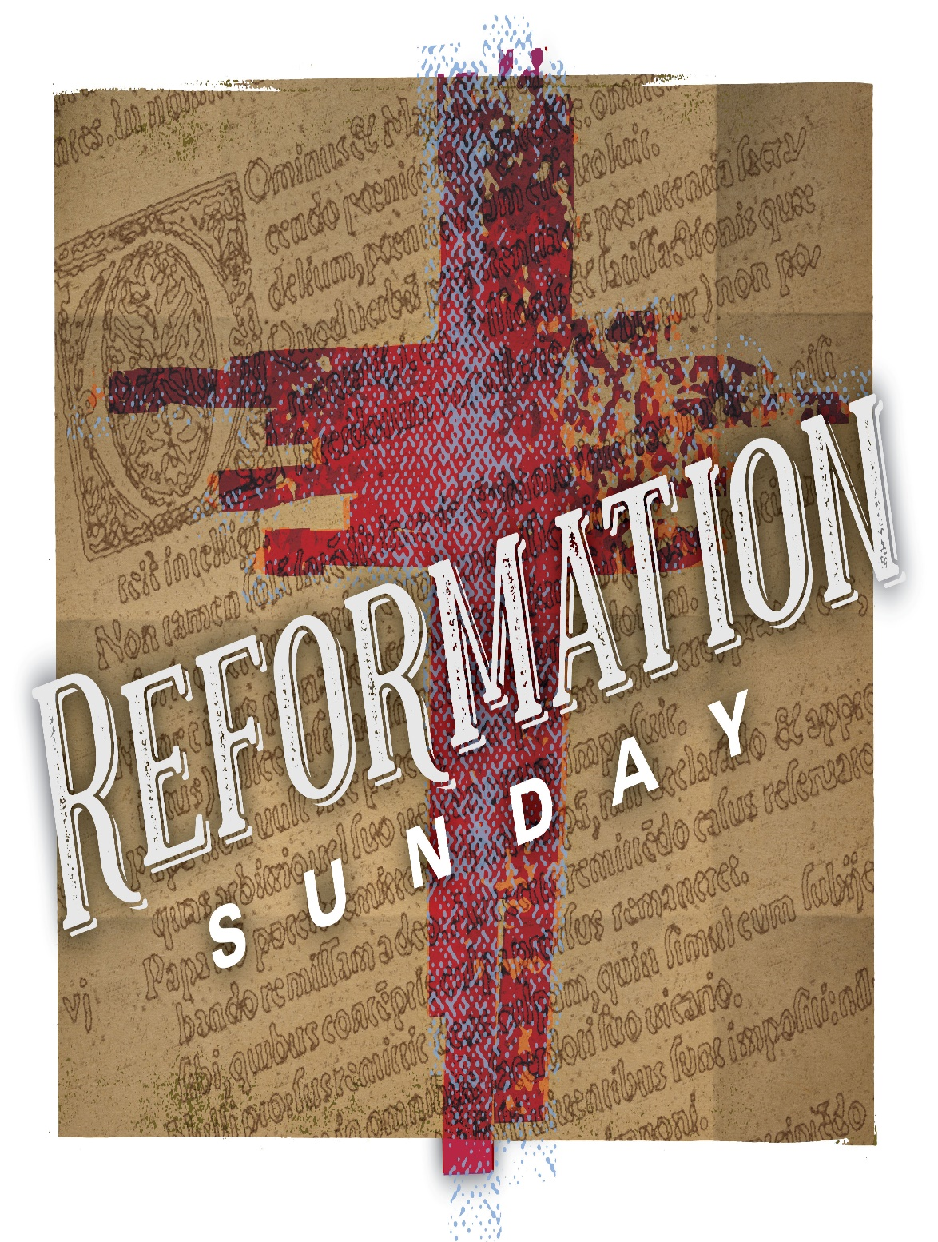

Eagle River Presbyterian Church
October 31, 2021

LITANY FOR REFORMATION SUNDAY

Leader: We give thanks for the gift of the Holy Spirit whose light brought new understanding of both the Living Word and the written Scripture.
People: We give thanks for the reminder of consistent grace and mercy from God through Jesus Christ.
Leader: We are grateful for the inspiration that led to the printing press, enabling the spread of information and the sharing of the gospel in many languages.
People: We thank God for the technologies that can be used for good for the support of communities and individuals.
Leader: Generous God, we thank you for open hearts that were prepared to hear and receive the good news of freedom in Christ.
People: We also thank God for our continued freedom in the Son to share that same news of salvation through your grace and Christ’s faithfulness.
Leader: We remember the lives that were lost in the struggle to reform the church on earth- those who were martyred, those who died fighting, those who perished in hiding, and who were killed on all sides.
People: We remember also the lives that have been lost throughout history in the name of religion and for those who die today for daring to believe.
Leader: We thank God for the instruction that comes through our church heritage- the confessions, the understanding of the saints, the gift of community, and a deeper appreciation of God’s gift of the Lord’s Supper and Baptism.
People: We thank God for the presence of Jesus Christ- in us, with us, and for us- and for the support of the Holy Spirit, ever-reforming us.
Leader: God of stability and change, we thank you that true reformation is always your work and always being done in us out of your love for your whole creation. We are ever reformed by the work of your love.
People: We are ever reformed by the work of God’s love. Amen.

Weekly Walk

Last week’s In-Person Attendance --------- 31
Month to Date Income --------- $12,788.80
Month to Date Expenses --------- $14,225.63

Upper Room devotionals for November and December are available in the narthex.

This is the last week to write holiday cards in the “Mail for the Military” campaign. All cards are due back next Sunday, Nov. 7.

We are beginning to collect donations for the Thanksgiving Blessing. This year our contribution will be gravy packets and canned peas. Please have your donations in by Nov. 21.

Lorinda Mitchell
Patti Malecha
Barbara Jordan
Travis Duft
McKayla Peterson
Ethel Dougherty
Colin Ossiander
Elias Gobeille
Bill McCarthy
Alex Davidson
Dale Berry
Joan Brossia
Debra Grundman
Nancy Davis
Paige Saylor
Whitney Lewis
Dave Charlton
Joshua Saylor

Jerry and Ruth McNearney…...October 2
Mike and Paige Saylor…...October 14

