GATHERING TO WORSHIP
Please take a moment during the Prelude to silence your cell phones and quietly prepare yourself for worship.
PRELUDE
WELCOME
*CALL TO WORSHIP

Leader: Grace to you and peace from the one who is and who was and who is to come,

People: and from Jesus Christ, the faithful witness, the firstborn of the dead, and the ruler of the kings of the earth.

Leader: Holy, holy, holy is the Lord of hosts.

People: The whole earth is full of God’s glory.

*PRAYER OF INVOCATION
Eternal God, you set Jesus Christ to rule over all things, and made us servants in your kingdom. By your Spirit empower us to love the unloved, and to minister to all in need. Then at the last bring us to your eternal realm where we may worship and adore you and be welcomed into your everlasting joy; through Jesus Christ our Lord, who lives and reigns with you in the unity of the Holy Spirit, one God, forever and ever. Amen.

*HYMN “We Gather Together” Hymnal 336

RECEIVING FORGIVENESS FROM
GOD AND EACH OTHER

*CALL TO CONFESSION

*PRAYER OF CONFESSION: Spoken and Silent (After the corporate Prayer of Confession, please take a few moments of silence to individually confess our sins to God.)
O Holy One, you showed us what it means to live by your
reign: sharing food with the hungry, freedom with the imprisoned, justice with the oppressed, and joy with the sorrowful. We ask your forgiveness, O God, for all the ways we fail to live as people who belong to your reign. Show us once more what our belonging means, for you are the beginning, you are the end, and, in every time between, you fill our lives with grace.

*DECLARATION OF FORGIVENESS
Leader: God has rescued us from the power of evil and claimed us for the realm of Jesus Christ, in whom we have redemption.
In the name of Jesus Christ, we are forgiven!
People: Thanks be to God!

CHILDREN’S MESSAGE

HEARING THE WORD
PSALM OF THE DAY Psalm 93 Pew Bible p.425

SCRIPTURE Daniel 7:9-10, 13-14 Pew Bible p.631
John 18:33-37 Pew Bible p.767
Revelation 1:4b-8 Pew Bible p.867

MESSAGE More Than Enough: Enough to Live
Rev. Piper Cartland

LITANY FOR CHRIST THE KING (from Our World Belongs to God/Faith Alive Christian Resources, 2004)
As followers of Jesus Christ, living in this world— which some seek to control, but which others view with despair— we declare with joy and trust: Our world belongs to God! From the beginning, through all the crises of our times, until his kingdom fully comes, God keeps covenant forever.
Our world belongs to him! God is King! Let the earth be glad!
Christ is Victor; his rule has begun. Hallelujah!
The Spirit is at work, renewing the creation. Praise the Lord!
Jesus ascended in triumph to his heavenly throne. There he hears our prayers, pleads our cause before the Father, and rules our world. Blessed are all who take refuge in him. Our hope for a new earth is not tied to what humans can do, for we believe that one day every challenge to God’s rule and every resistance to his will shall be crushed. Then his kingdom shall come fully, and our Lord shall rule forever.

RESPONDING TO THE WORD
SHARING OUR JOYS AND CONCERNS

PASTORAL PRAYER, followed by The Lord’s Prayer (we say sin)

MINUTES FOR MINISTRY

OFFERING OURSELVES TO GOD

GOING INTO THE WORLD
*HYMN “Crown Him with Many Crowns” Hymnal 268

*CHARGE AND BENEDICTION
POSTLUDE
*Those who are able please stand.

WELCOME! It is a joy to worship together in person. So that we may do so safely, here are the basic tenets for our COVID-19 Mitigation Plan: If the level of community transmission is substantial or high, the session recommends mask wear and social distancing by all congregants. If the level is low or moderate, mask wear and social distancing will be optional for vaccinated and recommended for unvaccinated and immunocompromised. The level of community transmission is posted by the entrance. Tithes/offerings may be placed in the offering plates at the back of the sanctuary.

LARGE PRINT HYMNALS with a black cover, are on the small bookcase in the rear of the sanctuary. If you use one, please put it back after worship.

ASSISTIVE LISTENING DEVICES available on request. Please request one from the Sound Tech at the sound desk.
There are cards in the pews for visitors to fill out and for anyone who needs to update their information. Please place the cards in the offering plates as needed. If you are visiting today, the worship service is our gift to you. Please contribute to the offering or not, as God leads. We delight in welcoming you, and we are glad that you’re here!
Children up to kindergarten age are welcome in the nursery. There are clipboards with coloring pages in the narthex if your children wish to stay in the sanctuary.
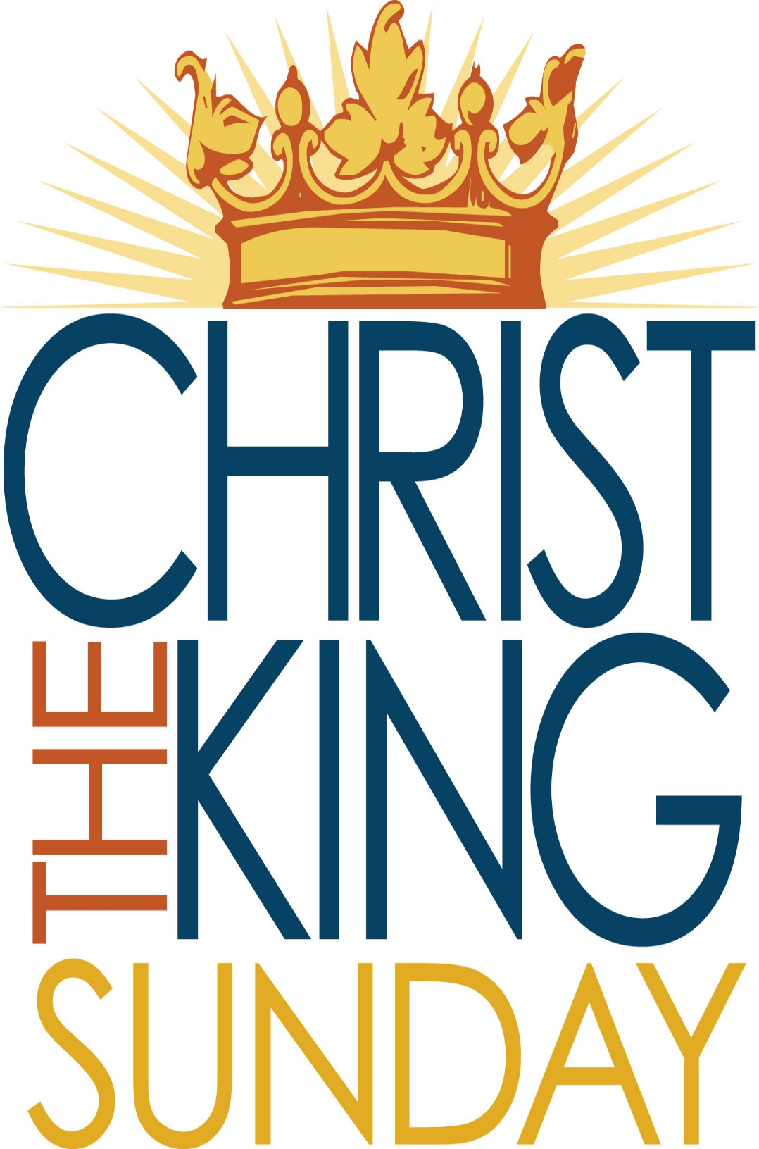

Eagle River Presbyterian Church
November 21, 2021

Weekly Walk

Sunday 10:00 am Worship
Tuesday 6:30 pm Deacons
Thursday & Friday Happy Thanksgiving! office closed

Last week’s In-Person Attendance --------- 35
Month to Date Income --------- $13,849.80
Month to Date Expenses --------- $15,901.10
The fellowship committee asks for help after worship today to hang some bulletin boards and brackets for banners, move some pews, and “fluff the wreaths” as we get the sanctuary and narthex ready for Advent and Christmas.

We will hold virtual new member classes on Zoom on Sunday, November 28 at 1 pm and on Monday evening November 29 at 7 pm. Come and find out a little more about our denomination and our church. Questions? Call Piper.

We are in need of lay leaders and Advent readers/candle-lighters for the remainder of the year! Sign-ups will be on the new bulletin board outside of the kitchen.

If you would like to sing or ring bells during the Christmas Eve service, please let Piper know.

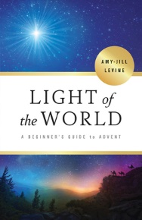
We will be starting an Advent Bible Study on December 1, called Light of the World – A Beginner’s Guide to Advent. It traces the Biblical foundations of Jesus’s birth in the stories of Zechariah and Elizabeth, Mary, the journey to Bethlehem and the visit of the Magi. We will meet virtually on Zoom. If you’re interested in joining, please let the church office know and we will add you to the list and get a book for you.
Weekly Walk

Sunday 10:00 am Worship
Tuesday 6:30 pm Deacons
Thursday & Friday Happy Thanksgiving! office closed

Last week’s In-Person Attendance --------- 35
Month to Date Income --------- $13,849.80
Month to Date Expenses --------- $15,901.10
The fellowship committee asks for help after worship today to hang some bulletin boards and brackets for banners, move some pews, and “fluff the wreaths” as we get the sanctuary and narthex ready for Advent and Christmas.

We will hold virtual new member classes on Zoom on Sunday, November 28 at 1 pm and on Monday evening November 29 at 7 pm. Come and find out a little more about our denomination and our church. Questions? Call Piper.

We are in need of lay leaders and Advent readers/candle-lighters for the remainder of the year! Sign-ups will be on the new bulletin board outside of the kitchen.

If you would like to sing or ring bells during the Christmas Eve service, please let Piper know.

We will be starting an Advent Bible Study on December 1, called Light of the World – A Beginner’s Guide to Advent. It traces the Biblical foundations of Jesus’s birth in the stories of Zechariah and Elizabeth, Mary, the journey to Bethlehem and the visit of the Magi. We will meet virtually on Zoom. If you’re interested in joining, please let the church office know and we will add you to the list and get a book for you.

