GATHERING TO WORSHIP
Please take a moment during the Prelude to silence your cell phones and quietly prepare yourself for worship.

PRELUDE
WELCOME
*CALL TO WORSHIP

Leader: The days are surely coming, says the Lord, when I will fulfill my promise to my people.

People: Justice and righteousness will fill the land and all will live in peace and safety.

Leader: Let us worship our God of hope!

*PRAYER OF INVOCATION
God of all hope and joy, open our hearts in welcome, that your Son, Jesus Christ, at his coming may find in us a dwelling prepared for him, who lives and reigns with you and the Holy Spirit, one God now and forever. Amen.

*HYMN “Come, Thou Long-Expected Jesus” Hymnal 82

LIGHTING OF THE ADVENT CANDLES

RECEIVING FORGIVENESS FROM
GOD AND EACH OTHER

*CALL TO CONFESSION

*PRAYER OF CONFESSION: Spoken and Silent (After the corporate Prayer of Confession, please take a few moments of silence to individually confess our sins to God.)
Merciful God, always with us, always coming: We confess that we do not know how to prepare for your Advent. We have forgotten how to hope in miracles; we have ignored the promise of your kingdom; we get distracted by all the busyness of this season. Forgive us, God. Grant us the simple wonder of the shepherds, the intelligent courage of the Magi,
and the patient faith of Mary and Joseph, that we may journey with them to Bethlehem and find the good news of a child born for us. Now, in the quiet of our hearts, we ask you to make us ready for his coming. Amen.

*DECLARATION OF FORGIVENESS
Leader: Every valley is lifted up; every mountain, made low.
Now the glory of the Lord is revealed, for the mouth of the Lord has spoken. In the name of Jesus Christ, we are forgiven!
People: Thanks be to God!

CHILDREN’S MESSAGE

HEARING THE WORD
PSALM OF THE DAY Psalm 25:1-10 Pew Bible p.393

SCRIPTURE Jeremiah 33:14-16 Pew Bible p.563
Luke 21:25-36 Pew Bible p.746
1 Thessalonians 3:9-13 Pew Bible p.836

MESSAGE Boundless Hope Rev. Piper Cartland

RESPONDING TO THE WORD
SHARING OUR JOYS AND CONCERNS

PASTORAL PRAYER, followed by The Lord’s Prayer (we say sin)

MINUTES FOR MINISTRY

OFFERING OURSELVES TO GOD

GOING INTO THE WORLD

*HYMN “While We Are Waiting, Come” Hymnal 92

*CHARGE AND BENEDICTION

POSTLUDE
*Those who are able please stand.

WELCOME! It is a joy to worship together in person. So that we may do so safely, here are the basic tenets for our COVID-19 Mitigation Plan: If the level of community transmission is substantial or high, the session recommends mask wear and social distancing by all congregants. If the level is low or moderate, mask wear and social distancing will be optional for vaccinated and recommended for unvaccinated and immunocompromised. The level of community transmission is posted by the entrance. Tithes/offerings may be placed in the offering plates at the back of the sanctuary. Fellowship will be shared outside, as weather permits.

LARGE PRINT HYMNALS with a black cover, are on the small bookcase in the rear of the sanctuary. If you use one, please put it back after worship.

ASSISTIVE LISTENING DEVICES available on request. Please request one from the Sound Tech at the sound desk.
There are cards in the pews for visitors to fill out and for anyone who needs to update their information. Please place the cards in the offering plates as needed. If you are visiting today, the worship service is our gift to you. Please contribute to the offering or not, as God leads. We delight in welcoming you, and we are glad that you’re here!
Children up to kindergarten age are welcome in the nursery. There are clipboards with coloring pages in the narthex if your children wish to stay in the sanctuary.

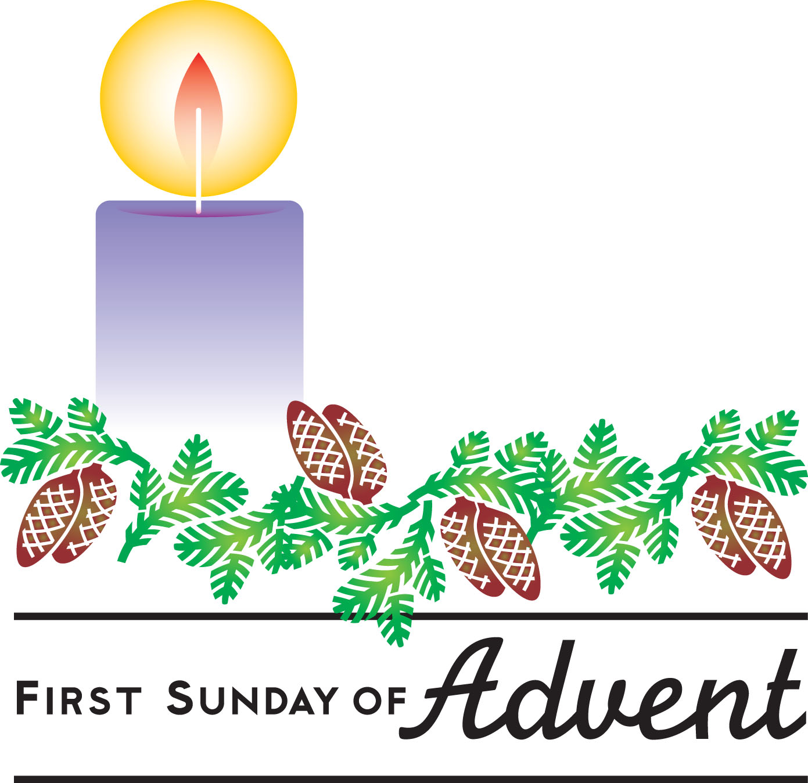

Weekly Walk

Sunday 10:00 am Worship
Sunday 1:00 pm New member class on Zoom
Monday 7:00 pm New member class on Zoom
Wednesday 7:00 pm Advent Bible Study on Zoom

Last week’s In-Person Attendance --------- 38
Month to Date Income --------- $16,035.80
Month to Date Expenses --------- $16,583.73

We will hold virtual new member classes on Zoom today at 1 pm and tomorrow evening at 7. Please let Piper know if you would like to join the class, and she will send you a link to the meeting.

Advent Bible Study begins this Wednesday at 7 pm on Zoom. Please pick up your book in the narthex if you’re planning to attend.

We are still recruiting singers and ringers – if you’d like to sing in our Christmas Eve choir or ring handbells that evening, please talk to Piper. Rehearsals will begin after worship on Sunday December 12th.

The deacons have prepared Advent bags for the congregation. They are in the narthex – please remember to take yours when you leave today.

Scott Bailey
Lucy Witt
Evleen Kelly
Olivia Lewis
Bill Dougherty
Colton Braunwarth
Maya Priess

Weekly Walk

Sunday 10:00 am Worship
Sunday 1:00 pm New member class on Zoom
Monday 7:00 pm New member class on Zoom
Wednesday 7:00 pm Advent Bible Study on Zoom

Last week’s In-Person Attendance --------- 38
Month to Date Income --------- $16,035.80
Month to Date Expenses --------- $16,583.73

We will hold virtual new member classes on Zoom today at 1 pm and tomorrow evening at 7. Please let Piper know if you would like to join the class, and she will send you a link to the meeting.

Advent Bible Study begins this Wednesday at 7 pm on Zoom. Please pick up your book in the narthex if you’re planning to attend.

We are still recruiting singers and ringers – if you’d like to sing in our Christmas Eve choir or ring handbells that evening, please talk to Piper. Rehearsals will begin after worship on Sunday December 12th.

The deacons have prepared Advent bags for the congregation. They are in the narthex – please remember to take yours when you leave today.

Scott Bailey
Lucy Witt
Evleen Kelly
Olivia Lewis
Bill Dougherty
Colton Braunwarth
Maya Priess

