GATHERING TO WORSHIP
Please take a moment during the Prelude to silence your cell phones and quietly prepare yourself for worship.

PRELUDE
WELCOME
*CALL TO WORSHIP

Leader: Come, let us worship God, singing joyful songs of praise!

People: For the glory of the Lord shines upon us, and calls us forth with thanksgiving.

Leader: Let us turn to the mountaintop, and let us give God the glory.

People: Come, let us worship God!

*PRAYER OF INVOCATION
O God, in the transfiguration of your Son you confirmed the mysteries of the faith by the witness of Moses and Elijah; and in the voice from the cloud you foreshadowed our adoption as your children. Make us, with Christ, heirs of your glory, and bring us to enjoy its fullness; through Jesus Christ our Lord,
who lives and reigns with you in the unity of the Holy Spirit, one God, now and forever. Amen.

*HYMN “Immortal, Invisible, God Only Wise” Hymnal 12 v.1-2

RECEIVING FORGIVENESS FROM
GOD AND EACH OTHER

*CALL TO CONFESSION

*PRAYER OF CONFESSION: Spoken and Silent (After the corporate Prayer of Confession, please take a few moments of silence to individually confess our sins to God.)
God of compassion, in Jesus Christ you reveal the light of your glory, but we turn away, distracted by our own plans.
We confess that we speak when we should listen, and act when we should wait. Forgive our aimless enthusiasms.
Grant us wisdom to live in your light and to follow in the way of your beloved Son, Jesus Christ, our Lord and Savior.

*DECLARATION OF FORGIVENESS
Leader: The one who calls light out of darkness now shines in our hearts to reveal the glory of God in the face of Jesus Christ. In the name of Jesus Christ, we are forgiven!
People: Thanks be to God!

CHILDREN’S MESSAGE

HEARING THE WORD
PSALM OF THE DAY Psalm 99 Pew Bible p.427

SCRIPTURE Exodus 34:29-35 Pew Bible p.66
Luke 6:27-38 Pew Bible p.729
Luke 9:28-36 Pew Bible p.733
2 Corinthians 3:12-4:2 Pew Bible p.818

MESSAGE The Art of Hearing: Hearing is Seeing
Rev. Piper Cartland

*HYMN “Immortal, Invisible, God Only Wise” Hymnal 12 v.3-4

RESPONDING TO THE WORD
SHARING OUR JOYS AND CONCERNS

PASTORAL PRAYER, followed by The Lord’s Prayer (we say sin)

MINUTES FOR MINISTRY

OFFERING OURSELVES TO GOD

SACRAMENT OF BAPTISM

PROFESSION OF FAITH Apostles’ Creed Hymnal p.35

THANKSGIVING OVER THE WATER

Pastor: The Lord be with you.

People: And also with you.

Pastor: Let us give thanks to the Lord our God.

People: It is right to give our thanks and praise.

BAPTISM OF WILLIAM ELMER JURENKA
GOING INTO THE WORLD

*HYMN “Baptized in Water” Hymnal 482

*CHARGE AND BENEDICTION

POSTLUDE
*Those who are able please stand.

WELCOME! It is a joy to worship together in person. So that we may do so safely, here are the basic tenets for our COVID-19 Mitigation Plan: If the level of community transmission is substantial or high, the session recommends mask wear and social distancing by all congregants. If the level is low or moderate, mask wear and social distancing will be optional for vaccinated and recommended for unvaccinated and immunocompromised. The level of community transmission is posted by the entrance. Tithes/offerings may be placed in the offering plates at the back of the sanctuary.

LARGE PRINT HYMNALS with a black cover, are on the small bookcase in the rear of the sanctuary. If you use one, please put it back after worship.

ASSISTIVE LISTENING DEVICES available on request. Please request one from the Sound Tech at the sound desk.
There are cards in the pews for visitors to fill out and for anyone who needs to update their information. Please place the cards in the offering plates as needed. If you are visiting today, the worship service is our gift to you. Please contribute to the offering or not, as God leads. We delight in welcoming you, and we are glad that you’re here!
Children up to kindergarten age are welcome in the nursery. There are clipboards with coloring pages in the narthex if your children wish to stay in the sanctuary.

Thank you to the Spencer family for sponsoring the altar flowers this month.
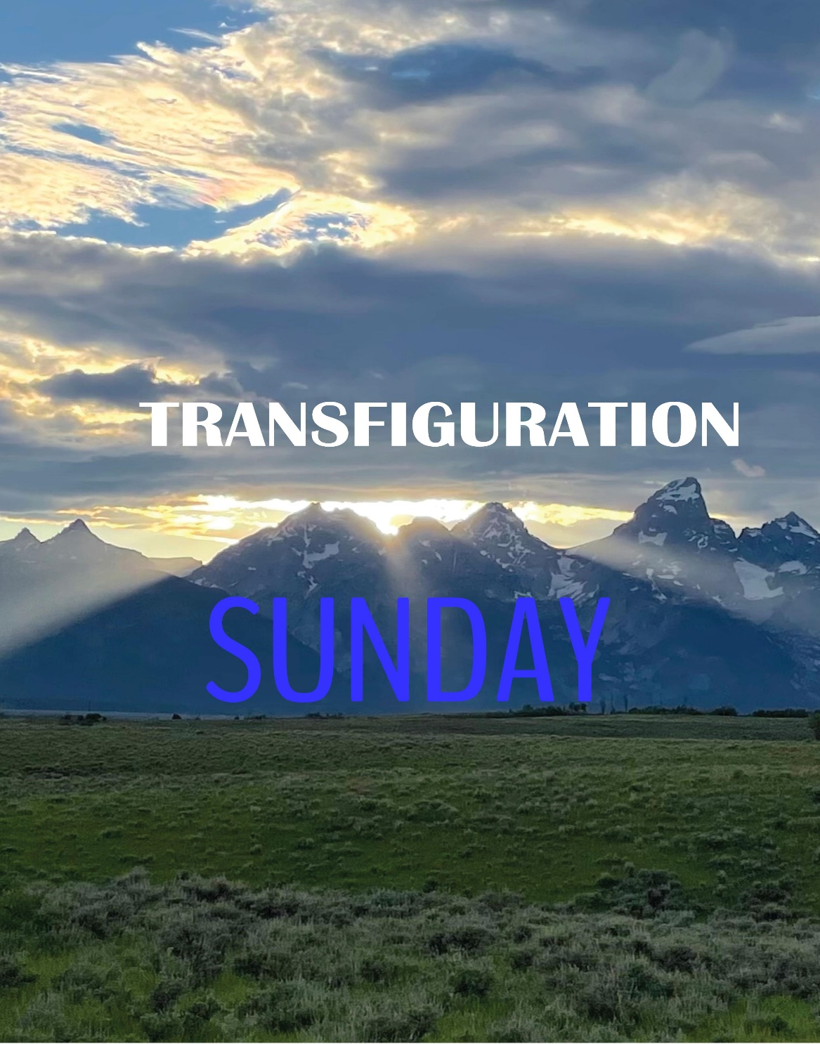

Eagle River Presbyterian Church
February 20, 2022

Weekly Walk

Sunday 10:00 am Worship
Sunday 11:00 am C.E. meeting
Sunday 11:00 am Deacons meeting
Monday Presidents’ Day office closed

Last week’s In-Person Attendance --------- 33
Month to Date Income --------- $9,898.07
Month to Date Expenses --------- $16,838.52

If you are interested in helping with Sunday school, please join Whitney Lewis for a short introduction to the curriculum and overview after worship today.

This week the Presbytery of Yukon will meet virtually from Wednesday through Saturday. The closing worship service will be virtual as it has been since the pandemic began, and session made the decision that we would worship with the Presbytery next Sunday, February 27, at 11 am. We will email the YouTube link to the congregation this week. If you’d like to join us in person, we are gathering at 10:15 am for fellowship, and then sharing the service on the screen in the sanctuary at 11 am and participating in worship together.
Ways you can keep up with your financial stewardship:
1) If you’re worshipping with us in person, you may leave your gift in one of the offering plates as you leave the sanctuary this morning. The plates are on the table to the right of the main door.
2) Donate online with a credit card by clicking the link from our website: www.erpresbyterian.org.
3) Visit your local bank or your bank’s website and set up a recurring electronic payment. Your bank may require the church’s account number. Please call the office for that information.
4) Checks can also be mailed to PO Box 771337 Eagle River, AK 99577

Weekly Walk

Sunday 10:00 am Worship
Sunday 11:00 am C.E. meeting
Sunday 11:00 am Deacons meeting
Monday Presidents’ Day office closed

Last week’s In-Person Attendance --------- 33
Month to Date Income --------- $9,898.07
Month to Date Expenses --------- $16,838.52

If you are interested in helping with Sunday school, please join Whitney Lewis for a short introduction to the curriculum and overview after worship today.

This week the Presbytery of Yukon will meet virtually from Wednesday through Saturday. The closing worship service will be virtual as it has been since the pandemic began, and session made the decision that we would worship with the Presbytery next Sunday, February 27, at 11 am. We will email the YouTube link to the congregation this week. If you’d like to join us in person, we are gathering at 10:15 am for fellowship, and then sharing the service on the screen in the sanctuary at 11 am and participating in worship together.
Ways you can keep up with your financial stewardship:
1) If you’re worshipping with us in person, you may leave your gift in one of the offering plates as you leave the sanctuary this morning. The plates are on the table to the right of the main door.
2) Donate online with a credit card by clicking the link from our website: www.erpresbyterian.org.
3) Visit your local bank or your bank’s website and set up a recurring electronic payment. Your bank may require the church’s account number. Please call the office for that information.
4) Checks can also be mailed to PO Box 771337 Eagle River, AK 99577

