GATHERING TO WORSHIP
Please take a moment during the Prelude to silence your cell phones and quietly prepare yourself for worship.

PRELUDE
WELCOME
*CALL TO WORSHIP

Leader: The Lord is our light,

People: light no darkness can overcome.

Leader: Jesus Christ is our salvation.

People: Jesus is the way, the truth, and the life.

*PRAYER OF INVOCATION
Loving God, you save all who seek refuge in you. Grant that we who know your salvation may walk always in your light,
take courage in your faithfulness, and rejoice in your astounding goodness to us. Through Christ, by the power of the Holy Spirit, we pray. Amen.

*HYMN “The God of Abraham Praise” Hymnal 49

RECEIVING FORGIVENESS FROM
GOD AND EACH OTHER

*CALL TO CONFESSION

*PRAYER OF CONFESSION: Spoken and Silent (After the corporate Prayer of Confession, please take a few moments of silence to individually confess our sins to God.)
Loving God, you have formed a covenant with us,
committing yourself to us and inviting us to walk with you.
Yet we have resisted, seeking other companions,
going in different ways, thinking that we know best.
Now we find ourselves far from life, further still from you.
Have mercy on our waywardness. Help us find our way back.
Give us faith so that we can hold the hand you have extended to us in Jesus Christ.

*DECLARATION OF FORGIVENESS
Leader: God, our light and our salvation, does not forsake us or leave us with our sin. In Christ we are forgiven and offered the gift of healing repentance.
People: Thanks be to God!

CHILDREN’S MESSAGE

HEARING THE WORD
PSALM OF THE DAY Psalm 27 Pew Bible p.393

SCRIPTURE Genesis 15:1-18 Pew Bible p.10
Luke 13:31-35 Pew Bible p.739
Philippians 3:17-4:1 Pew Bible p.832

MESSAGE Character and Calling: Discipline
Rev. Piper Cartland

RESPONDING TO THE WORD

SHARING OUR JOYS AND CONCERNS

PASTORAL PRAYER, followed by The Lord’s Prayer (we say sin)

MINUTES FOR MINISTRY

OFFERING OURSELVES TO GOD

GOING INTO THE WORLD

*HYMN “If Thou But Trust in God to Guide Thee” Hymnal 816

*CHARGE AND BENEDICTION

POSTLUDE
*Those who are able please stand.

WELCOME! It is a joy to worship together in person. So that we may do so safely, here are the basic tenets for our COVID-19 Mitigation Plan: If the level of community transmission is substantial or high, the session recommends mask wear and social distancing by all congregants. If the level is low or moderate, mask wear and social distancing will be optional for vaccinated and recommended for unvaccinated and immunocompromised. The level of community transmission is posted by the entrance. Tithes/offerings may be placed in the offering plates at the back of the sanctuary.

LARGE PRINT HYMNALS with a black cover, are on the small bookcase in the rear of the sanctuary. If you use one, please put it back after worship.

ASSISTIVE LISTENING DEVICES available on request. Please request one from the Sound Tech at the sound desk.
There are cards in the pews for visitors to fill out and for anyone who needs to update their information. Please place the cards in the offering plates as needed. If you are visiting today, the worship service is our gift to you. Please contribute to the offering or not, as God leads. We delight in welcoming you, and we are glad that you’re here!
Children up to kindergarten age are welcome in the nursery. There are clipboards with coloring pages in the narthex if your children wish to stay in the sanctuary.

Thanks to the Hodgson family for sponsoring the altar flowers this month.

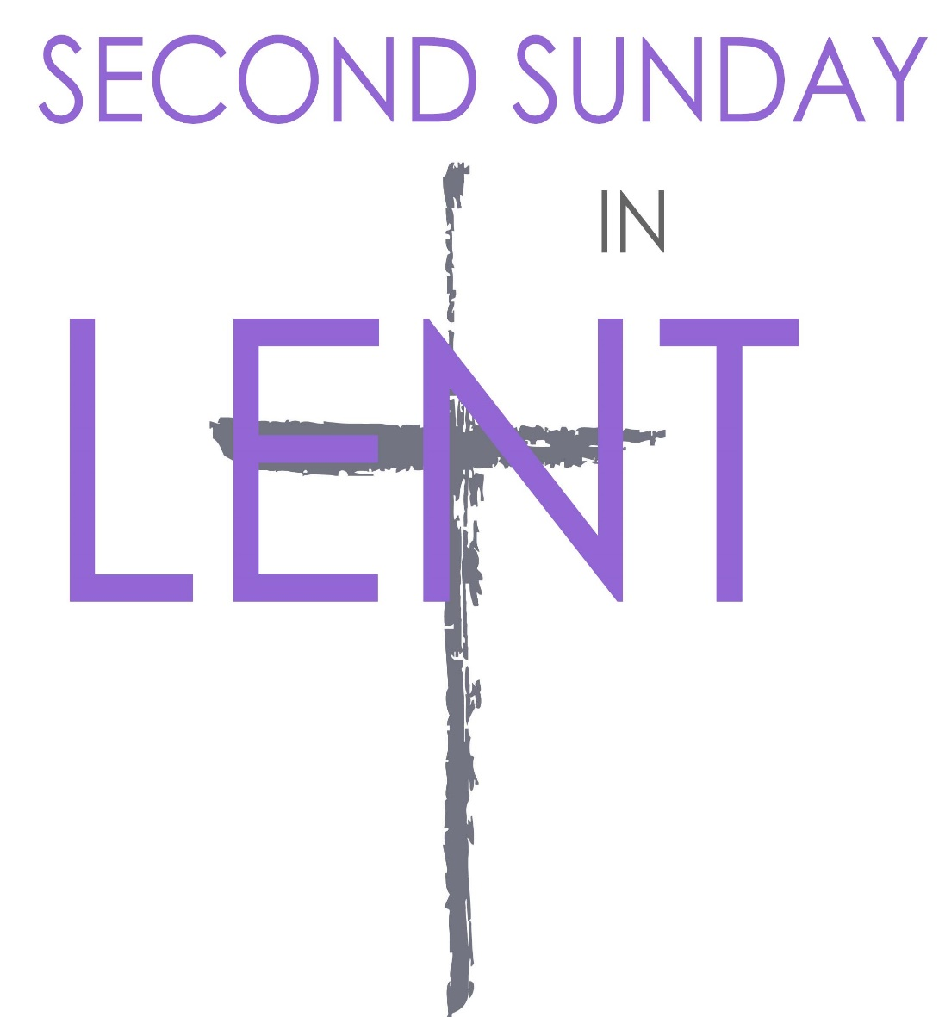

Eagle River Presbyterian Church
March 13, 2022

Weekly Walk
March 13, 2022

Sunday 10:00 am Worship
Sunday 1:00-3:00 pm Seed exchange
Tuesday 7:00 pm Session meeting
Wednesday 6:30 pm Bible study on Zoom

Last week’s In-Person Attendance --------- 15
Month to Date Income --------- $7,554.80
Month to Date Expenses --------- $16,256.51

We have roses on the pulpit today to celebrate two new grandchildren in the congregation. Amelia James Berry, granddaughter of Emily and Dale Berry, was born on March 6th, weighing 6 lbs 13 oz. She is doing well, as are her parents Nate and Lauren and big brother Sebastian. Todd and Debby Carter have a new grandson, Bowen Steve Mancill, born on March 7th to Abigail and Michael and big sisters Anora and Tayvn. Bowen weighed 7 lbs 9 oz. Welcome to the world, Amelia and Bowen!

Today from 1-3 pm there will be a seed exchange, hosted by the gardening club, Anchor Gardens. It will take place outside by our garden beds, and all are welcome to attend!

There is a new sign-up sheet for volunteers to help teach Sunday school this spring. Please sign up on the bulletin board outside the kitchen.

Weekly Walk
March 13, 2022

Sunday 10:00 am Worship
Sunday 1:00-3:00 pm Seed exchange
Tuesday 7:00 pm Session meeting
Wednesday 6:30 pm Bible study on Zoom

Last week’s In-Person Attendance --------- 15
Month to Date Income --------- $7,554.80
Month to Date Expenses --------- $16,256.51
We have roses on the pulpit today to celebrate two new grandchildren in the congregation. Amelia James Berry, granddaughter of Emily and Dale Berry, was born on March 6th, weighing 6 lbs 13 oz. She is doing well, as are her parents Nate and Lauren and big brother Sebastian. Todd and Debby Carter have a new grandson, Bowen Steve Mancill, born on March 7th to Abigail and Michael and big sisters Anora and Tayvn. Bowen weighed 7 lbs 9 oz. Welcome to the world, Amelia and Bowen!

Today from 1-3 pm there will be a seed exchange, hosted by the gardening club, Anchor Gardens. It will take place outside by our garden beds, and all are welcome to attend!

There is a new sign-up sheet for volunteers to help teach Sunday school this spring. Please sign up on the bulletin board outside the kitchen.

Ways you can keep up with your financial stewardship:
1) If you’re worshipping with us in person, you may leave your gift in one of the offering plates as you leave the sanctuary this morning. The plates are on the table to the right of the main door.
2) Donate online with a credit card by clicking the link from our website: www.erpresbyterian.org.
3) Visit your local bank or your bank’s website and set up a recurring electronic payment. Your bank may require the church’s account number. Please call the office for that information.
4) Checks can also be mailed to PO Box 771337 Eagle River, AK 99577

Ways you can keep up with your financial stewardship:
1) If you’re worshipping with us in person, you may leave your gift in one of the offering plates as you leave the sanctuary this morning. The plates are on the table to the right of the main door.
2) Donate online with a credit card by clicking the link from our website: www.erpresbyterian.org.
3) Visit your local bank or your bank’s website and set up a recurring electronic payment. Your bank may require the church’s account number. Please call the office for that information.
4) Checks can also be mailed to PO Box 771337 Eagle River, AK 99577

