GATHERING TO WORSHIP
Please take a moment during the Prelude to silence your cell phones and quietly prepare yourself for worship.

PRELUDE
WELCOME
*CALL TO WORSHIP

Leader: Everyone who thirsts:

People: Come to the waters, seek the Lord, repent and return

so that you may live.

Leader: All who are hungry for righteousness:

People: Come to the waters, seek the Lord, repent and return

so that you may live.

Leader: All who need the help of God:

People: Come to the waters, seek the Lord, repent and return

so that you may live.

*PRAYER OF INVOCATION

*HYMN “Come, Ye Sinners, Poor and Needy” Hymnal 415

RECEIVING FORGIVENESS FROM
GOD AND EACH OTHER

*CALL TO CONFESSION

*PRAYER OF CONFESSION: Spoken and Silent (After the corporate Prayer of Confession, please take a few moments of silence to individually confess our sins to God.)
Holy God, we confess that we have grown complacent in our response to you. You set before us a rich feast of blessing,
but we are drawn to lesser things that cannot satisfy. You call us to attend to urgent needs in the world, but we indulge our own desires. Our ways are not your ways; our thoughts do not ascend to your thoughts. Forgive us when we fall short of your claim upon our lives. Disturb our complacency and quicken our desire for a more fruitful life. Be patient, we pray, as we amend who we are, in the hope of becoming who you intend us to be. We ask this in the name of our Savior,
your Son, Jesus Christ. Amen.

*DECLARATION OF FORGIVENESS
Leader: God’s love is sure and steadfast, always providing a way out, a way through, a way back to God.
People: Through the waters of baptism, we have died with Christ and are raised with him. With gratitude, in faith,
we will walk the way of Christ.

CHILDREN’S MESSAGE

HEARING THE WORD

PSALM OF THE DAY Psalm 63:1-8 Pew Bible p.409

SCRIPTURE Isaiah 55:1-9 Pew Bible p.524
Luke 13:1-9 Pew Bible p.738
1 Corinthians 10:1-13 Pew Bible p.811
MESSAGE Character and Calling: Holiness
Rev. Piper Cartland

ORDINATION AND INSTALLATION OF NEW OFFICERS
Pastor: There are varieties of gifts, but it is the same spirit who gives them.
People: There are different ways of serving God, but it is the same Lord who is served.
Pastor: God works through each person in a unique way, but it is God’s purpose that is accomplished.
People: To each is given a gift of the Spirit to be used for the common good.
Pastor: Together we are the body of Christ, and individually members of it.

PROFESSION OF FAITH Apostles’ Creed Hymnal p.35

PRAYER OF ORDINATION AND INSTALLATION

RESPONDING TO THE WORD
SHARING OUR JOYS AND CONCERNS

PASTORAL PRAYER, followed by The Lord’s Prayer (we say sin)

MINUTES FOR MINISTRY

OFFERING OURSELVES TO GOD

GOING INTO THE WORLD

*HYMN “Guide Me, O Thou Great Jehovah” Hymnal 65

*CHARGE AND BENEDICTION

POSTLUDE
*Those who are able please stand.

WELCOME! It is a joy to worship together in person. So that we may do so safely, here are the basic tenets for our COVID-19 Mitigation Plan: If the level of community transmission is substantial or high, the session recommends mask wear and social distancing by all congregants. If the level is low or moderate, mask wear and social distancing will be optional for vaccinated and recommended for unvaccinated and immunocompromised. The level of community transmission is posted by the entrance. Tithes/offerings may be placed in the offering plates at the back of the sanctuary.

LARGE PRINT HYMNALS with a black cover, are on the small bookcase in the rear of the sanctuary. If you use one, please put it back after worship.

ASSISTIVE LISTENING DEVICES available on request. Please request one from the Sound Tech at the sound desk.
There are cards in the pews for visitors to fill out and for anyone who needs to update their information. Please place the cards in the offering plates as needed. If you are visiting today, the worship service is our gift to you. Please contribute to the offering or not, as God leads. We delight in welcoming you, and we are glad that you’re here!
Children up to kindergarten age are welcome in the nursery. There are clipboards with coloring pages in the narthex if your children wish to stay in the sanctuary.
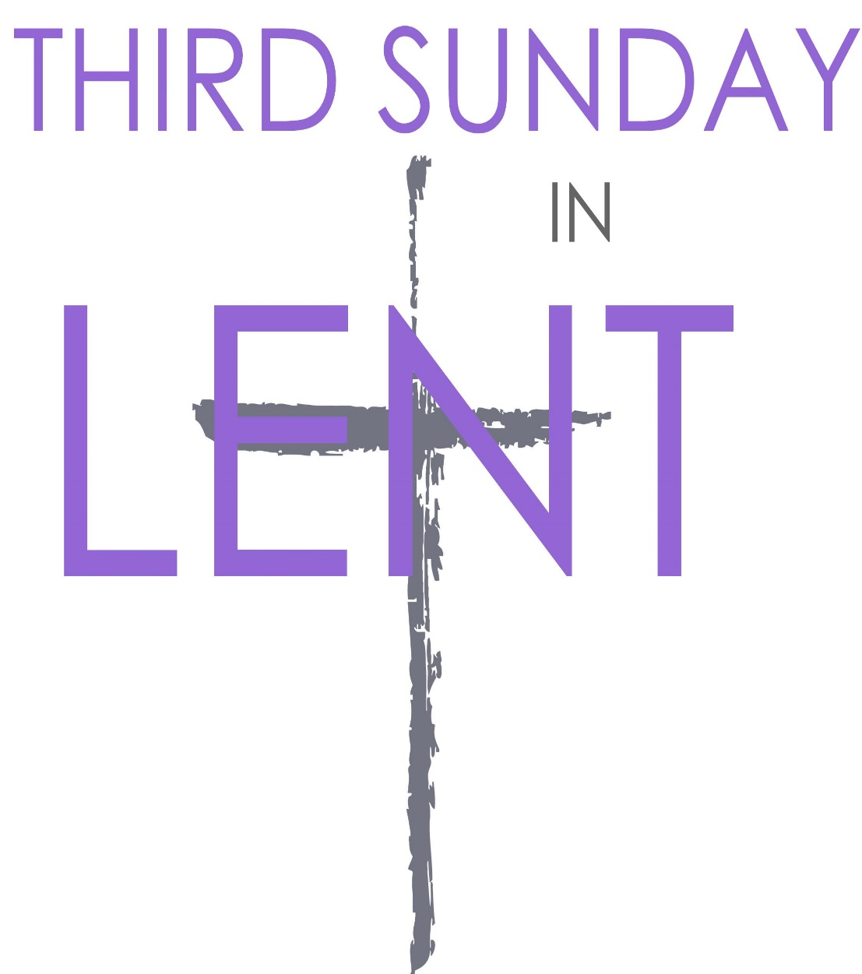

Eagle River Presbyterian Church
March 20, 2022

Weekly Walk

Sunday 10:00 am Worship
Sunday 11:00 am Easter music info. meeting
Sunday 11:15 am Deacons meeting
Wednesday 6:30 pm Bible study on Zoom

Last week’s In-Person Attendance --------- 36
Month to Date Regular Income --------- $12,669.80
Month to Date Regular Expenses --------- $20,470.82

There will be a short organizational meeting after worship for people interested in participating in Easter chancel choir or handbells. Handbell rehearsals will be on April 3 and 10 after worship and on Saturday April 16. Choir rehearsals yet to be decided.

The Session is considering a proposal to relocate the nursery from its current space to Room 14, the larger of the two fellowship rooms. If you would like to discuss the proposal, please contact an elder: Nancy Davis, Matthew Hobbie, Melissa Hodgson, Becky Musick, Linda Homan, or Bill Musick. The Session will vote at their next regular meeting on April 19th so please make sure to talk with someone before then. Thank you!

Ways you can keep up with your financial stewardship:
1) If you’re worshipping with us in person, you may leave your gift in one of the offering plates as you leave the sanctuary this morning. The plates are on the table to the right of the main door.
2) Donate online with a credit card by clicking the link from our website: www.erpresbyterian.org.
3) Visit your local bank or your bank’s website and set up a recurring electronic payment. Your bank may require the church’s account number. Please call the office for that information.
4) Checks can also be mailed to PO Box 771337 Eagle River, AK 99577

Weekly Walk

Sunday 10:00 am Worship
Sunday 11:00 am Easter music info. meeting
Sunday 11:15 am Deacons meeting
Wednesday 6:30 pm Bible study on Zoom

Last week’s In-Person Attendance --------- 36
Month to Date Regular Income --------- $12,669.80
Month to Date Regular Expenses --------- $20,470.82

There will be a short organizational meeting after worship for people interested in participating in Easter chancel choir or handbells. Handbell rehearsals will be on April 3 and 10 after worship and on Saturday April 16. Choir rehearsals yet to be decided.

The Session is considering a proposal to relocate the nursery from its current space to Room 14, the larger of the two fellowship rooms. If you would like to discuss the proposal, please contact an elder: Nancy Davis, Matthew Hobbie, Melissa Hodgson, Becky Musick, Linda Homan, or Bill Musick. The Session will vote at their next regular meeting on April 19th so please make sure to talk with someone before then. Thank you!

Ways you can keep up with your financial stewardship:
1) If you’re worshipping with us in person, you may leave your gift in one of the offering plates as you leave the sanctuary this morning. The plates are on the table to the right of the main door.
2) Donate online with a credit card by clicking the link from our website: www.erpresbyterian.org.
3) Visit your local bank or your bank’s website and set up a recurring electronic payment. Your bank may require the church’s account number. Please call the office for that information.
4) Checks can also be mailed to PO Box 771337 Eagle River, AK 99577

