GATHERING TO WORSHIP
Please take a moment during the Prelude to silence your cell phones and quietly prepare yourself for worship.

PRELUDE
WELCOME
*CALL TO WORSHIP

Leader: We are ambassadors for Christ.

People: God has entrusted to us the message of reconciliation.

Leader: We gather as God’s beloved family to worship God and offer our praise.

People: Let us join our hearts in song and in prayer.

*PRAYER OF INVOCATION
Gracious God, seeker of the lost: draw your children back to your loving embrace, restore us to our inheritance as daughters and sons, and reconcile our hearts to you, that we may become ambassadors of your reconciling love to all the world. Through Christ by the power of the Holy Spirit we pray. Amen.

*HYMN “Come, Thou Fount of Every Blessing” Hymnal 475

RECEIVING FORGIVENESS FROM
GOD AND EACH OTHER

*CALL TO CONFESSION

*PRAYER OF CONFESSION: Spoken and Silent (After the corporate Prayer of Confession, please take a few moments of silence to individually confess our sins to God.)
Loving God, you have formed a covenant with us, committing yourself to us and inviting us to walk with you.
Yet we have resisted, seeking other companions, going in different ways, thinking that we know best. Now we find ourselves far from life, further still from you. Have mercy on our waywardness. Help us find our way back. Give us faith so that we can hold the hand you have extended to us in Jesus Christ.

*DECLARATION OF FORGIVENESS
Leader: God, our light and our salvation, does not forsake us or leave us with our sin. In Christ we are forgiven and offered the gift of healing repentance.
People: Thanks be to God!

CHILDREN’S MESSAGE

HEARING THE WORD

PSALM OF THE DAY Psalm 32 Pew Bible p.395

*HYMN “Amazing Grace” Hymnal 649 v.1-3

SCRIPTURE Luke 15:1-3, 11b-32 Pew Bible p.740

MESSAGE The Journey Home Rev. Todd M. Carter

RESPONDING TO THE WORD

SHARING OUR JOYS AND CONCERNS

PASTORAL PRAYER, followed by The Lord’s Prayer (we say sin)

MINUTES FOR MINISTRY

OFFERING OURSELVES TO GOD

GOING INTO THE WORLD

*HYMN “Amazing Grace” Hymnal 649 v.4-5

*CHARGE AND BENEDICTION

POSTLUDE
*Those who are able please stand.

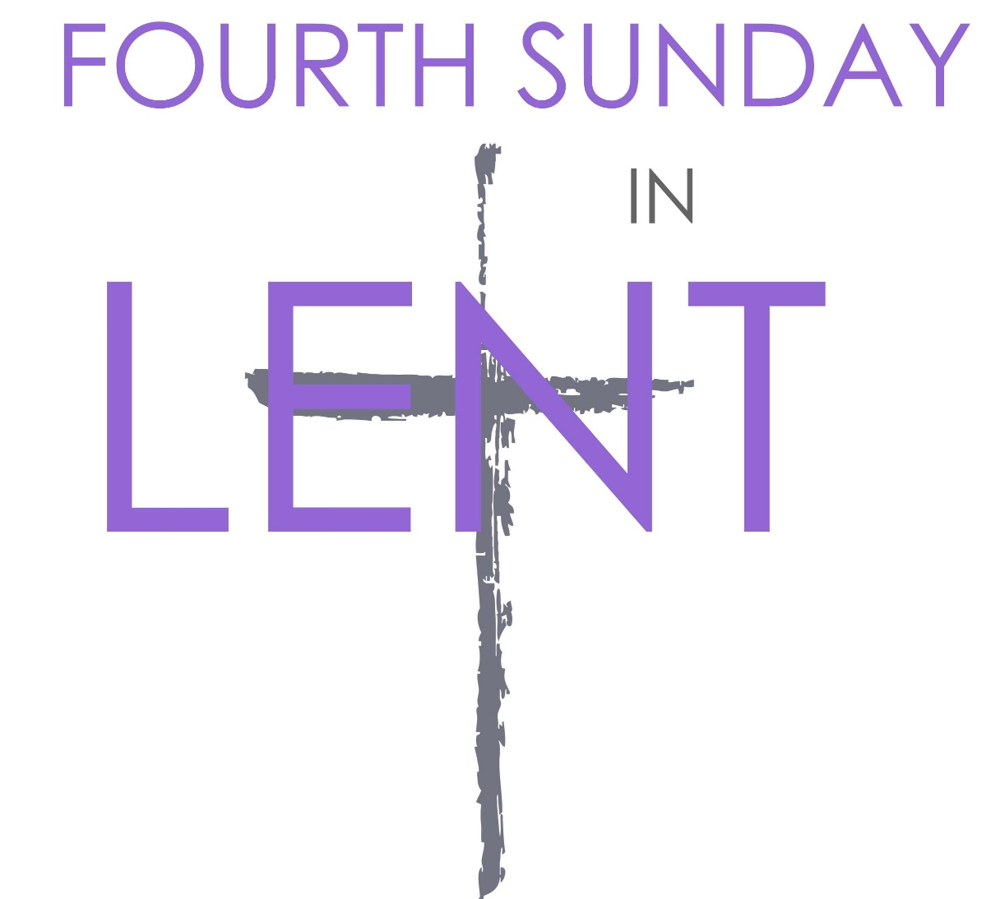
WELCOME! It is a joy to worship together in person. So that we may do so safely, here are the basic tenets for our COVID-19 Mitigation Plan: If the level of community transmission is substantial or high, the session recommends mask wear and social distancing by all congregants. If the level is low or moderate, mask wear and social distancing will be optional for vaccinated and recommended for unvaccinated and immunocompromised. The level of community transmission is posted by the entrance. Tithes/offerings may be placed in the offering plates at the back of the sanctuary.

LARGE PRINT HYMNALS with a black cover, are on the small bookcase in the rear of the sanctuary. If you use one, please put it back after worship.

ASSISTIVE LISTENING DEVICES available on request. Please request one from the Sound Tech at the sound desk.
There are cards in the pews for visitors to fill out and for anyone who needs to update their information. Please place the cards in the offering plates as needed. If you are visiting today, the worship service is our gift to you. Please contribute to the offering or not, as God leads. We delight in welcoming you, and we are glad that you’re here!
Children up to kindergarten age are welcome in the nursery. There are clipboards with coloring pages in the narthex if your children wish to stay in the sanctuary.

Thanks to the Hodgson family for sponsoring the altar flowers this month.

Eagle River Presbyterian Church
March 27, 2022

Weekly Walk

Sunday 10:00 am Worship
Sunday 1-2:30 pm Combined youth group
Wednesday 6:30 pm Bible study on Zoom

Last week’s In-Person Attendance ---------42
Month to Date Income --------- $18,000.80
Month to Date Expenses --------- $23,256.80
Easter handbell and choir rehearsals start next week. There is still time to participate – email Piper and let her know.

We are collecting treats to fill Easter eggs for the kids. There will be an egg hunt after worship on April 17. Thank you in advance for your donations!

The youth will be volunteering this afternoon at F.I.S.H. (Fellowship in Serving Humanity), an organization that delivers food to the homebound in Anchorage. They will be helping to organize donations and bag food. The address is 2200 E. Tudor

The Session is considering a proposal to relocate the nursery from its current space to Room 14, the larger of the two fellowship rooms. This would allow our children’s ministries to all be located on the same side of the building, make space available for a trustee workroom and periodic Food Pantry needs, and allow the smaller fellowship room to be used for meetings and classes. Future congregational meals would be held in our new expanded narthex. If you have feedback or would like to discuss the proposal, please contact an elder: Nancy Davis, Matthew Hobbie, Melissa Hodgson, Becky Musick, Linda Homan, or Bill Musick. The Session will vote at their next regular meeting on April 19th so please make sure to talk with someone before then. Thank you!

Ways you can keep up with your financial stewardship:
1) If you’re worshipping with us in person, you may leave your gift in one of the offering plates as you leave the sanctuary this morning. The plates are on the table to the right of the main door.
2) Donate online with a credit card by clicking the link from our website: www.erpresbyterian.org.
3) Visit your local bank or your bank’s website and set up a recurring electronic payment. Your bank may require the church’s account number. Please call the office for that information.
4) Checks can also be mailed to PO Box 771337 Eagle River, AK 99577

Rick Kelly
Larry Frick, Jr
Peyton Lewis
Connor Frick
Matthew Toth
John Luke Anderson
Linda Kelly
Ralph Kiehl
Iola Rasic
Sharon Frick
Lisa Anderson
Olivia Petroccia
Jon Hodgson

Rick & Linda Kelly
Chuck & Linda Homan

