GATHERING TO WORSHIP
Please take a moment during the Prelude to silence your cell phones and quietly prepare yourself for worship.

PRELUDE
WELCOME
*CALL TO WORSHIP
Leader: The season of Lent sets us on a journey.
People: The journey begins in the wilderness.
Leader: We follow the way of Jesus, who faced trials, trouble, temptation, and testing.
People: Like Jesus, we are not alone. The Holy Spirit is with us. God’s Word is on our lips.
Leader: Our call is to trust in God alone, to do God’s will in all things.
People: For God leads us not only into the wilderness, but also through the wilderness.

*PRAYER OF INVOCATION
Almighty God, your Son fasted forty days in the wilderness, and was tempted as we are but did not sin. Give us grace to direct our lives in obedience to your Spirit,
that as you know our weakness, so we may know your power to save; through Jesus Christ our redeemer, who lives and reigns with you in the unity of the Holy Spirit, one God, now and forever. Amen.

*HYMN “Lord, Who Throughout These Forty Days” Hymnal 166

RECEIVING FORGIVENESS FROM
GOD AND EACH OTHER
*CALL TO CONFESSION

*PRAYER OF CONFESSION: Spoken and Silent (After the corporate Prayer of Confession, please take a few moments of silence to individually confess our sins to God.)
O God, our refuge and fortress, forgive us when we fail to trust in you. We fall to temptation; we are swayed by false words; we speak false words of our own.
We choose our ease and comfort over your demanding claims upon us and upon the world. In turning from you, we settle for less than the abundant generosity you intend. Forgive us, we pray. Do not let us be put to shame, O God. Hear us as we call to you and show us your salvation. In Christ’s name we pray. Amen.

*DECLARATION OF FORGIVENESS
Leader: Scripture declares, The Lord is generous to all who call on God’s name.
Friends, believe the good news: God does not turn away from us, but desires to bring us into the glorious freedom offered in Jesus Christ. Everyone who calls on the name of the Lord will be saved.
People: Thanks be to God!

CHILDREN’S MESSAGE

HEARING THE WORD
PSALM OF THE DAY Psalm 91 Pew Bible p.424

SCRIPTURES Deuteronomy 26:1-11 Pew Bible p.143
Luke 4:1-13 Pew Bible p.727
Romans 10:8b-13 Pew Bible p.802

MESSAGE Character and Calling: Belief Rev. Piper Cartland

*AFFIRMATION OF FAITH Adapted from the Confession of 1967
The reconciling work of Jesus was the supreme crisis in the life of humankind.
His cross and resurrection become personal crisis and present hope for women and men when the gospel is proclaimed and believed. In this experience, the Spirit brings God’s forgiveness to all, moves people to respond in faith,
repentance, and obedience, and initiates the new life in Christ.

RESPONDING TO THE WORD
SHARING OUR JOYS AND CONCERNS

PASTORAL PRAYER
MINUTES FOR MINISTRY

OFFERING OURSELVES TO GOD

CELEBRATING THE LORD’S SUPPER
*HYMN “You Who Dwell in the Shelter of the Lord” Hymnal 43 v.1-2

INVITATION TO THE TABLE

GREAT PRAYER OF THANKSGIVING AND THE LORD’S PRAYER (we say sin)
Pastor: The Lord be with you.
People: And also with you.
Pastor: Lift up your hearts.
People: We lift them to the Lord.
Pastor: Let us give thanks to the Lord our God.
People: It is right to give our thanks and praise.

WORDS OF INSTITUTION
COMMUNION OF THE PEOPLE
PRAYER

GOING INTO THE WORLD

*HYMN “You Who Dwell in the Shelter of the Lord” Hymnal 43 v.3-4

*CHARGE AND BENEDICTION
POSTLUDE

*Those who are able please stand

WELCOME! It is a joy to worship together in person. So that we may do so safely, here are the basic tenets for our COVID-19 Mitigation Plan: If the level of community transmission is substantial or high, the session recommends mask wear and social distancing by all congregants. If the level is low or moderate, mask wear and social distancing will be optional for vaccinated and recommended for unvaccinated and
immunocompromised. The level of community transmission is posted by the entrance. Tithes/offerings may be placed in the offering plates at the back of the sanctuary.

LARGE PRINT HYMNALS, with a black cover, are on the small bookcase in the rear of the sanctuary. If you use one, please put it back after worship.

ASSISTIVE LISTENING DEVICES available on request. Please request one from the Sound Tech at the sound desk.
There are cards are in the pews for visitors to fill out and for anyone who needs to update their information. Please place the cards in the offering plates as needed. If you are visiting today, the worship service is our gift to you. Please contribute to the offering, or not, as God leads. We delight in welcoming you, and we are glad that you’re here!
Children up to kindergarten age are welcome in the nursery. There are clipboards with coloring pages in the narthex if your children wish to stay in the sanctuary.
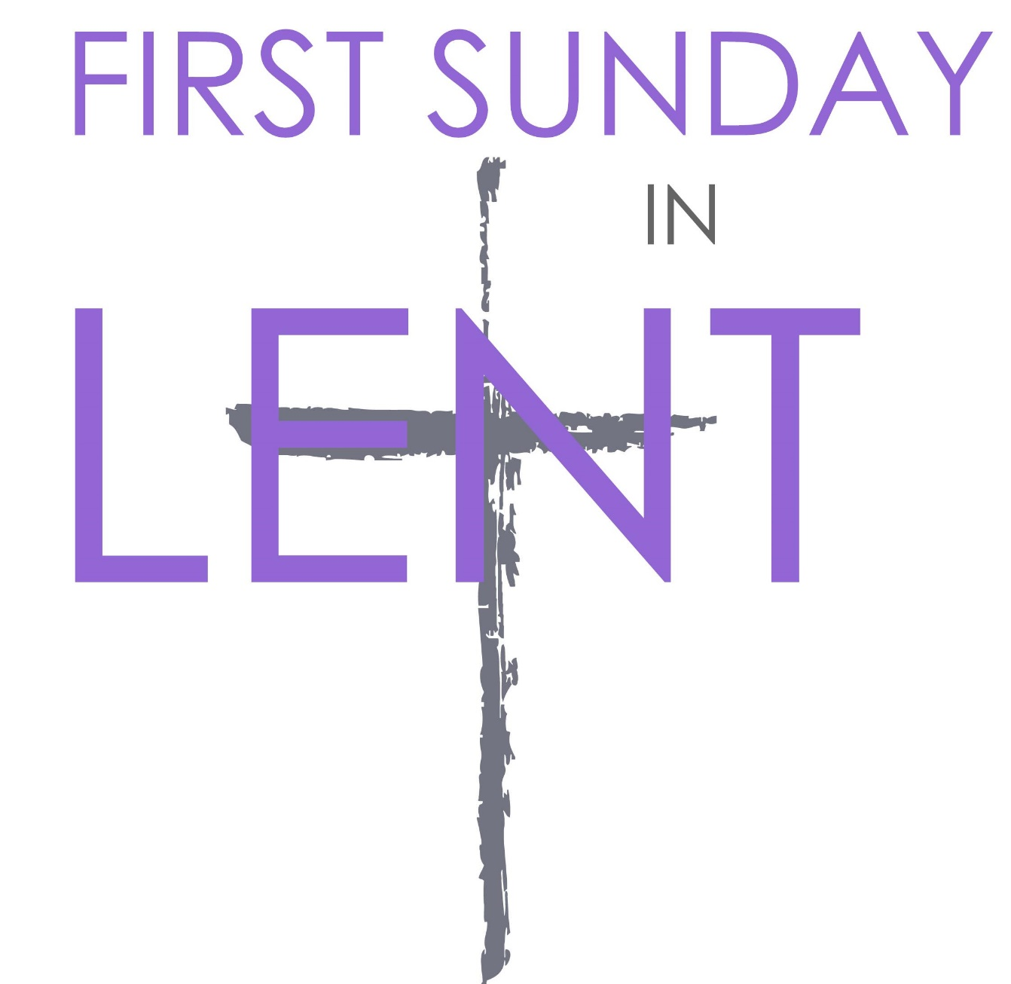

Eagle River Presbyterian Church

March 6, 2022

Weekly Walk
March 6, 2022

Sunday 10:00 am Worship
Wednesday 6:30 pm on Zoom Bible Study
Friday office closed

Last week’s In-Person Attendance --------- 18
February Month-End Regular Income --------- $13,089.07
February Month-End Regular Expenses --------- $19,383.31

Wednesday night Bible study will resume this Wednesday with a study of forgiveness. We will meet each Wednesday on Zoom throughout Lent. There are still books available if you would like to join.
Lay leaders are needed for the month of March, and we have a new sign-up sheet for Sunday school teachers to help teach this spring. Both sign-up sheets are on the bulletin board outside the kitchen.

Next Sunday, March 13, from 1-3 pm there will be a seed exchange, hosted by the local gardening club, Anchor Gardens. The exchange will take place outside by our garden beds, and all are invited to attend!

Ways you can keep up with your financial stewardship:
1) If you’re worshipping with us in person, you may leave your gift in one of the offering plates as you leave the sanctuary this morning. The plates are on the table to the right of the main door.
2) Donate online with a credit card by clicking the link from our website: www.erpresbyterian.org.
3) Visit your local bank or your bank’s website and set up a recurring electronic payment. Your bank may require the church’s account number. Please call the office for that information.
4) Checks can also be mailed to PO Box 771337 Eagle River, AK 99577

Weekly Walk
March 6, 2022

Sunday 10:00 am Worship
Wednesday 6:30 pm on Zoom Bible Study
Friday office closed

Last week’s In-Person Attendance --------- 18
February Month-End Regular Income --------- $13,089.07
February Month-End Regular Expenses --------- $19,383.31

Wednesday night Bible study will resume this Wednesday with a study of forgiveness. We will meet each Wednesday on Zoom throughout Lent. There are still books available if you would like to join.
Lay leaders are needed for the month of March, and we have a new sign-up sheet for Sunday school teachers to help teach this spring. Both sign-up sheets are on the bulletin board outside the kitchen.

Next Sunday, March 13, from 1-3 pm there will be a seed exchange, hosted by the local gardening club, Anchor Gardens. The exchange will take place outside by our garden beds, and all are invited to attend!

Ways you can keep up with your financial stewardship:
1) If you’re worshipping with us in person, you may leave your gift in one of the offering plates as you leave the sanctuary this morning. The plates are on the table to the right of the main door.
2) Donate online with a credit card by clicking the link from our website: www.erpresbyterian.org.
3) Visit your local bank or your bank’s website and set up a recurring electronic payment. Your bank may require the church’s account number. Please call the office for that information.
4) Checks can also be mailed to PO Box 771337 Eagle River, AK 99577

