Eagle River Presbyterian Church
April 17,2022

GATHERING TO WORSHIP
Please take a moment during the Prelude to silence your cell phones and quietly prepare yourself for worship.

PRELUDE
WELCOME
CHORAL INTROIT “I Serve a Risen Savior”

*CALL TO WORSHIP
Leader: Alleluia! Christ is risen.
People: He is risen indeed. Alleluia!
Leader: Praise the God and Father of our Lord Jesus Christ.
People: He has given us new life and hope. He has raised Jesus from the dead.
Leader: God has claimed us as his own.
People: He has brought us out of darkness. He has made us light to the world.
Leader: Alleluia! Christ is risen.
People: He is risen indeed. Alleluia!

*PRAYER OF INVOCATION

*HYMN “The Day of Resurrection” Hymnal 233

RECEIVING FORGIVENESS FROM
GOD AND EACH OTHER
*CALL TO CONFESSION

*PRAYER OF CONFESSION: Spoken and Silent (After the corporate Prayer of Confession, please take a few moments of silence to individually confess our sins to God.)
Lord, bring new life where we are worn and tired; new love where we have turned hard-hearted; forgiveness where we feel hurt and where we have wounded; and the joy and freedom of your Holy Spirit where we are prisoners of ourselves.
*DECLARATION OF FORGIVENESS
Leader: O, give thanks to the Lord, for God is good! God’s steadfast love endures forever. Through the risen Christ, this day and every day we are forgiven.
People: Alleluia! Amen.

CHILDREN’S MESSAGE

HEARING THE WORD
PSALM OF THE DAY Psalm 118:1-2, 14-24 Pew Bible p.436

CHORAL ANTHEM “Lord of the Dance”

SCRIPTURES Isaiah 65:17-25 Pew Bible p.532 Luke 24:1-12 Pew Bible p.748 1 Corinthians 15:12-26 Pew Bible p.815

MESSAGE Character and Calling: Victory! Rev. Piper Cartland

RESPONDING TO THE WORD
SHARING OUR JOYS AND CONCERNS

PASTORAL PRAYER, followed by The Lord’s Prayer (we say sin)
* “Praise God from Whom All Blessings Flow” Hymnal 606

SACRAMENT OF BAPTISM

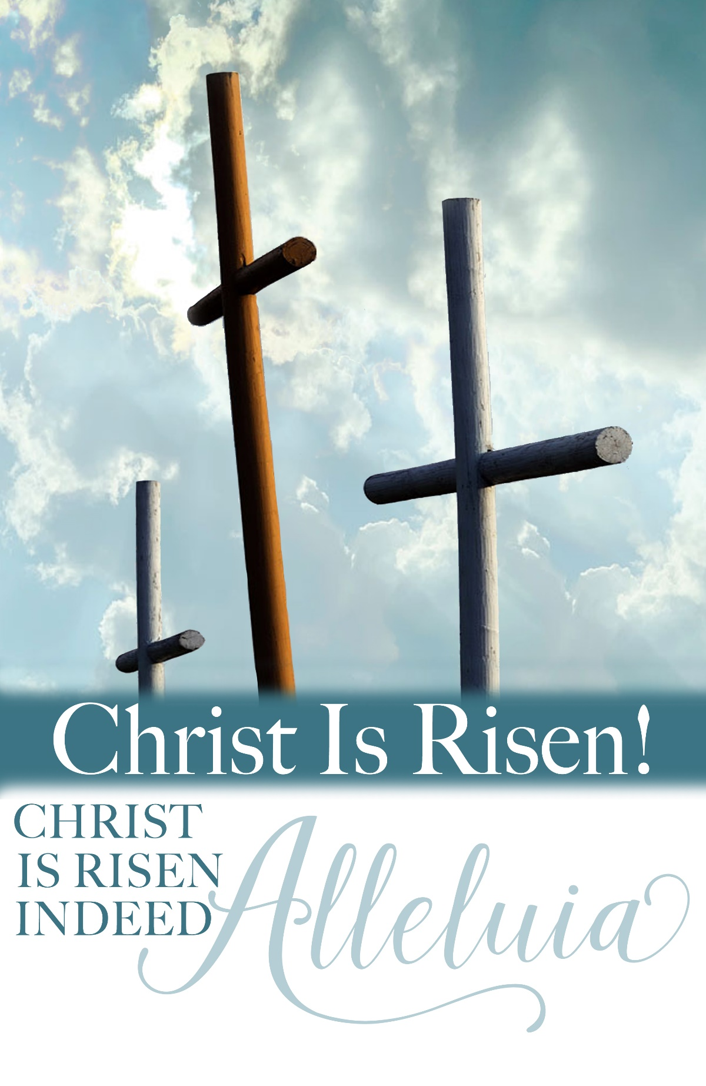
PROFESSION OF FAITH Apostles’ Creed Hymnal p.35

THANKSGIVING OVER THE WATER

Pastor: The Lord be with you.

People: And also with you.

Pastor: Let us give thanks to the Lord our God.

People: It is right to give our thanks and praise.

BAPTISMS of Iola Grace Rasic, Olivia Jane Lewis and

Peyton Reese Lewis

GOING INTO THE WORLD

HANDBELL ANTHEM “Christ the Lord is Risen Today”

*HYMN “Jesus Christ is Risen Today” Hymnal 232

*CHARGE AND BENEDICTION

POSTLUDE
*Those who are able may stand

WELCOME! It is a joy to worship together in person. So that we may do so safely, here are the basic tenets for our COVID-19 Mitigation Plan: If the level of community transmission is substantial or high, the session recommends mask wear and social distancing by all congregants. If the level is low or moderate, mask wear and social distancing will be optional for vaccinated and recommended for unvaccinated and immunocompromised. The level of community transmission is posted by the entrance. Tithes/offerings may be placed in the offering plates at the back of the sanctuary.

LARGE PRINT HYMNALS with a black cover, are on the small bookcase in the rear of the sanctuary. If you use one, please put it back after worship.

ASSISTIVE LISTENING DEVICES available on request. Please request one from the Sound Tech at the sound desk.
There are cards in the pews for visitors to fill out and for anyone who needs to update their information. Please place the cards in the offering plates. If you are visiting today, the worship service is our gift to you. Please contribute to the offering or not, as God leads. We delight in welcoming you, and we are glad that you’re here!

Children up to kindergarten age are welcome in the nursery. There are clipboards with coloring pages in the narthex if your children wish to stay in the sanctuary.

Thanks to the Malechas for sponsoring the altar flowers this month!

SACRAMENT OF BAPTISM
Hear the words of our Lord Jesus Christ:
All authority in heaven and on earth
Weekly Walk

Sunday 10:00 am Worship
Tuesday 7:00 pm Session Meeting

Last week’s In-Person Attendance ---------48
Month to Date Income --------- $10,604.80
Month to Date Expenses --------- $14,558.68

The two roses on the pulpit today are for new grandchildren in our congregation. Todd and Debby Carter had a grandson, Henry Walter, born to parents Christopher and Sarah Blastick. He arrived April 7 and weighing 7 lbs 1oz. Diane and Bill Walters had a grandson, Max William, born to parents Jessica and Robert Lanzafame. He arrived April 13 weighing 8 lbs. 10 oz. Congratulations to the proud grandparents!

Please take a look at our Lay Leader and Sunday School sign-ups, on the bulletin board by the kitchen. There are many openings!

The Session is considering a proposal to relocate the nursery from its current space to Room 14, the larger of the two fellowship rooms. This would allow our children’s ministries to all be located on the same side of the building, make space available for a trustee workroom and periodic Food Pantry needs, and allow the smaller fellowship room to be used for meetings and classes. Future congregational meals would be held in our new expanded
narthex. If you have feedback or would like to discuss the
proposal, please contact an elder: Nancy Davis, Matthew Hobbie, Melissa Hodgson, Becky Musick, Linda Homan, or Bill Musick. The Session will vote this Tuesday, April 19th so please make sure to talk with someone before then. Thank you!

