GATHERING TO WORSHIP
Please take a moment during the Prelude to silence your cell phones and quietly prepare yourself for worship.
PRELUDE
WELCOME
*CALL TO WORSHIP
Leader: God makes a way out of no way.
People: God sees our tears and turns them into joy.
Leader: God makes the impossible possible
People: and sees the desperate needs of all people.
Leader: Come close, healing Lord, and receive our worship.

*PRAYER OF INVOCATION
Creator God, you have formed us as your own, so whether we are weeping or laughing, dreaming or shouting for joy, we are always coming home to you.
For all this and more, we thank you in Jesus’ name. Amen.

*HYMN “How Firm a Foundation” Hymnal 463 v.1-3

RECEIVING FORGIVENESS FROM
GOD AND EACH OTHER

*CALL TO CONFESSION

*PRAYER OF CONFESSION: Spoken and Silent (After the corporate Prayer of Confession, please take a few moments of silence to individually confess our sins to God.)
Merciful God, you pardon all who truly repent and turn to you. We humbly confess our sins and ask your mercy. We have not loved you with a pure heart,
nor have we loved our neighbors as ourselves. We have not done justice, loved kindness, or walked humbly with you, our God. Have mercy on us, O God, in your loving-kindness. In your great compassion, cleanse us from our sin. Do not cast us away from your presence, or take your Holy Spirit from us. Restore to us the joy of your salvation and sustain us with your bountiful Spirit.

*DECLARATION OF FORGIVENESS
Leader: Do not fear, says the Lord, for I have redeemed you. I have called you by name; you are mine. God is doing a new thing; now it springs forth! By the grace of Jesus Christ, we are forgiven!
People: Thanks be to God!

CHILDREN’S MESSAGE

HEARING THE WORD

PSALM OF THE DAY Psalm 126 Pew Bible p.441

SCRIPTURES Isaiah 43:16-21 Pew Bible p.515
John 12:1-8 Pew Bible p.761
Philippians 3:4b-14 Pew Bible p.832

MESSAGE Character and Calling: Faith Rev. Piper Cartland

*AFFIRMATION OF FAITH
This is the good news which we have received, in which we stand, and by which we are saved, if we hold it fast: that Christ died for our sins according to the scriptures, that he was buried, that he was raised on the third day, and that he appeared first to the women, then to Peter, and to the Twelve, and then to many faithful witnesses. We believe that Jesus is the Christ, the Son of the living God. Jesus Christ is the first and the last, the beginning and the end;
he is our Lord and our God. Amen.

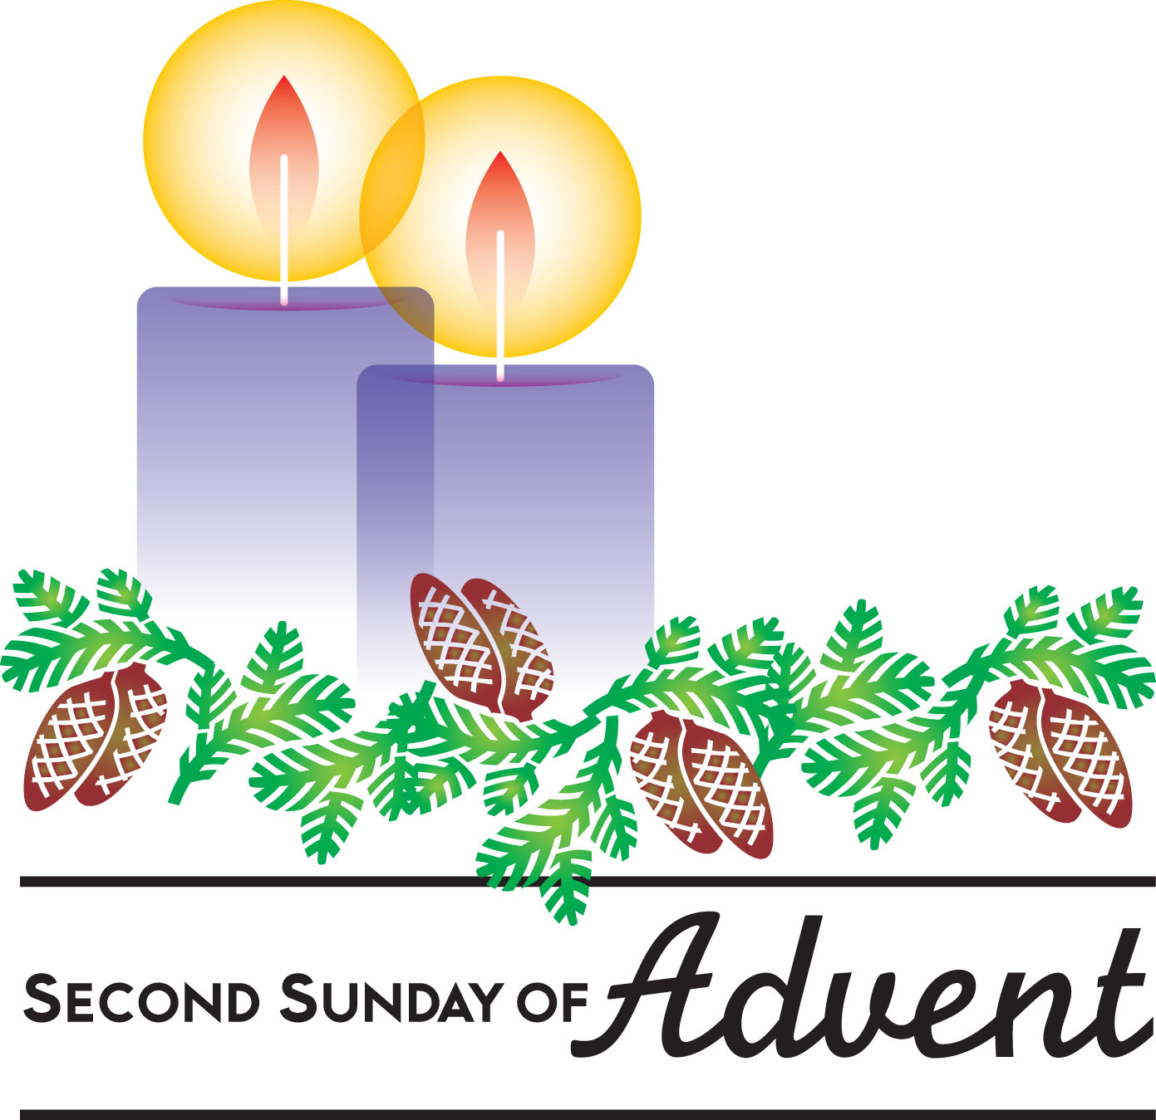
RESPONDING TO THE WORD

SHARING OUR JOYS AND CONCERNS

PASTORAL PRAYER
MINUTES FOR MINISTRY

OFFERING OURSELVES TO GOD
*DOXOLOGY “Praise God from Whom All Blessings Flow” Hymnal 606

CELEBRATING THE LORD’S SUPPER

*HYMN “How Firm a Foundation” Hymnal 463 v.4-5

INVITATION TO THE TABLE

GREAT PRAYER OF THANKSGIVING AND THE LORD’S PRAYER (we say sin)

Pastor: The Lord be with you.
People: And also with you.
Pastor: Lift up your hearts.
People: We lift them to the Lord.
Pastor: Let us give thanks to the Lord our God.
People: It is right to give our thanks and praise.

WORDS OF INSTITUTION
COMMUNION OF THE PEOPLE
PRAYER

GOING INTO THE WORLD

*HYMN “To God Be the Glory” Hymnal 634

*CHARGE AND BENEDICTION
POSTLUDE

*Those who are able please stand

WELCOME! It is a joy to worship together in person. So that we may do so safely, here are the basic tenets for our COVID-19 Mitigation Plan: If the level of community transmission is substantial or high, the session recommends mask wear and social distancing by all congregants. If the level is low or moderate, mask wear and social distancing will be optional for vaccinated and recommended for unvaccinated and
immunocompromised. The level of community transmission is posted by the entrance. Tithes/offerings may be placed in the offering plates at the back of the sanctuary.

LARGE PRINT HYMNALS, with a black cover, are on the small bookcase in the rear of the sanctuary. If you use one, please put it back after worship.

ASSISTIVE LISTENING DEVICES available on request. Please request one from the Sound Tech at the sound desk.
There are cards are in the pews for visitors to fill out and for anyone who needs to update their information. Please place the cards in the offering plates as needed. If you are visiting today, the worship service is our gift to you. Please contribute to the offering, or not, as God leads. We delight in welcoming you, and we are glad that you’re here!
Children up to kindergarten age are welcome in the nursery. There are clipboards with coloring pages in the narthex if your children wish to stay in the sanctuary.
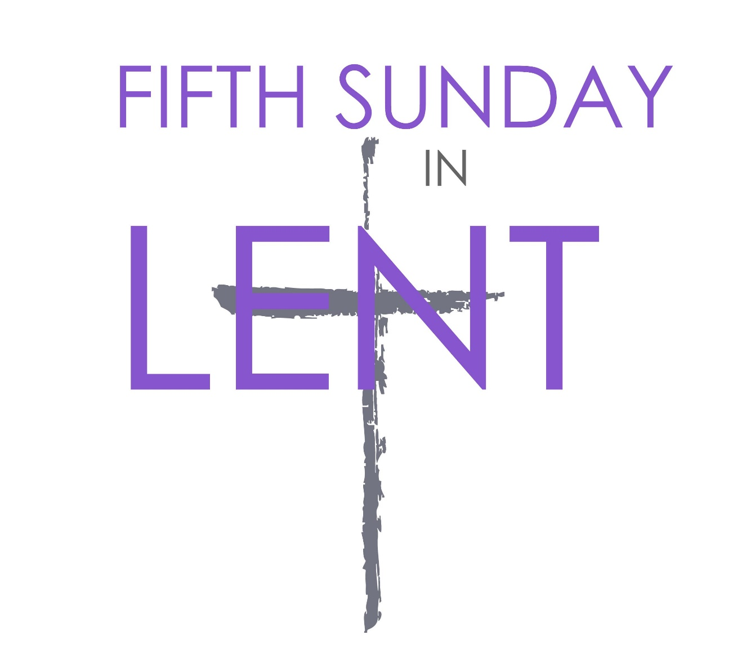

Eagle River Presbyterian Church

April 3, 2022

Weekly Walk

Sunday 10:00 am Worship
Sunday 11:00 am Choir meeting and Handbell rehearsal
Sunday 12:30 pm – 2:00 Combined Youth Group @ ERPC
Wednesday 6:30 pm Lent Bible Study on Zoom

Last week’s In-Person Attendance --------- 29
March Month-End Regular Income --------- $20,400.80
Month to Date Expenses --------- $23,933.70
If you’d like to sing in the Easter chancel choir, we’ll have a very brief meeting after worship to decide on rehearsal times. Then the handbell choir will rehearse.

We are collecting treats to fill Easter eggs for the annual egg hunt on April 17! There is a basket on the table in the narthex. Thank you!

We have a mission/outreach opportunity: a family who lost everything in the Eagle River apartment fire last August was unable to benefit from the Lions Club drive. We are collecting gently used household items to help them start over. There is a list on the bulletin board in the narthex; if you have any items that you’d like to contribute, you may bring them to the church during office hours or on Sunday.

We have received a donation of Covid home-testing kits. They are in a box in the Narthex. Please take some if you need them!

The Session is considering a proposal to relocate the nursery from its current space to Room 14, the larger of the two fellowship rooms. This would allow our children’s ministries to all be located on the same side of the building, make space available for a trustee workroom and periodic Food Pantry needs, and allow the
Weekly Walk

Sunday 10:00 am Worship
Sunday 11:00 am Choir meeting and Handbell rehearsal
Sunday 12:30 pm – 2:00 Combined Youth Group @ ERPC
Wednesday 6:30 pm Lent Bible Study on Zoom

Last week’s In-Person Attendance --------- 29
March Month-End Regular Income --------- $20,400.80
Month to Date Expenses --------- $23,933.70
If you’d like to sing in the Easter chancel choir, we’ll have a very brief meeting after worship to decide on rehearsal times. Then the handbell choir will rehearse.

We are collecting treats to fill Easter eggs for the annual egg hunt on April 17! There is a basket on the table in the narthex. Thank you!

We have a mission/outreach opportunity: a family who lost everything in the Eagle River apartment fire last August was unable to benefit from the Lions Club drive. We are collecting gently used household items to help them start over. There is a list on the bulletin board in the narthex; if you have any items that you’d like to contribute, you may bring them to the church during office hours or on Sunday.

We have received a donation of Covid home-testing kits. They are in a box in the Narthex. Please take some if you need them!

The Session is considering a proposal to relocate the nursery from its current space to Room 14, the larger of the two fellowship rooms. This would allow our children’s ministries to all be located on the same side of the building, make space available for a trustee workroom and periodic Food Pantry needs, and allow the smaller fellowship room to be used for meetings and classes. Future congregational meals would be held in our new expanded narthex. If you have feedback or would like to discuss the proposal, please contact an elder: Nancy Davis, Matthew Hobbie, Melissa Hodgson, Becky Musick, Linda Homan, or Bill Musick. The Session will vote at their next regular meeting on April 19th so please make sure to talk with someone before then.

Ways you can keep up with your financial stewardship:
1) If you’re worshipping with us in person, you may leave your gift in one of the offering plates as you leave the sanctuary this morning. The plates are on the table to the right of the main door.
2) Donate online with a credit card by clicking the link from our website: www.erpresbyterian.org.
3) Visit your local bank or your bank’s website and set up a recurring electronic payment. Your bank may require the church’s account number. Please call the office for that information.
4) Checks can also be mailed to PO Box 771337 Eagle River, AK 99577

smaller fellowship room to be used for meetings and classes. Future congregational meals would be held in our new expanded narthex. If you have feedback or would like to discuss the proposal, please contact an elder: Nancy Davis, Matthew Hobbie, Melissa Hodgson, Becky Musick, Linda Homan, or Bill Musick. The Session will vote at their next regular meeting on April 19th so please make sure to talk with someone before then.

Ways you can keep up with your financial stewardship:
1) If you’re worshipping with us in person, you may leave your gift in one of the offering plates as you leave the sanctuary this morning. The plates are on the table to the right of the main door.
2) Donate online with a credit card by clicking the link from our website: www.erpresbyterian.org.
3) Visit your local bank or your bank’s website and set up a recurring electronic payment. Your bank may require the church’s account number. Please call the office for that information.
4) Checks can also be mailed to PO Box 771337 Eagle River, AK 99577

