GATHERING TO WORSHIP
Please take a moment during the Prelude to silence your cell phones and quietly prepare yourself for worship.

PRELUDE
WELCOME
*CALL TO WORSHIP
Leader: Jesus Christ is risen from the dead!
People: Alleluia!
Leader: Blessing and honor and glory and might be to our God forever and ever!
People: Alleluia!

*PRAYER OF INVOCATION
Living Lord, you meet us in unexpected places and surprise us with the abundance of your love. Feed us by your Word and fill us with your Spirit so that we may follow you this day, and always; through Jesus Christ, your Son, our Savior. Amen.

*HYMN “Praise Ye the Lord, the Almighty!” Hymnal 35

RECEIVING FORGIVENESS FROM
GOD AND EACH OTHER

*CALL TO CONFESSION

*PRAYER OF CONFESSION: Spoken and Silent (After the corporate Prayer of Confession, please take a few moments of silence to individually confess our sins to God.)
Lord God, in the light of your glory we see the evil we have done, the suffering we have caused, the good we have refused, and the truth we have denied. Heal us of our sin, wash us in your mercy, and feed us with your grace, so that we may follow your way and tell the good news of the gospel. Amen.

*DECLARATION OF FORGIVENESS
Leader: Rise up from the dust! Cast off the shroud of sorrow and put on the joy of the Lord. In Jesus Christ we are forgiven.
People: Thanks be to God!

CHILDREN’S MESSAGE

HEARING THE WORD
PSALM OF THE DAY Psalm 30 Pew Bible p.394

SCRIPTURE Luke 7:1-17 Pew Bible p.730

MESSAGE The Capernaum Chronicles Rev. Todd M. Carter

*AFFIRMATION OF FAITH - Nicene Creed Hymnal p.34

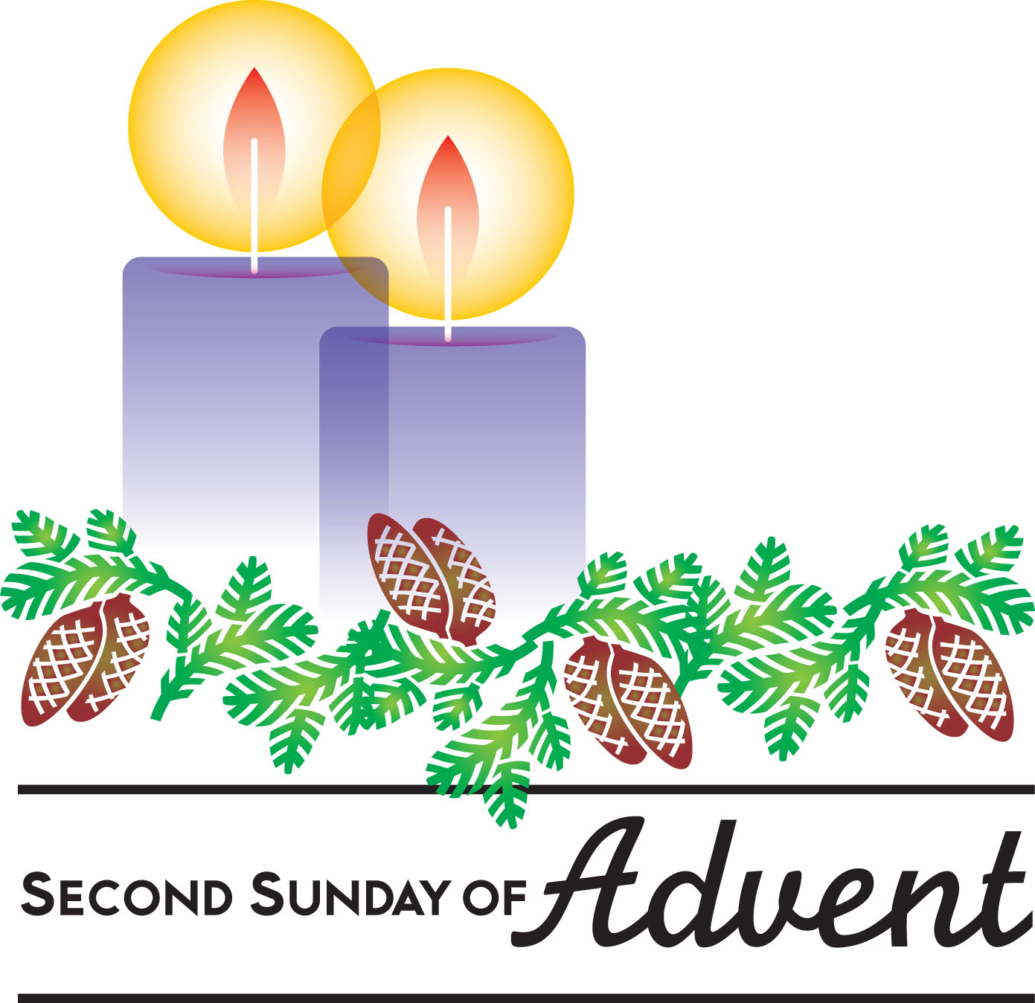
RESPONDING TO THE WORD
SHARING OUR JOYS AND CONCERNS

PASTORAL PRAYER
MINUTES FOR MINISTRY

OFFERING OURSELVES TO GOD
* “Praise God from Whom All Blessings Flow” Hymnal 606

CELEBRATING THE LORD’S SUPPER
*HYMN “Jesu, Jesu, Fill Us with Your Love Hymnal 203

INVITATION TO THE TABLE

GREAT PRAYER OF THANKSGIVING AND THE LORD’S PRAYER (we say sin)
Pastor: The Lord be with you.
People: And also with you.
Pastor: Lift up your hearts.
People: We lift them to the Lord.
Pastor: Let us give thanks to the Lord our God.
People: It is right to give our thanks and praise.

WORDS OF INSTITUTION
COMMUNION OF THE PEOPLE
PRAYER

GOING INTO THE WORLD

*HYMN “Christ is Risen! Shout Hosanna!” Hymnal 248

*CHARGE AND BENEDICTION
POSTLUDE
*Those who are able please stand.

WELCOME! It is a joy to worship together in person. So that we may do so safely, here are the basic tenets for our COVID-19 Mitigation Plan: If the level of community transmission is substantial or high, the session recommends mask wear and social distancing by all congregants. If the level is low or moderate, mask wear and social distancing will be optional for vaccinated and recommended for unvaccinated and immunocompromised. The level of community transmission is posted by the entrance. Tithes/offerings may be placed in the offering plates at the back of the sanctuary.

LARGE PRINT HYMNALS with a black cover, are on the small bookcase in the rear of the sanctuary. If you use one, please put it back after worship.

ASSISTIVE LISTENING DEVICES available on request. Please request one from the Sound Tech at the sound desk.
There are cards in the pews for visitors to fill out and for anyone who needs to update their information. Please place the cards in the offering plates as needed. If you are visiting today, the worship service is our gift to you. Please contribute to the offering or not, as God leads. We delight in welcoming you, and we are glad that you’re here!
Children up to kindergarten age are welcome in the nursery. There are clipboards with coloring pages in the narthex if your children wish to stay in the sanctuary.

Eagle River Presbyterian Church
May 1, 2022

Weekly Walk

Sunday 10:00 am Worship
Sunday 12:30 – 2pm Youth Group

Last week’s In-Person Attendance --------- 39
April Month End Regular Income --------- $18,036.08
April Month End Regular Expenses --------- $17,356.99

The combined youth group will meet at ERPC at 12:30. They will be helping in the garden, and lunch will be provided.

Next Sunday is Mother’s Day! The deacons will be hosting a brunch after worship. Please join us to celebrate!

We will have a parents’ night out on May 20. If you are interested in having your child or children participate, please contact the church office.
It’s almost camp season! Check out some Presbyterian children and youth camp opportunities on the bulletin board by the front door.

Ways you can keep up with your financial stewardship:
1) If you’re worshipping with us in person, you may leave your gift in one of the offering plates as you leave the sanctuary this morning. The plates are on the table to the right of the main door.
2) Donate online with a credit card by clicking the link from our website: www.erpresbyterian.org.
3) Visit your local bank or your bank’s website and set up a recurring electronic payment. Your bank may require the church’s account number. Please call the office for that information.
4) Checks can also be mailed to PO Box 771337 Eagle River, AK 99577

Weekly Walk

Sunday 10:00 am Worship
Sunday 12:30 – 2pm Youth Group

Last week’s In-Person Attendance --------- 39
April Month End Regular Income --------- $18,036.08
April Month End Regular Expenses --------- $17,356.99

The combined youth group will meet at ERPC at 12:30. They will be helping in the garden, and lunch will be provided.

Next Sunday is Mother’s Day! The deacons will be hosting a brunch after worship. Please join us to celebrate!

We will have a parents’ night out on May 20. If you are interested in having your child or children participate, please contact the church office.
It’s almost camp season! Check out some Presbyterian children and youth camp opportunities on the bulletin board by the front door.

Ways you can keep up with your financial stewardship:
1) If you’re worshipping with us in person, you may leave your gift in one of the offering plates as you leave the sanctuary this morning. The plates are on the table to the right of the main door.
2) Donate online with a credit card by clicking the link from our website: www.erpresbyterian.org.
3) Visit your local bank or your bank’s website and set up a recurring electronic payment. Your bank may require the church’s account number. Please call the office for that information.
4) Checks can also be mailed to PO Box 771337 Eagle River, AK 99577

