GATHERING TO WORSHIP
Please take a moment during the Prelude to silence your cell phones and quietly prepare yourself for worship.

PRELUDE
WELCOME
*CALL TO WORSHIP
Leader: Lift your hearts, raise your voices, and join the heavenly host who forever sing:
People: Amen! Blessing and glory and wisdom and thanksgiving and honor and power and might be to our God forever and ever! Amen.

*PRAYER OF INVOCATION
Shepherd of Souls, you call us to an abundant feast at the table of your word; open our hearts to feed on your goodness, that by the power of the Holy Spirit we might dwell evermore deeply in you. Amen.

*HYMN “Thine Is the Glory” Hymnal 238

RECEIVING FORGIVENESS FROM
GOD AND EACH OTHER

*CALL TO CONFESSION
*PRAYER OF CONFESSION: Spoken and Silent (After the corporate Prayer of Confession, please take a few moments of silence to individually confess our sins to God.)
Holy God, we confess that we have strayed from your paths of right relationship and peace, and we have dishonored you,
ourselves, and your creation; we repent of these hurtful ways.
Forgive us, we pray, as we learn to forgive others, and guide our feet into the way of peace. Amen.

*DECLARATION OF FORGIVENESS
Leader: Hear the sound of your Shepherd’s voice: Jesus says, I give you eternal life. You will never perish. No one can snatch you out of my hand. Believe the good news.
People: In Jesus Christ, we are forgiven, nurtured, and safe.

CHILDREN’S MESSAGE

HEARING THE WORD
PSALM OF THE DAY Psalm 23 Pew Bible p.392

SCRIPTURE Acts 9:36-43 Pew Bible p.778
John 10:22-30 Pew Bible p.760
Revelation 7:9-17 Pew Bible p.871

MESSAGE Resurrection People: A Vision of the Church
Rev. Piper Cartland

RESPONDING TO THE WORD

SHARING OUR JOYS AND CONCERNS

PASTORAL PRAYER, followed by The Lord’s Prayer (we say sin)
MINUTES FOR MINISTRY

OFFERING OURSELVES TO GOD
* “Praise God from Whom All Blessings Flow” Hymnal 606

SACRAMENT OF BAPTISM

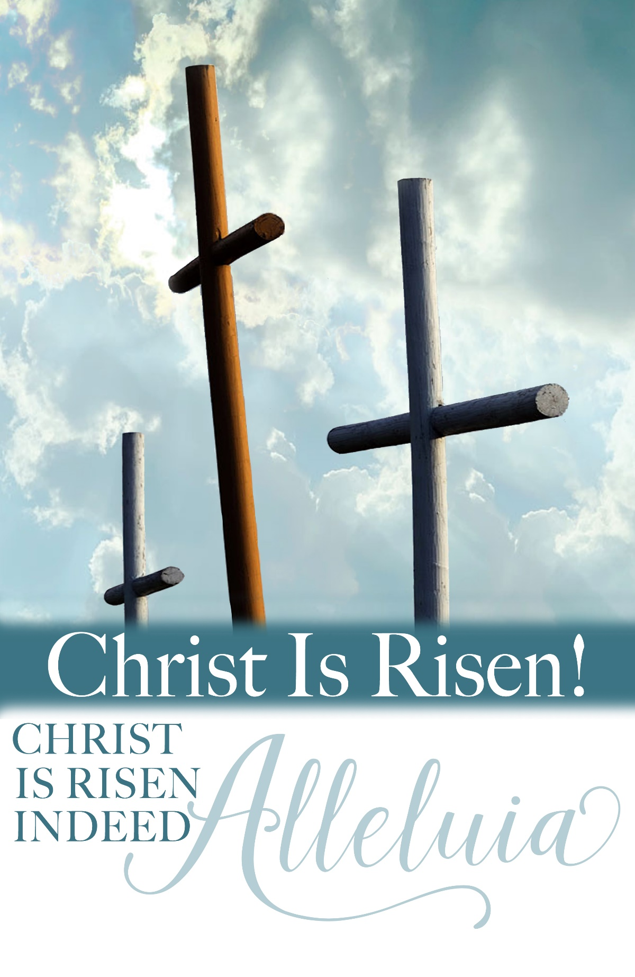
PROFESSION OF FAITH Apostles’ Creed Hymnal p.35

THANKSGIVING OVER THE WATER

Pastor: The Lord be with you.

People: And also with you.

Pastor: Let us give thanks to the Lord our God.

People: It is right to give our thanks and praise.

BAPTISM of John Luke Anderson

GOING INTO THE WORLD

*HYMN “The King of Love My Shepherd Is” Hymnal 802

*CHARGE AND BENEDICTION
POSTLUDE
*Those who are able please stand.

WELCOME! It is a joy to worship together in person. So that we may do so safely, here are the basic tenets for our COVID-19 Mitigation Plan: If the level of community transmission is substantial or high, the session recommends mask wear and social distancing by all congregants. If the level is low or moderate, mask wear and social distancing will be optional for vaccinated and recommended for unvaccinated and immunocompromised. The level of community transmission is posted by the entrance. Tithes/offerings may be placed in the offering plates at the back of the sanctuary.

LARGE PRINT HYMNALS with a black cover, are on the small bookcase in the rear of the sanctuary. If you use one, please put it back after worship.

ASSISTIVE LISTENING DEVICES available on request. Please request one from the Sound Tech at the sound desk.
There are cards in the pews for visitors to fill out and for anyone who needs to update their information. Please place the cards in the offering plates as needed. If you are visiting today, the worship service is our gift to you. Please contribute to the offering or not, as God leads. We delight in welcoming you, and we are glad that you’re here!
Children up to kindergarten age are welcome in the nursery. There are clipboards with coloring pages in the narthex if your children wish to stay in the sanctuary.

Thank you to Scott Bailey for sponsoring the altar flowers in May.

Eagle River Presbyterian Church
May 8, 2022

Weekly Walk

Sunday 10:00 am Worship
Sunday 11:00 am Mother’s Day brunch

Last week’s In-Person Attendance --------- 46
Month to Date Income --------- $3,186.00
Month to Date Expenses --------- $8,250.83

The rose on the pulpit last Sunday was there to honor the birth of Todd and Debby Carter’s newest grandson, Arrow Keith Archer, born April 30 to Rebecca and Matthew Archer in Manassas, VA. He was 7 lbs 1 oz and 19 inches. Congratulations to the parents and grandparents!
The Chinooks baseball team is searching for host families for the Summer 2022 season. It’s usually two players per home. Host families provide breakfast and lunch-making materials, and the team provides supper. Each host family gets a $35/day tax credit per player. Players will start arriving the first of June and leave the first of August. Please contact Betty Jo Worthington @ 694-2735 for more details.

We need lay leaders, nursery helpers, and one more Sunday school teacher this month! Please check the sign-up sheets on the bulletin board outside the kitchen.

We will be honoring our graduating seniors and presenting Bibles to our third graders during worship next Sunday, May 15. We think we know everyone who should be receiving gifts, but if you have a child in one of those age groups, please let the office or Piper know.

Weekly Walk

Sunday 10:00 am Worship
Sunday 11:00 am Mother’s Day brunch

Last week’s In-Person Attendance --------- 46
Month to Date Income --------- $3,186.00
Month to Date Expenses --------- $8,250.83

The rose on the pulpit last Sunday was there to honor the birth of Todd and Debby Carter’s newest grandson, Arrow Keith Archer, born April 30 to Rebecca and Matthew Archer in Manassas, VA. He was 7 lbs 1 oz and 19 inches. Congratulations to the parents and grandparents!

The Chinooks baseball team is searching for host families for the Summer 2022 season. It’s usually two players per home. Host families provide breakfast and lunch-making materials, and the team provides supper. Each host family gets a $35/day tax credit per player. Players will start arriving the first of June and leave the first of August. Please contact Betty Jo Worthington @ 694-2735 for more details.

We need lay leaders, nursery helpers, and one more Sunday school teacher this month! Please check the sign-up sheets on the bulletin board outside the kitchen.

We will be honoring our graduating seniors and presenting Bibles to our third graders during worship next Sunday, May 15. We think we know everyone who should be receiving gifts, but if you have a child in one of those age groups, please let the office or Piper know.

