GATHERING TO WORSHIP
Please take a moment during the Prelude to silence your cell phones and quietly prepare yourself for worship.

PRELUDE
WELCOME
*CALL TO WORSHIP
Leader: Praise the Lord, all the earth!
People: Praise the Lord from the heavens; praise the Lord in the heights.
Leader: Praise the name of the Lord, and the Lord’s glory shall be praised,
People: for people near and people far, for people present and people to come, for the young and for those wise with age.
Leader: Come, let us praise the Lord; come, let us worship God.

*PRAYER OF INVOCATION
O God, form the minds of your faithful people into a single will. Make us love what you command and desire what you promise, that, amid all the changes of this world, our hearts may be fixed where true joy is found; through Jesus Christ our Lord, who lives and reigns with you in the unity of the Holy Spirit, one God, now and forever. Amen.

*HYMN “For the Beauty of the Earth” Hymnal 14

RECEIVING FORGIVENESS FROM
GOD AND EACH OTHER

*CALL TO CONFESSION

*PRAYER OF CONFESSION: Spoken and Silent (After the corporate Prayer of Confession, please take a few moments of silence to individually confess our sins to God.)
God of mercy, your command to love one another across all differences opens us to new horizons, yet we often respond with fear and judgment that hinders your goal for humanity.
Forgive our sins, we pray, and give us a true repentance that leads to life for all creation. We pray in Jesus’ name. Amen.

*DECLARATION OF FORGIVENESS
Leader: God’s promises are trustworthy and true; your sins are forgiven. Be at peace to serve the Lord, and may you always be known by your love.
People: Alleluia! Thanks be to God.

CHILDREN’S MESSAGE - honoring Third Graders and Seniors: Iris Holzberger, Penelope Hobbie, Rhiannon Cottle, Kierin Frick

HEARING THE WORD
PSALM OF THE DAY Psalm 148 Pew Bible p.448

SCRIPTURE Acts 11:1-18 Pew Bible p.779
John 13:31-35 Pew Bible p.763
Revelation 21:1-6 Pew Bible p.878

MESSAGE Resurrection People: A God of New Beginnings
Rev. Piper Cartland

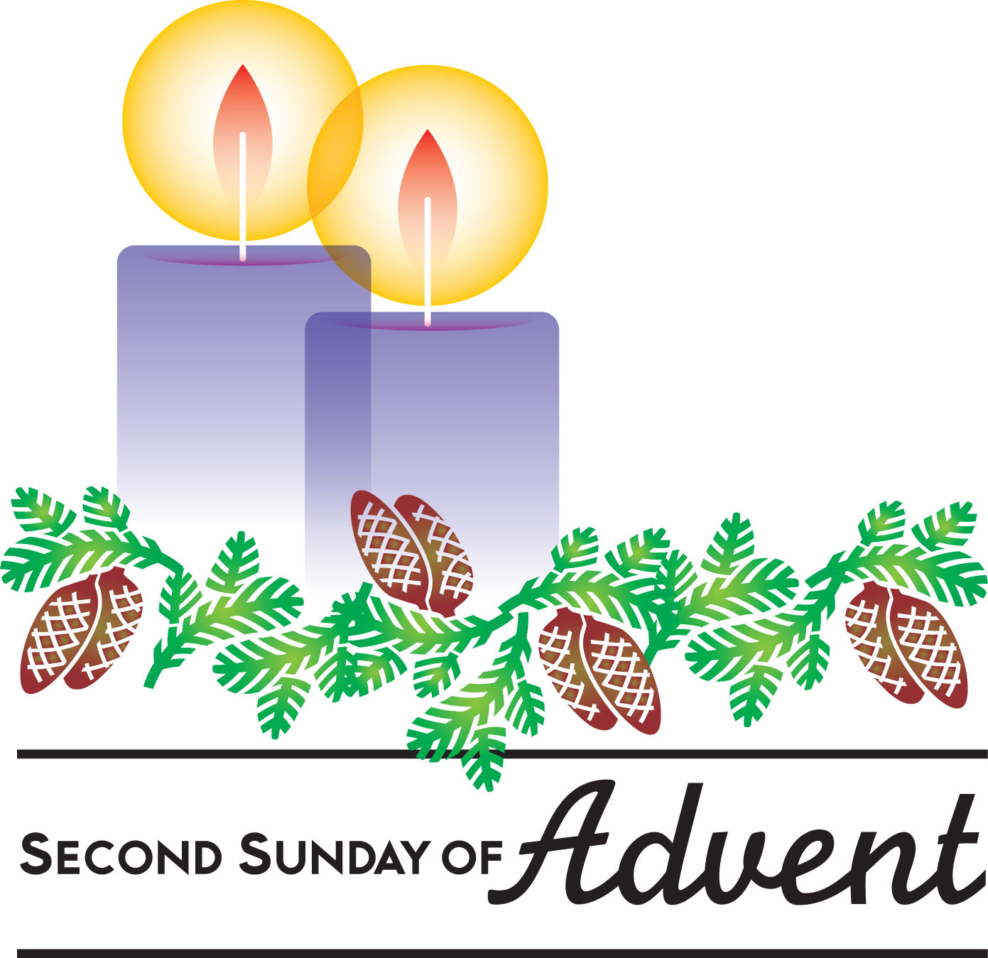
RESPONDING TO THE WORD
SHARING OUR JOYS AND CONCERNS

PASTORAL PRAYER
MINUTES FOR MINISTRY

OFFERING OURSELVES TO GOD
* “Praise God from Whom All Blessings Flow” Hymnal 606

GOING INTO THE WORLD

*HYMN “Glorious Things of Thee are Spoken” Hymnal 81

*CHARGE AND BENEDICTION
POSTLUDE
*Those who are able please stand.

WELCOME! It is a joy to worship together in person. So that we may do so safely, here are the basic tenets for our COVID-19 Mitigation Plan: If the level of community transmission is substantial or high, the session recommends mask wear and social distancing by all congregants. If the level is low or moderate, mask wear and social distancing will be optional for vaccinated and recommended for unvaccinated and immunocompromised. The level of community transmission is posted by the entrance. Tithes/offerings may be placed in the offering plates at the back of the sanctuary.

LARGE PRINT HYMNALS with a black cover, are on the small bookcase in the rear of the sanctuary. If you use one, please put it back after worship.

ASSISTIVE LISTENING DEVICES available on request. Please request one from the Sound Tech at the sound desk.
There are cards in the pews for visitors to fill out and for anyone who needs to update their information. Please place the cards in the offering plates as needed. If you are visiting today, the worship service is our gift to you. Please contribute to the offering or not, as God leads. We delight in welcoming you, and we are glad that you’re here!
Children up to kindergarten age are welcome in the nursery. There are clipboards with coloring pages in the narthex if your children wish to stay in the sanctuary.

Thank you to Scott Bailey for sponsoring the altar flowers this month.

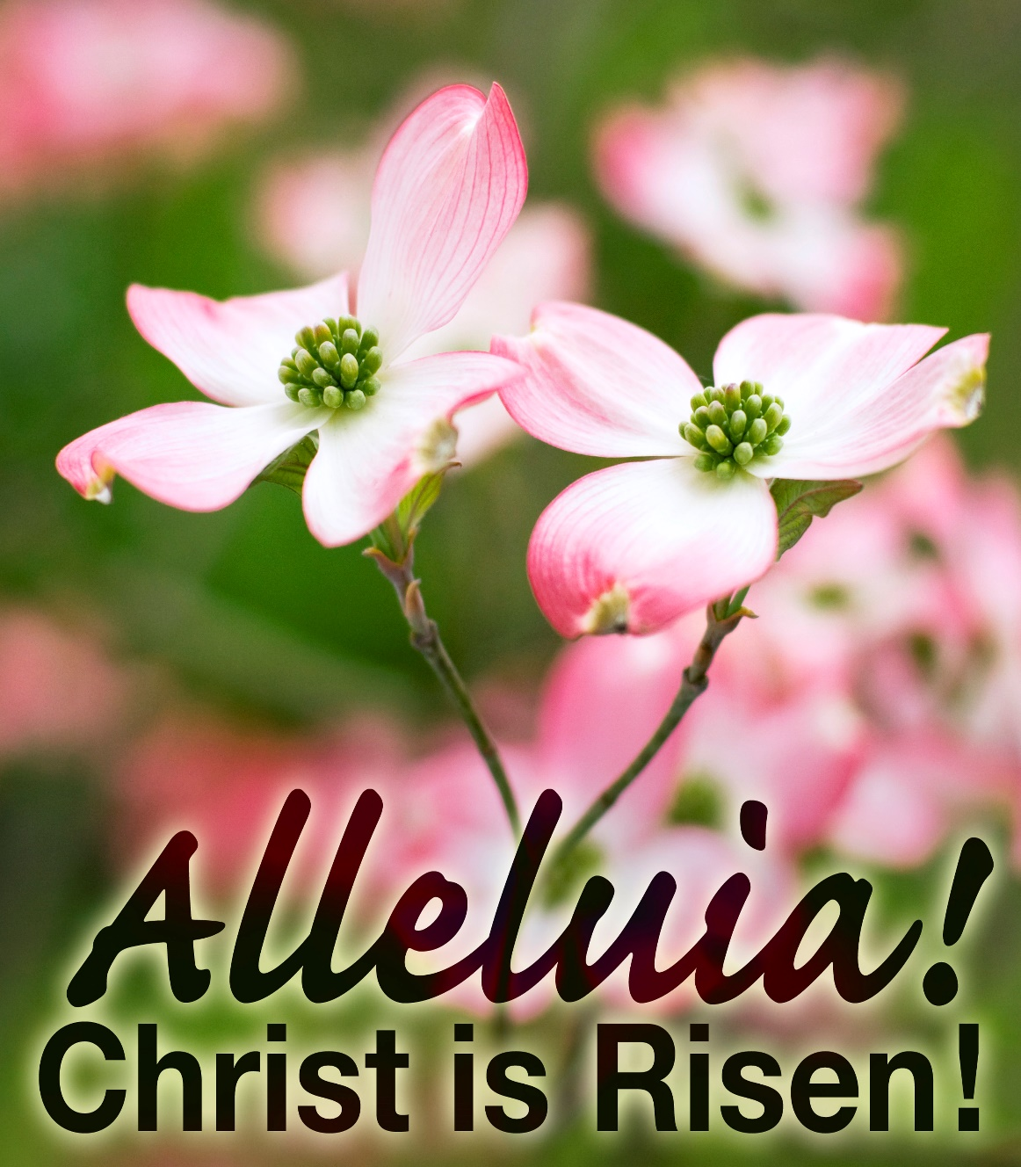

Eagle River Presbyterian Church
May 15, 2022

Weekly Walk

Sunday 10:00 am Worship
Friday 6:00 pm Parents’ Night Out

Last week’s In-Person Attendance --------- 45
Month to Date Income --------- $10,356.91
Month to Date Expenses --------- $12,908.28

This Friday evening, May 20, the deacons will host a parents’ night out for families! Please RSVP by Wednesday to the office or to Stephanie Spencer.

The Chinooks baseball team needs host families for the Summer 2022 season, starting the first of June and ending the first of August. Host families provide housing and two meals a day, usually breakfast and lunch. Please contact Betty Jo Worthington @ 694-2735 for more details or visit cerchinooks.com/apply/host-families.html

Ways you can keep up with your financial stewardship:
1) If you’re worshipping with us in person, you may leave your gift in one of the offering plates as you leave the sanctuary this morning. The plates are on the table to the right of the main door.
2) Donate online with a credit card by clicking the link from our website: www.erpresbyterian.org.
3) Visit your local bank or your bank’s website and set up a recurring electronic payment. Your bank may require the church’s account number. Please call the office for that information.
4) Checks can also be mailed to PO Box 771337 Eagle River, AK 99577

Weekly Walk

Sunday 10:00 am Worship
Friday 6:00 pm Parents’ Night Out

Last week’s In-Person Attendance --------- 45
Month to Date Income --------- $10,356.91
Month to Date Expenses --------- $12,908.28

This Friday evening, May 20, the deacons will host a parents’ night out for families! Please RSVP by Wednesday to the office or to Stephanie Spencer.

The Chinooks baseball team needs host families for the Summer 2022 season, starting the first of June and ending the first of August. Host families provide housing and two meals a day, usually breakfast and lunch. Please contact Betty Jo Worthington @ 694-2735 for more details or visit cerchinooks.com/apply/host-families.html

Ways you can keep up with your financial stewardship:
1) If you’re worshipping with us in person, you may leave your gift in one of the offering plates as you leave the sanctuary this morning. The plates are on the table to the right of the main door.
2) Donate online with a credit card by clicking the link from our website: www.erpresbyterian.org.
3) Visit your local bank or your bank’s website and set up a recurring electronic payment. Your bank may require the church’s account number. Please call the office for that information.
4) Checks can also be mailed to PO Box 771337 Eagle River, AK 99577

