GATHERING TO WORSHIP
Please take a moment during the Prelude to silence your cell phones and quietly prepare yourself for worship.

PRELUDE
WELCOME

*CALL TO WORSHIP
Leader: Alleluia, Christ is risen.
People: The Lord is risen indeed, alleluia.
Leader: Let the peoples praise you, O God.
People: Let all the peoples praise you.

*PRAYER OF INVOCATION
O God, you have prepared for those who love you joys beyond understanding. Pour into our hearts such love for you, that, loving you above all else, we may obtain your promises, which exceed all that we can desire; through Jesus Christ our Lord,
who is alive and reigns with you in the unity of the Holy Spirit,
one God, forever and ever. Amen.

*HYMN “Shall We Gather at the River” Hymnal 375

RECEIVING FORGIVENESS FROM
GOD AND EACH OTHER

*CALL TO CONFESSION

*PRAYER OF CONFESSION: Spoken and Silent (After the corporate Prayer of Confession, please take a few moments of silence to individually confess our sins to God.)
Loving God, we confess that we are an anxious people who deny your blessing and fail to keep your word. Forgive us, we pray, for these and all our sins, that we might live in peace and reflect your love in the world; through Jesus Christ we pray. Amen.

*DECLARATION OF FORGIVENESS
Leader: Let your hearts be still, for God loves you and forgives all your wrongdoing. Beloved, receive the peace of Christ.
People: Thanks be to God.

CHILDREN’S MESSAGE

HEARING THE WORD

PSALM OF THE DAY Psalm 67 Pew Bible p.411

SCRIPTURE Acts 16:9-15 Pew Bible p.784
John 14:23-29 Pew Bible p.764
Revelation 21:10,22-22:5 Pew Bible p.878

MESSAGE Rev. Curt Karns

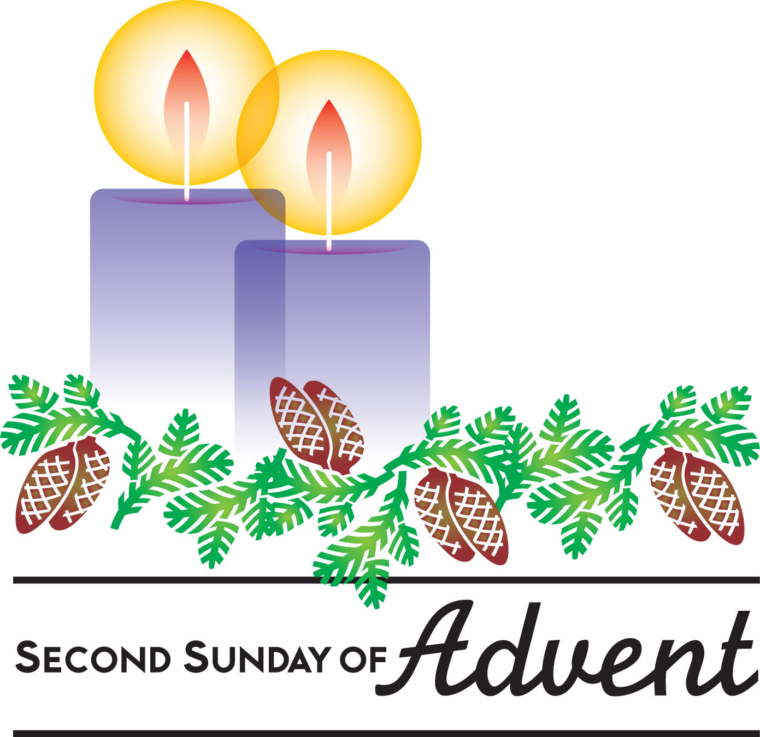
RESPONDING TO THE WORD
SHARING OUR JOYS AND CONCERNS

PASTORAL PRAYER
MINUTES FOR MINISTRY

OFFERING OURSELVES TO GOD
* “Praise God from Whom All Blessings Flow” Hymnal 606

GOING INTO THE WORLD

*HYMN “Go to the World!” Hymnal 295

*CHARGE AND BENEDICTION
POSTLUDE

*Those who are able please stand.

WELCOME! It is a joy to worship together in person. So that we may do so safely, here are the basic tenets for our COVID-19 Mitigation Plan: If the level of community transmission is substantial or high, the session recommends mask wear and social distancing by all congregants. If the level is low or moderate, mask wear and social distancing will be optional for vaccinated and recommended for unvaccinated and immunocompromised. The level of community transmission is posted by the entrance. Tithes/offerings may be placed in the offering plates at the back of the sanctuary.

LARGE PRINT HYMNALS with a black cover, are on the small bookcase in the rear of the sanctuary. If you use one, please put it back after worship.

ASSISTIVE LISTENING DEVICES available on request. Please request one from the Sound Tech at the sound desk.
There are cards in the pews for visitors to fill out and for anyone who needs to update their information. Please place the cards in the offering plates as needed. If you are visiting today, the worship service is our gift to you. Please contribute to the offering or not, as God leads. We delight in welcoming you, and we are glad that you’re here!
Children up to kindergarten age are welcome in the nursery. There are clipboards with coloring pages in the narthex if your children wish to stay in the sanctuary.

Eagle River Presbyterian Church
May 22, 2022

Weekly Walk

Sunday 10:00 am Worship
Friday Office closed

Last week’s In-Person Attendance --------- 42
Month to Date Income --------- $13,611.91
Month to Date Expenses --------- $14,118.48

The office will be closed the next two Fridays, May 27 and June 3, as well as Memorial Day, May 30. Elizabeth will be on vacation. Piper will be back in the office later this week.

Please check the sign-up board for: nursery helpers to be on-call during worship each Sunday, if extra help is needed; lay leaders, especially for next Sunday, May 29. Thank you!
Mark your calendar for a fellowship event! On June 12, ERPC will be feeding the Chinooks and tailgating together. Come watch the game at Loretta French Park and then stay to eat! Sign-up and details to come.

Anchor Gardens currently has access to lots of goat and sheep “fertilizer” – if you would like some for your home garden, please talk to Brent Koenen.

Ways you can keep up with your financial stewardship:
1) If you’re worshipping with us in person, you may leave your gift in one of the offering plates as you leave the sanctuary this morning. The plates are on the table to the right of the main door.
2) Donate online with a credit card by clicking the link from our website: www.erpresbyterian.org.
3) Visit your local bank or your bank’s website and set up a recurring electronic payment. Your bank may require the church’s account number. Please call the office for that information.
4) Checks can also be mailed to PO Box 771337 Eagle River, AK 99577

Weekly Walk

Sunday 10:00 am Worship
Friday Office closed

Last week’s In-Person Attendance --------- 42
Month to Date Income --------- $13,611.91
Month to Date Expenses --------- $14,118.48

The office will be closed the next two Fridays, May 27 and June 3, as well as Memorial Day, May 30. Elizabeth will be on vacation. Piper will be back in the office later this week.

Please check the sign-up board for: nursery helpers to be on-call during worship each Sunday, if extra help is needed; lay leaders, especially for next Sunday, May 29. Thank you!
Mark your calendar for a fellowship event! On June 12, ERPC will be feeding the Chinooks and tailgating together. Come watch the game at Loretta French Park and then stay to eat! Sign-up and details to come.

Anchor Gardens currently has access to lots of goat and sheep “fertilizer” – if you would like some for your home garden, please talk to Brent Koenen.

Ways you can keep up with your financial stewardship:
1) If you’re worshipping with us in person, you may leave your gift in one of the offering plates as you leave the sanctuary this morning. The plates are on the table to the right of the main door.
2) Donate online with a credit card by clicking the link from our website: www.erpresbyterian.org.
3) Visit your local bank or your bank’s website and set up a recurring electronic payment. Your bank may require the church’s account number. Please call the office for that information.
4) Checks can also be mailed to PO Box 771337 Eagle River, AK 99577

