GATHERING TO WORSHIP
Please take a moment during the Prelude to silence your cell phones and quietly prepare yourself for worship.

PRELUDE
WELCOME
*CALL TO WORSHIP
Leader: Our help is in the name of the Lord,
People: maker of heaven and earth.
Leader: This is the day that the Lord has made;
People: let us rejoice and be glad in it.
Leader: The grace of the Lord Jesus Christ be with you all.
People: And also with you.
Leader: Let us worship God.

*PRAYER OF INVOCATION

*HYMN “There is a Place of Quiet Rest” Hymnal 824

RECEIVING FORGIVENESS FROM
GOD AND EACH OTHER

*CALL TO CONFESSION

*PRAYER OF CONFESSION: Spoken and Silent (After the corporate Prayer of Confession, please take a few moments of silence to individually confess our sins to God.)
Holy and merciful God, in your presence we confess our failure to be what you created us to be. You alone know how often we have sinned in wandering from your ways, in wasting your gifts, in forgetting your love. By your loving mercy, help us to live in your light and abide in your ways, for the sake of Jesus Christ our Savior.
*DECLARATION OF FORGIVENESS
Leader: Anyone who is in Christ is a new creation. The old life has gone; a new life has begun. Know that you are forgiven
and be at peace.
People: Thanks be to God.

CHILDREN’S MESSAGE

HEARING THE WORD

PSALM OF THE DAY Psalm 42 Pew Bible p.401

SCRIPTURE 1 Kings 19:1-15 Pew Bible p.255
Luke 8:26-39 Pew Bible p.732
Galatians 3:23-29 Pew Bible p.825

MESSAGE Called ~ To God’s Heart Rev. Piper Cartland
LITANY FOR FATHER’S DAY
In life and in death we belong to God. Through the grace of our Lord Jesus Christ, the love of God, and the communion of the Holy Spirit, we trust in the one triune God, the Holy One of Israel, whom alone we worship and serve. We trust in God,
whom Jesus called Abba, Father. In sovereign love God created the world good and makes everyone equally in God’s image, male and female, of every race and people to live as one community. But we rebel against God; we hide from our Creator. Ignoring God’s commandments, we violate the image of God in others and ourselves, accept lies as truth, exploit neighbor and nature, and threaten death to the planet entrusted to our care. We deserve God’s condemnation. Yet God acts with justice and mercy to redeem creation. In everlasting love, the God of Abraham and Sarah chose a covenant people to bless all families of the earth. Hearing their cry, God delivered the children of Israel from the house of bondage. Loving us still, God makes us heirs with Christ of the covenant. Like a mother who will not forsake her nursing child, like a father who runs to welcome the prodigal home, God is faithful still. With believers in every time and place, we rejoice that nothing in life or in death can separate us from the love of God in Christ Jesus our Lord.

RESPONDING TO THE WORD

SHARING OUR JOYS AND CONCERNS

PASTORAL PRAYER, followed by The Lord’s Prayer (we say sin)
MINUTES FOR MINISTRY

OFFERING OURSELVES TO GOD
* “Praise God from Whom All Blessings Flow” Hymnal 606

GOING INTO THE WORLD

*HYMN “Eternal Father, Strong to Save ” Hymnal 8

*CHARGE AND BENEDICTION
POSTLUDE

*Those who are able please stand.

WELCOME! It is a joy to worship together in person. So that we may do so safely, here are the basic tenets for our COVID-19 Mitigation Plan: If the level of community transmission is substantial or high, the session recommends mask wear and social distancing by all congregants. If the level is low or moderate, mask wear and social distancing will be optional for vaccinated and recommended for unvaccinated and immunocompromised. The level of community transmission is posted by the entrance. Tithes/offerings may be placed in the offering plates at the back of the sanctuary.

LARGE PRINT HYMNALS with a black cover, are on the small bookcase in the rear of the sanctuary. If you use one, please put it back after worship.

ASSISTIVE LISTENING DEVICES available on request. Please request one from the Sound Tech at the sound desk.
There are cards in the pews for visitors to fill out and for anyone who needs to update their information. Please place the cards in the offering plates as needed. If you are visiting today, the worship service is our gift to you. Please contribute to the offering or not, as God leads. We delight in welcoming you, and we are glad that you’re here!
Children up to kindergarten age are welcome in the nursery. There are clipboards with coloring pages in the narthex if your children wish to stay in the sanctuary.

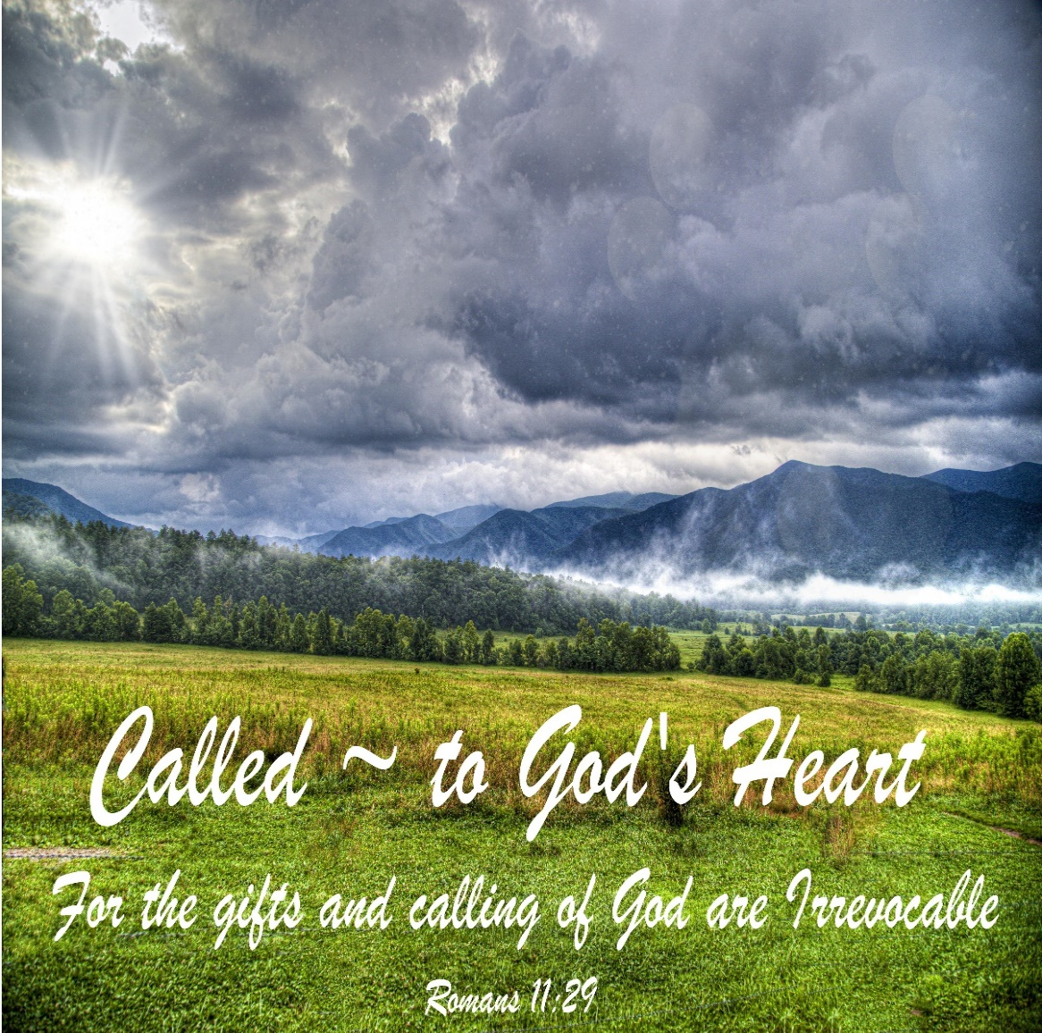

Eagle River Presbyterian Church
June 19, 2022

Weekly Walk

Sunday 10:00 am Worship
Sunday 11:00 am Father’s Day BBQ

Last week’s In-Person Attendance --------- 41
Month to Date Income --------- $9,081.00
Month to Date Expenses --------- $17,234.36 (including quarterly building insurance payment of $5,291.75)
Father’s Day BBQ is today at 11am! Even if you did not bring a dish, please stay-- there is enough food for everyone.

Do you have some extra time this summer? The Food Pantry could use your help!
- Driver assistants on Monday and Tuesday mornings to help pick up food from Freddy’s and Walmart. Some heavy lifting required. On-call, back-up drivers are also appreciated.
- Regular volunteers to help stock food on Thursday mornings – particularly June 23 and 30.
- Help processing a large donation on Monday, Thursday or Friday afternoon this week.
Please email the volunteer coordinator at cerfp1.volunteer@gmail.com or call the pantry and leave a message: 907-694-5228. Thank you!
Ways you can keep up with your financial stewardship:
1) If you’re worshipping with us in person, you may leave your gift in one of the offering plates as you leave the sanctuary this morning. The plates are on the table to the right of the main door.
2) Donate online with a credit card by clicking the link from our website: www.erpresbyterian.org.
3) Visit your local bank or your bank’s website and set up a recurring electronic payment.
4) Checks can also be mailed to PO Box 771337 Eagle River, AK 99577

