GATHERING TO WORSHIP
Please take a moment during the Prelude to silence your cell phones and quietly prepare yourself for worship.

PRELUDE
WELCOME
*CALL TO WORSHIP
Leader: In Jesus Christ all the fullness of God was pleased to dwell. Through him God was reconciled to all things in heaven and on earth, even to us, that we might be holy and blameless before God.
People: In awe and gratitude, let us worship the Lord our God.

*PRAYER OF INVOCATION
Almighty God, you brought creation into being through Christ,
and in Christ all things find their purpose. Open our eyes to see the world as your gift and to use your gifts for the sake of Christ, that through the witness of our lives the gospel may be proclaimed to all people. Amen.

*HYMN “I Sing the Mighty Power of God” Hymnal 32

RECEIVING FORGIVENESS FROM
GOD AND EACH OTHER

*CALL TO CONFESSION

*PRAYER OF CONFESSION: Spoken and Silent (After the corporate Prayer of Confession, please take a few moments of silence to individually confess our sins to God.)
Merciful Savior, you stand beside us, yet we prefer to stand on our own. You choose us, yet we choose worry. You attend to us, yet we attend to our work. Forgive us, gentle Teacher. Call us by name and visit us once more that we might find at your feet our joy, our purpose, and our hope. Amen.

*DECLARATION OF FORGIVENESS
Leader: Listen, I will tell you a mystery! By his body and his cross, Jesus reconciles all who were once estranged. Christ in you is the glory of God. Believe the good news.
People: In Jesus Christ we are forgiven!

CHILDREN’S MESSAGE

HEARING THE WORD

PSALM OF THE DAY Psalm 15 Pew Bible p.388

SCRIPTURE Amos 8:1-12 Pew Bible p.651
Luke 10:38-42 Pew Bible p.735
Colossians 1:15-28 Pew Bible p.833

MESSAGE Called ~ To Transformation Rev. Piper Cartland

RESPONDING TO THE WORD

SHARING OUR JOYS AND CONCERNS

PASTORAL PRAYER, followed by The Lord’s Prayer (we say sin)
MINUTES FOR MINISTRY

OFFERING OURSELVES TO GOD
* “Praise God from Whom All Blessings Flow” Hymnal 606

GOING INTO THE WORLD

*HYMN “God of the Ages, Whose Almighty Hand ”Hymnal 331

*CHARGE AND BENEDICTION
POSTLUDE

*Those who are able please stand.

WELCOME! It is a joy to worship together in person. So that we may do so safely, here are the basic tenets for our COVID-19 Mitigation Plan: If the level of community transmission is substantial or high, the session recommends mask wear and social distancing by all congregants. If the level is low or moderate, mask wear and social distancing will be optional for vaccinated and recommended for unvaccinated and immunocompromised. The level of community transmission is posted by the entrance. Tithes/offerings may be placed in the offering plates at the back of the sanctuary.

LARGE PRINT HYMNALS with a black cover, are on the small bookcase in the rear of the sanctuary. If you use one, please put it back after worship.

ASSISTIVE LISTENING DEVICES available on request. Please request one from the Sound Tech at the sound desk.
There are cards in the pews for visitors to fill out and for anyone who needs to update their information. Please place the cards in the offering plates as needed. If you are visiting today, the worship service is our gift to you. Please contribute to the offering or not, as God leads. We delight in welcoming you, and we are glad that you’re here!
Children up to kindergarten age are welcome in the nursery. There are clipboards with coloring pages in the narthex if your children wish to stay in the sanctuary.

Thank you to the Musicks for sponsoring the altar flowers this month.

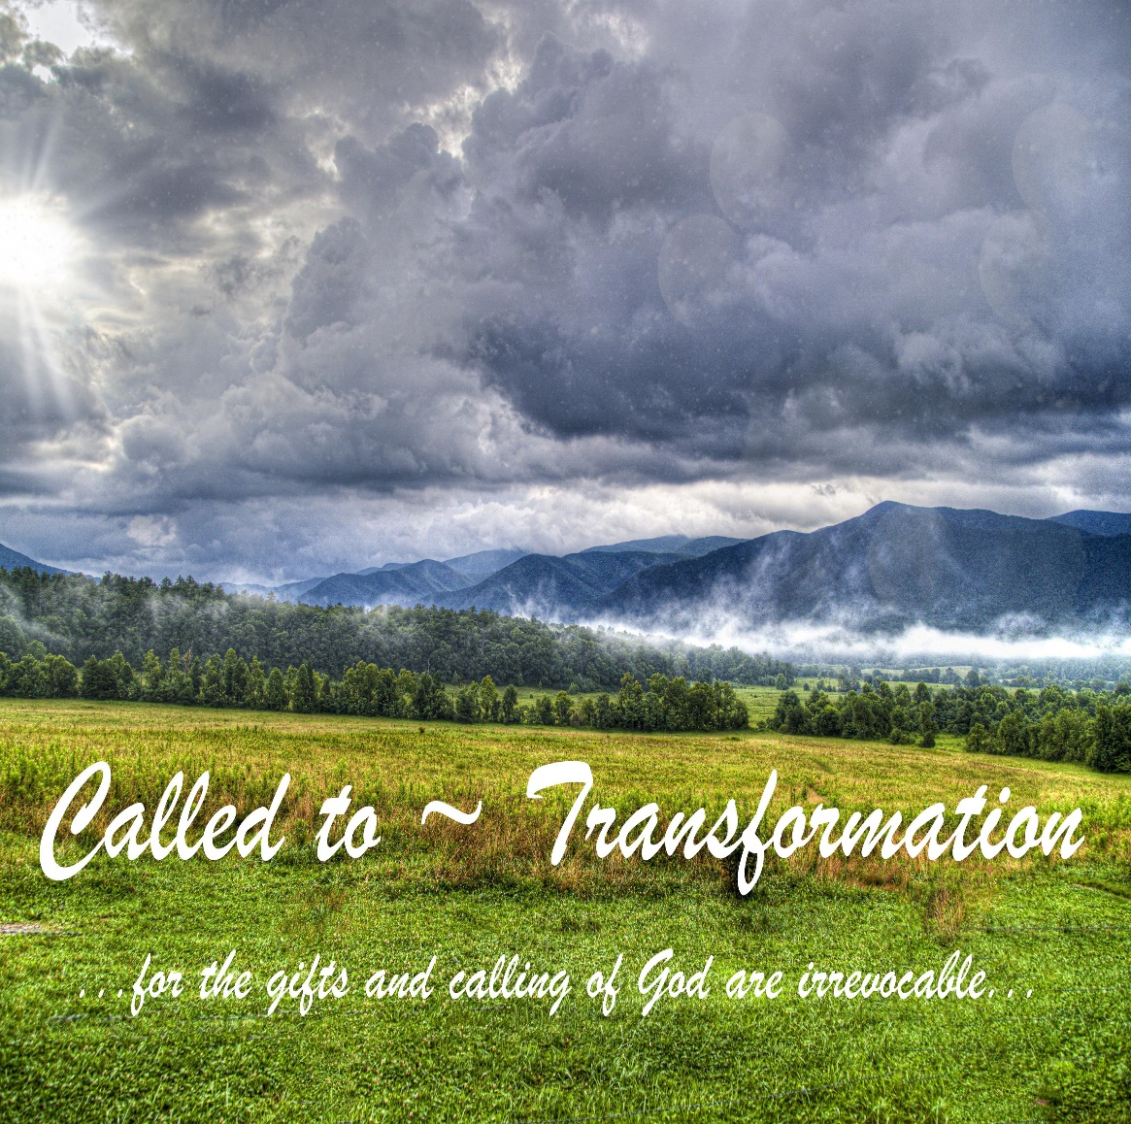

Eagle River Presbyterian Church
July 17, 2022

Eagle River Presbyterian Church
July 17, 2022

Weekly Walk

Sunday 10:00 am Worship

Last week’s In-Person Attendance --------- 37
Month to Date Income --------- $9,555.84
Month to Date Expenses --------- $10,672.97

There will not be a Session meeting in July. The next meeting is scheduled for August 16.

Next Sunday we will welcome Curt Karns to the pulpit. The Cartlands will be busy moving and unpacking this week.

The Food Pantry can use your donations of non-perishable food, household cleaners and personal toiletries. Please check the Chugiak-Eagle River Food Pantry Facebook page or the bulletin board for a complete list of the most needed items.

Ways you can keep up with your financial stewardship:
1) If you’re worshipping with us in person, you may leave your gift in one of the offering plates as you leave the sanctuary this morning. The plates are on the table to the right of the main door.
2) Donate online with a credit card by clicking the link from our website: www.erpresbyterian.org.
3) Visit your local bank or your bank’s website and set up a recurring electronic payment.
4) Checks can also be mailed to PO Box 771337 Eagle River, AK 99577

Eagle River Presbyterian Church
July 17, 2022

Weekly Walk

Sunday 10:00 am Worship

Last week’s In-Person Attendance --------- 37
Month to Date Income --------- $9,555.84
Month to Date Expenses --------- $10,672.97

There will not be a Session meeting in July. The next meeting is scheduled for August 16.

Next Sunday we will welcome Curt Karns to the pulpit. The Cartlands will be busy moving and unpacking this week.

The Food Pantry can use your donations of non-perishable food, household cleaners and personal toiletries. Please check the Chugiak-Eagle River Food Pantry Facebook page or the bulletin board for a complete list of the most needed items.

Ways you can keep up with your financial stewardship:
1) If you’re worshipping with us in person, you may leave your gift in one of the offering plates as you leave the sanctuary this morning. The plates are on the table to the right of the main door.
2) Donate online with a credit card by clicking the link from our website: www.erpresbyterian.org.
3) Visit your local bank or your bank’s website and set up a recurring electronic payment.
4) Checks can also be mailed to PO Box 771337 Eagle River, AK 99577

