GATHERING TO WORSHIP
Please take a moment during the Prelude to silence your cell phones and quietly prepare yourself for worship.

PRELUDE
WELCOME
*CALL TO WORSHIP
Leader: Show us your steadfast love, O Lord, and grant us your salvation.
People: The Lord will speak peace to the faithful, to those who turn to God in their hearts.
Leader: Surely salvation is at hand for those who fear the Lord,
and God’s glory will dwell in our land.

*PRAYER OF INVOCATION
Almighty God, we pray for your blessing on the church in this place. Here may the faithful find salvation, and the careless be awakened. Here may the doubting find faith, and the anxious be encouraged. Here may the tempted find help, and the sorrowful comfort. Here may the weary find rest, and the strong be renewed. Here may the aged find consolation and the young be inspired; through Jesus Christ our Lord. Amen.

*HYMN “Great is Thy Faithfulness” Hymnal 39

RECEIVING FORGIVENESS FROM
GOD AND EACH OTHER

*CALL TO CONFESSION

*PRAYER OF CONFESSION: Spoken and Silent (After the corporate Prayer of Confession, please take a few moments of silence to individually confess our sins to God.)
Gracious God, we humbly confess that we have fallen short
of who you call us to be. We seek peace and comfort in our lives, ignoring the needs of those around us. We live our lives in ways that bring chaos and calamity to our neighbors. Cleanse us from sin and show us your steadfast love, so that in turning to you, we may seek unity and peace for all of creation.

*DECLARATION OF FORGIVENESS
Leader: Beloved, God has forgiven all of your trespasses. You are alive together with God. Know that you are forgiven and be at peace.
People: Thanks be to God!

CHILDREN’S MESSAGE

HEARING THE WORD
PSALM OF THE DAY Psalm 138 Pew Bible p.444

SCRIPTURE Genesis 18:20-32 Pew Bible p.12
Luke 11:1-13 Pew Bible p.735
Colossians 2:6-15 Pew Bible p.834

MESSAGE Rev. Curt Karns

RESPONDING TO THE WORD
SHARING OUR JOYS AND CONCERNS

PASTORAL PRAYER, followed by The Lord’s Prayer (we say sin)
MINUTES FOR MINISTRY

OFFERING OURSELVES TO GOD
* “Praise God from Whom All Blessings Flow” Hymnal 606

GOING INTO THE WORLD

*HYMN “What a Friend We Have in Jesus ” Hymnal 465

*CHARGE AND BENEDICTION
POSTLUDE

*Those who are able please stand.

WELCOME! It is a joy to worship together in person. So that we may do so safely, here are the basic tenets for our COVID-19 Mitigation Plan: If the level of community transmission is substantial or high, the session recommends mask wear and social distancing by all congregants. If the level is low or moderate, mask wear and social distancing will be optional for vaccinated and recommended for unvaccinated and immunocompromised. The level of community transmission is posted by the entrance. Tithes/offerings may be placed in the offering plates at the back of the sanctuary.

LARGE PRINT HYMNALS with a black cover, are on the small bookcase in the rear of the sanctuary. If you use one, please put it back after worship.

ASSISTIVE LISTENING DEVICES available on request. Please request one from the Sound Tech at the sound desk.
There are cards in the pews for visitors to fill out and for anyone who needs to update their information. Please place the cards in the offering plates as needed. If you are visiting today, the worship service is our gift to you. Please contribute to the offering or not, as God leads. We delight in welcoming you, and we are glad that you’re here!
Children up to kindergarten age are welcome in the nursery. There are clipboards with coloring pages in the narthex if your children wish to stay in the sanctuary.

Thank you to the Musicks for sponsoring the altar flowers this month.

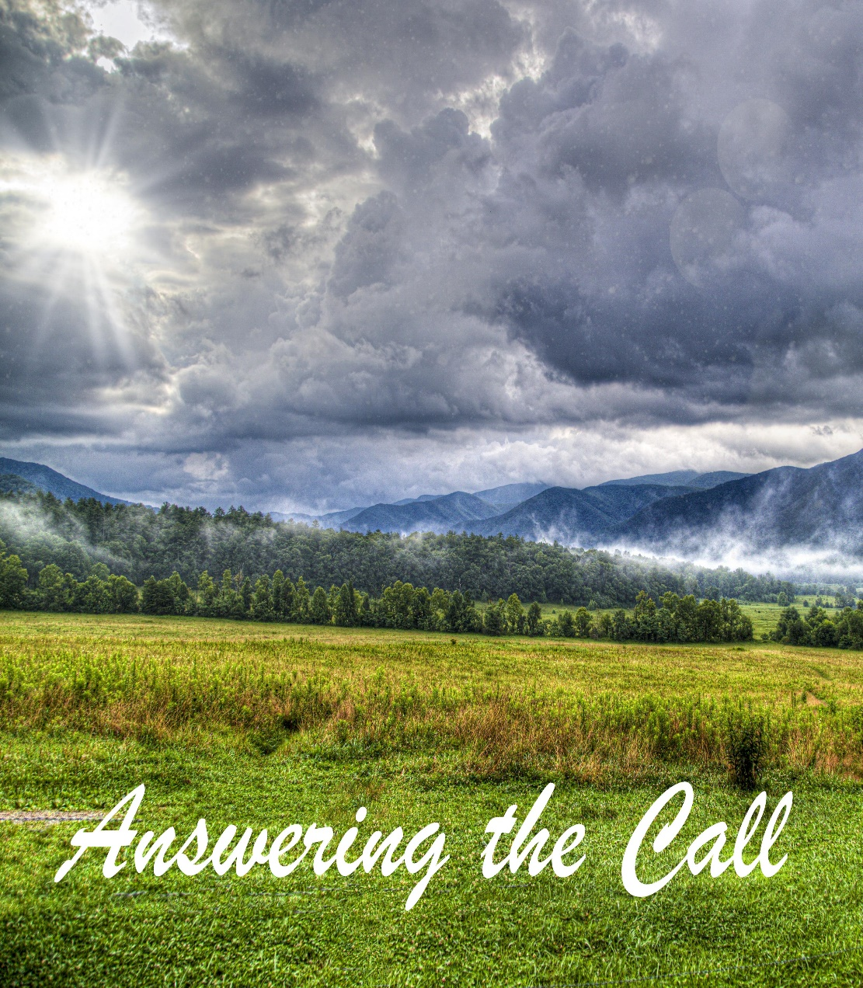

Eagle River Presbyterian Church
July 24, 2022

Weekly Walk
July 24, 2022

Sunday 10:00 am Worship

Last week’s In-Person Attendance --------- 27
Month to Date Income --------- $13,121.84
Month to Date Expenses --------- $14,103.91

Garden update: Our head gardener, Brent Koenen, has recently begun harvesting! So far, the garden has yielded several pounds of radishes, peas, and broccoli. Be on the lookout for opportunities to come and help harvest soon. All vegetables go directly to the Chugiak-Eagle River Food Pantry.

Today we welcome Rev. Curt Karns to the pulpit. Rev. Karns is the former executive presbyter of the Yukon Presbytery, and he and his wife, Cindee, live in Eagle River.

Ways you can keep up with your financial stewardship:
1) If you’re worshipping with us in person, you may leave your gift in one of the offering plates as you leave the sanctuary this morning. The plates are on the table to the right of the main door.
2) Donate online with a credit card by clicking the link from our website: www.erpresbyterian.org.
3) Visit your local bank or your bank’s website and set up a recurring electronic payment.
4) Checks can also be mailed to PO Box 771337 Eagle River, AK 99577

Weekly Walk
July 24, 2022

Sunday 10:00 am Worship

Last week’s In-Person Attendance --------- 27
Month to Date Income --------- $13,121.84
Month to Date Expenses --------- $14,103.91

Garden update: Our head gardener, Brent Koenen, has recently begun harvesting! So far, the garden has yielded several pounds of radishes, peas, and broccoli. Be on the lookout for opportunities to come and help harvest soon. All vegetables go directly to the Chugiak-Eagle River Food Pantry.

Today we welcome Rev. Curt Karns to the pulpit. Rev. Karns is the former executive presbyter of the Yukon Presbytery, and he and his wife, Cindee, live in Eagle River.

Ways you can keep up with your financial stewardship:
1) If you’re worshipping with us in person, you may leave your gift in one of the offering plates as you leave the sanctuary this morning. The plates are on the table to the right of the main door.
2) Donate online with a credit card by clicking the link from our website: www.erpresbyterian.org.
3) Visit your local bank or your bank’s website and set up a recurring electronic payment.
4) Checks can also be mailed to PO Box 771337 Eagle River, AK 99577

