GATHERING TO WORSHIP
Please take a moment during the Prelude to silence your cell phones and quietly prepare yourself for worship.

PRELUDE
WELCOME
*CALL TO WORSHIP
Leader: God has given us this day.
People: God’s steadfast love endures forever.
Leader: God has gathered us together.
People: God’s steadfast love endures forever.
Leader: There are many places we could be and many things we could be doing, but God has brought us together to worship.
People: God’s steadfast love endures forever.

*PRAYER OF INVOCATION
Startle us, O God, with your truth, and open our minds to your Spirit, that we may be one with Christ our Lord, and serve as faithful disciples, through Jesus Christ. Amen.

*HYMN “Praise the Lord! God’s Glories Show” Hymnal 33

RECEIVING FORGIVENESS FROM
GOD AND EACH OTHER

*CALL TO CONFESSION

*PRAYER OF CONFESSION: Spoken and Silent (After the corporate Prayer of Confession, please take a few moments of silence to individually confess our sins to God.)
Nurturing God, you continue to lead us in upright ways on account of your love for us. Yet we do not always follow your call; we turn away from you and go our own way. Forgive us,
and return us to our rightful home in you, through Jesus Christ our Savior. Amen.

*DECLARATION OF FORGIVENESS
Leader: God’s steadfast love endures forever. Beyond the cross, beyond the grave, beyond our sin, God’s steadfast love endures forever. This is good news!
People: In Jesus Christ we are forgiven!

CHILDREN’S MESSAGE

HEARING THE WORD

PSALM OF THE DAY Psalm 107:1-9 Pew Bible p.432

SCRIPTURE Eccl. 1:2, 12-14; 2:18-23 Pew Bible p.472
Luke 12:13-21 Pew Bible p.737
Colossians 3:1-11 Pew Bible p.834

MESSAGE Called ~ to Choose Rev. Piper Cartland

RESPONDING TO THE WORD
SHARING OUR JOYS AND CONCERNS

PASTORAL PRAYER, followed by The Lord’s Prayer (we say sin)
MINUTES FOR MINISTRY

OFFERING OURSELVES TO GOD
* “Praise God from Whom All Blessings Flow” Hymnal 606

GOING INTO THE WORLD

*HYMN “Be Thou My Vision ” Hymnal 450

*CHARGE AND BENEDICTION
POSTLUDE

*Those who are able please stand.

WELCOME! It is a joy to worship together in person. So that we may do so safely, here are the basic tenets for our COVID-19 Mitigation Plan: If the level of community transmission is substantial or high, the session recommends mask wear and social distancing by all congregants. If the level is low or moderate, mask wear and social distancing will be optional for vaccinated and recommended for unvaccinated and immunocompromised. The level of community transmission is posted by the entrance. Tithes/offerings may be placed in the offering plates at the back of the sanctuary.

LARGE PRINT HYMNALS with a black cover, are on the small bookcase in the rear of the sanctuary. If you use one, please put it back after worship.

ASSISTIVE LISTENING DEVICES available on request. Please request one from the Sound Tech at the sound desk.
There are cards in the pews for visitors to fill out and for anyone who needs to update their information. Please place the cards in the offering plates as needed. If you are visiting today, the worship service is our gift to you. Please contribute to the offering or not, as God leads. We delight in welcoming you, and we are glad that you’re here!
Children up to kindergarten age are welcome in the nursery. There are clipboards with coloring pages in the narthex if your children wish to stay in the sanctuary.

Thank you to the Musicks for sponsoring the altar flowers this month.

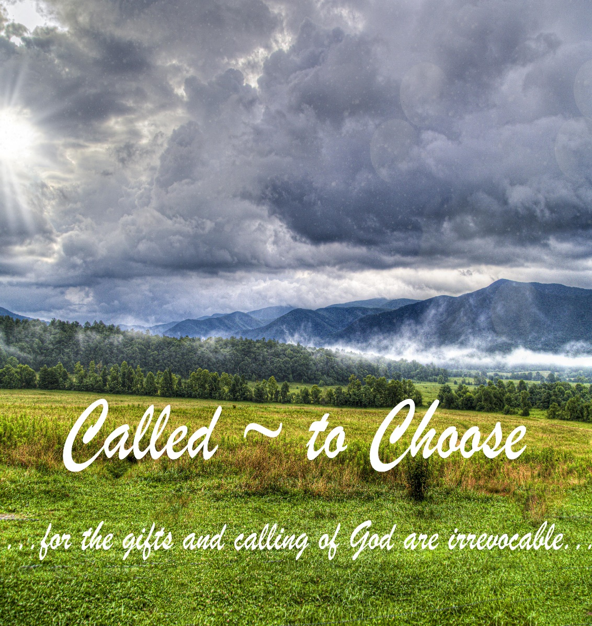

Eagle River Presbyterian Church
July 31, 2022

Weekly Walk
July 31, 2022

Sunday 10:00 am Worship

Last week’s In-Person Attendance --------- 29
Month to Date Income --------- $24,786.84
Month to Date Expenses --------- $15,233.89

We have begun our annual school supply drive for families in need at Fire Lake Elementary. There is a supply list on our website and in the narthex. Thank you for your donations!

Lay leaders are needed for August. Please sign up on the bulletin board outside the kitchen.

The Presbytery of Yukon is looking to hire a Stated Clerk. This job requires approximately 10-20 hours per week and is open to PC(USA) pastors, ruling elders, and commissioned pastors. If you would like more information, please contact the office or the interim presbytery exec, Rev. Leisa Carrick, at exec@pbyukon.org.

Ways you can keep up with your financial stewardship:
1) If you’re worshipping with us in person, you may leave your gift in one of the offering plates as you leave the sanctuary this morning. The plates are on the table to the right of the main door.
2) Donate online with a credit card by clicking the link from our website: www.erpresbyterian.org.
3) Visit your local bank or your bank’s website and set up a recurring electronic payment.
4) Checks can also be mailed to PO Box 771337 Eagle River, AK 99577

Paul Cartland
Melissa Hodgson
Claire Hodgson
Rachel Rasic
Abbie Spencer
Gary McCarthy
Hayley Banks
Wes Freimuth
Chelsea Berry
Kay Witt
Bill Musick
Luca Rasic

Lloyd and Carol Pool…..July 6
Myles and Megan Gobeille…..July 11
Jon and Melissa Hodgson…..July 21
Jerry and Joan Brossia…..July 21
Bill and Teri Swears…..July 24
Paul and Piper Cartland…..July 25

