GATHERING TO WORSHIP
Please take a moment during the Prelude to silence your cell phones and quietly prepare yourself for worship.
PRELUDE
WELCOME
*CALL TO WORSHIP
Leader: Call upon the Lord! I asked for help and I was healed!
People: We asked for freedom, and we were given liberty beyond measure!
Praise God!

*PRAYER OF INVOCATION
God of the covenant, in our baptism you called us to proclaim the coming of your kingdom. Give us courage like you gave the apostles, that we may faithfully witness to your love and peace in every circumstance of life, in the name of Jesus Christ our redeemer, who lives and reigns with you in the unity of the Holy Spirit,
one God, forever and ever. Amen.

*HYMN “Brethren, We Have Met to Worship” Hymnal 396

RECEIVING FORGIVENESS FROM
GOD AND EACH OTHER

*CALL TO CONFESSION

*PRAYER OF CONFESSION: Spoken and Silent (After the corporate Prayer of Confession, please take a few moments of silence to individually confess our sins to God.)
God of perfect love, you continually bring forth life, transforming sadness to joy, and despair to hope. We are weak, but you are strong. Our ways are flawed, but your ways are true. We are seldom right, but you are never wrong. Forgive us, redeem us, transform us. Take away the sin that burdens us, and restore us to the people you would have us be, for the sake of Jesus Christ our Savior.
*DECLARATION OF FORGIVENESS
Leader: Relentlessly God seeks us out. With abundant grace and boundless mercy, God seeks us out. This is good news!
People: In Jesus Christ we are forgiven!

CHILDREN’S MESSAGE

HEARING THE WORD

PSALM OF THE DAY Psalm 66:1-9 Pew Bible p.410

SCRIPTURES 2 Kings 5:1-14 Pew Bible p.263
Luke 10:1-11, 16-20 Pew Bible p.734
Galatians 6:1-16 Pew Bible p.826

MESSAGE Called ~ to the Harvest Rev. Piper Cartland

*AFFIRMATION OF FAITH
Christ Jesus, though he was in the form of God, did not regard equality with God as something to be exploited, but emptied himself, taking the form of a slave, being born in human likeness. And being found in human form he humbled himself and became obedient to the point of death—even death on a cross. Therefore God also highly exalted him and gave him the name that is above every name, so that at the name of Jesus every knee should bend, in heaven and on earth and under the earth, and every tongue should confess to the glory of God: Jesus Christ is Lord! Amen.

RESPONDING TO THE WORD

SHARING OUR JOYS AND CONCERNS

PASTORAL PRAYER
MINUTES FOR MINISTRY

OFFERING OURSELVES TO GOD
*DOXOLOGY “Praise God from Whom All Blessings Flow” Hymnal 606

CELEBRATING THE LORD’S SUPPER
*HYMN “For the Fruit of All Creation” Hymnal 36

INVITATION TO THE TABLE

GREAT PRAYER OF THANKSGIVING AND THE LORD’S PRAYER (we say sin)
Pastor: The Lord be with you.
People: And also with you.
Pastor: Lift up your hearts.
People: We lift them to the Lord.
Pastor: Let us give thanks to the Lord our God.
People: It is right to give our thanks and praise.

WORDS OF INSTITUTION
COMMUNION OF THE PEOPLE
PRAYER

GOING INTO THE WORLD

*HYMN “O Beautiful for Spacious Skies” Hymnal 338

*CHARGE AND BENEDICTION
POSTLUDE

*Those who are able please stand

WELCOME! It is a joy to worship together in person. So that we may do so safely, here are the basic tenets for our COVID-19 Mitigation Plan: If the level of community transmission is substantial or high, the session recommends mask wear and social distancing by all congregants. If the level is low or moderate, mask wear and social distancing will be optional for vaccinated and recommended for unvaccinated and
immunocompromised. The level of community transmission is posted by the entrance. Tithes/offerings may be placed in the offering plates at the back of the sanctuary.

LARGE PRINT HYMNALS, with a black cover, are on the small bookcase in the rear of the sanctuary. If you use one, please put it back after worship.

ASSISTIVE LISTENING DEVICES available on request. Please request one from the Sound Tech at the sound desk.
There are cards are in the pews for visitors to fill out and for anyone who needs to update their information. Please place the cards in the offering plates as needed. If you are visiting today, the worship service is our gift to you. Please contribute to the offering, or not, as God leads. We delight in welcoming you, and we are glad that you’re here!
Children up to kindergarten age are welcome in the nursery. There are clipboards with coloring pages in the narthex if your children wish to stay in the sanctuary.
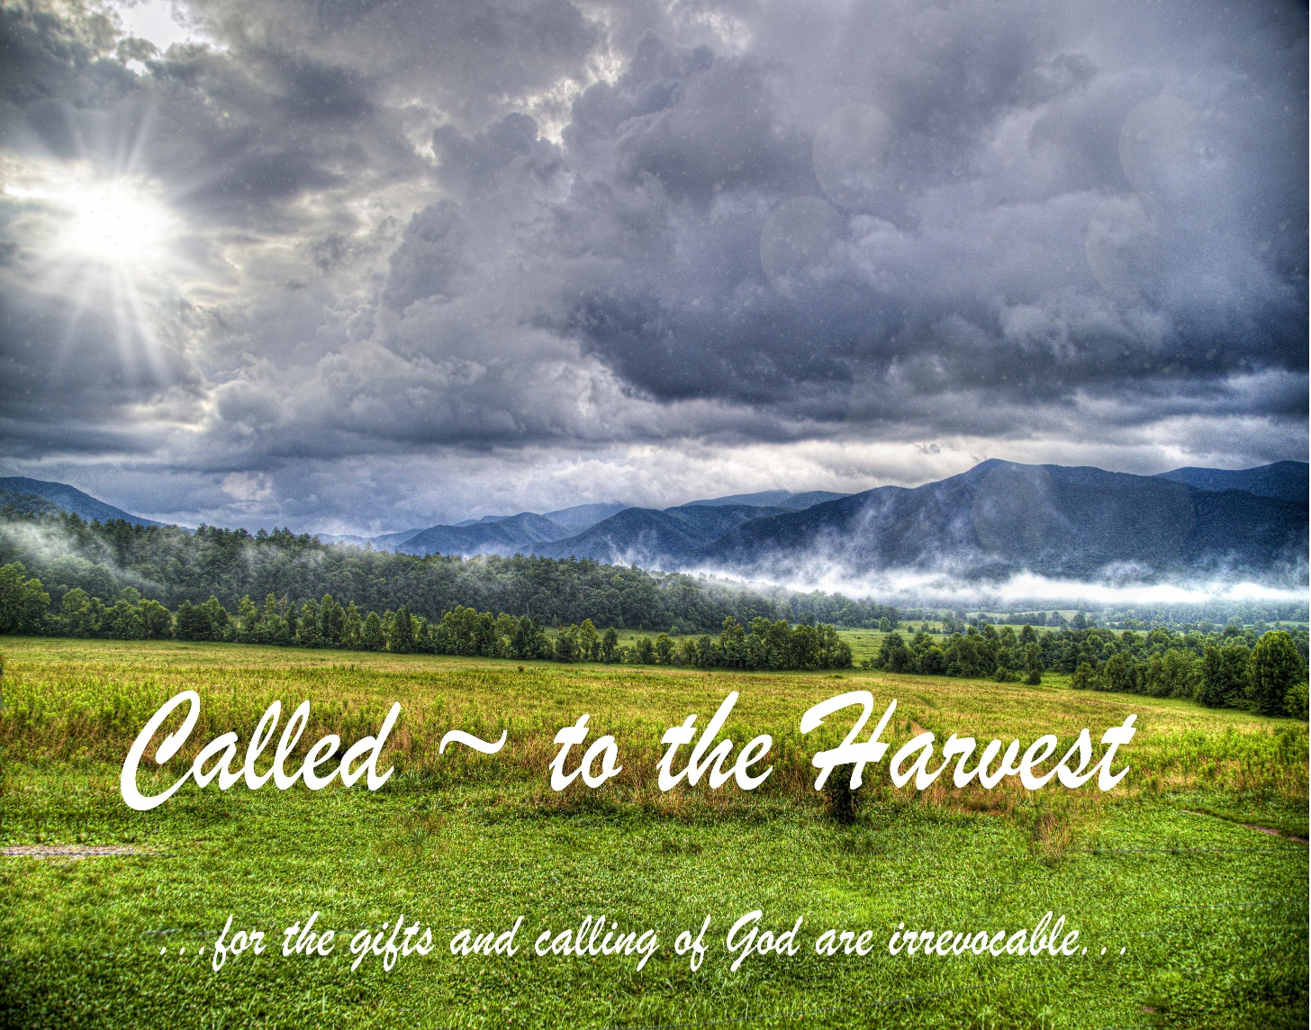

Eagle River Presbyterian Church
July 3, 2022

Weekly Walk

Sunday 10:00 am Worship
Monday Office closed 4th of July holiday

Last week’s In-Person Attendance --------- 37
Month-End Regular Income --------- $14,082.00
Month-End Regular Expenses --------- $20,744.23 (including quarterly building insurance payment of $5,291.75)

The number of families served by the Food Pantry has increased by 60% in the past two months, and supplies are going out faster. The pantry can use donations of:
Household cleaners – dish soap, laundry soap
Personal toiletries – hand/body soap, shampoo/conditioner, toothpaste/toothbrushes (pkgs of 1-2)
Non-perishable food – peanut butter, crackers, cereal, pasta sauce, pasta and rice mixes (hamburger helper, pasta roni, rice-a-roni, etc), soups (cream of chicken, chicken noodle, vegetable, vegetable beef) ravioli, condiments, coffee, tea
There is also a volunteer form on the bulletin board by the entrance if you are interested in volunteering.

Ways you can keep up with your financial stewardship:
1) If you’re worshipping with us in person, you may leave your gift in one of the offering plates as you leave the sanctuary this morning. The plates are on the table to the right of the main door.
2) Donate online with a credit card by clicking the link from our website: www.erpresbyterian.org.
3) Visit your local bank or your bank’s website and set up a recurring electronic payment.
4) Checks can also be mailed to PO Box 771337 Eagle River, AK 99577

Weekly Walk

Sunday 10:00 am Worship
Monday Office closed 4th of July holiday

Last week’s In-Person Attendance --------- 37
Month-End Regular Income --------- $14,082.00
Month-End Regular Expenses --------- $20,744.23 (including quarterly building insurance payment of $5,291.75)

The number of families served by the Food Pantry has increased by 60% in the past two months, and supplies are going out faster. The pantry can use donations of:
Household cleaners – dish soap, laundry soap
Personal toiletries – hand/body soap, shampoo/conditioner, toothpaste/toothbrushes (pkgs of 1-2)
Non-perishable food – peanut butter, crackers, cereal, pasta sauce, pasta and rice mixes (hamburger helper, pasta roni, rice-a-roni, etc), soups (cream of chicken, chicken noodle, vegetable, vegetable beef) ravioli, condiments, coffee, tea
There is also a volunteer form on the bulletin board by the entrance if you are interested in volunteering.

Ways you can keep up with your financial stewardship:
1) If you’re worshipping with us in person, you may leave your gift in one of the offering plates as you leave the sanctuary this morning. The plates are on the table to the right of the main door.
2) Donate online with a credit card by clicking the link from our website: www.erpresbyterian.org.
3) Visit your local bank or your bank’s website and set up a recurring electronic payment.
4) Checks can also be mailed to PO Box 771337 Eagle River, AK 99577

