GATHERING TO WORSHIP
Please take a moment during the Prelude to silence your cell phones and quietly prepare yourself for worship.

PRELUDE
WELCOME
*CALL TO WORSHIP
Leader: God is our rock and our refuge,
People: a strong and mighty fortress.
Leader: Beloved people of light, come; the Lord is our hope.
People: Let us worship God!

*PRAYER OF INVOCATION
Faithful God, you have blessed us with the inheritance of grace that we might live as people of justice, righteousness, and peace. Stir in us your power and fill us with the love of Christ,
strong and true, that we may be always eager to serve your
promised reign of peace. Amen.

*HYMN “Holy God, We Praise Your Name” Hymnal 4

RECEIVING FORGIVENESS FROM
GOD AND EACH OTHER

*CALL TO CONFESSION

*PRAYER OF CONFESSION: Spoken and Silent (After the corporate Prayer of Confession, please take a few moments of silence to individually confess our sins to God.)
God of goodness and truth, we have failed to seek after your wisdom and have followed paths that have led away from you. Forgive our foolish ways, and lead us in your truth, that we may live in the fullness of life as you intend through Christ our Lord. Amen.

*DECLARATION OF FORGIVENESS
Leader: The Lord is our hope and our trust, our light and salvation. Believe the good news!
People: In Jesus Christ, we are forgiven.

CHILDREN’S MESSAGE

HEARING THE WORD

PSALM OF THE DAY Psalm 103 Pew Bible p.428

SCRIPTURE Isaiah 58:9b-14 Pew Bible p.527
Luke 13:10-17 Pew Bible p.738
Hebrews 12:18-29 Pew Bible p.853

MESSAGE Called ~ to Worship Rev. Piper Cartland

RESPONDING TO THE WORD

SHARING OUR JOYS AND CONCERNS

PASTORAL PRAYER, followed by The Lord’s Prayer (we say sin)
MINUTES FOR MINISTRY

OFFERING OURSELVES TO GOD
* “Praise God from Whom All Blessings Flow” Hymnal 606

GOING INTO THE WORLD

*HYMN “Immortal, Invisible, God Only Wise” Hymnal 12

*CHARGE AND BENEDICTION
POSTLUDE

*Those who are able please stand.

WELCOME! It is a joy to worship together in person. So that we may do so safely, here are the basic tenets for our COVID-19 Mitigation Plan: If the level of community transmission is substantial or high, the session recommends mask wear and social distancing by all congregants. If the level is low or moderate, mask wear and social distancing will be optional for vaccinated and recommended for unvaccinated and immunocompromised. The level of community transmission is posted by the entrance. Tithes/offerings may be placed in the offering plates at the back of the sanctuary.

LARGE PRINT HYMNALS with a black cover, are on the small bookcase in the rear of the sanctuary. If you use one, please put it back after worship.

ASSISTIVE LISTENING DEVICES available on request. Please request one from the Sound Tech at the sound desk.
There are cards in the pews for visitors to fill out and for anyone who needs to update their information. Please place the cards in the offering plates as needed. If you are visiting today, the worship service is our gift to you. Please contribute to the offering or not, as God leads. We delight in welcoming you, and we are glad that you’re here!
Children up to kindergarten age are welcome in the nursery. There are clipboards with coloring pages in the narthex if your children wish to stay in the sanctuary.

Thank you to Suellyn Novak for sponsoring the communion table flowers this month.

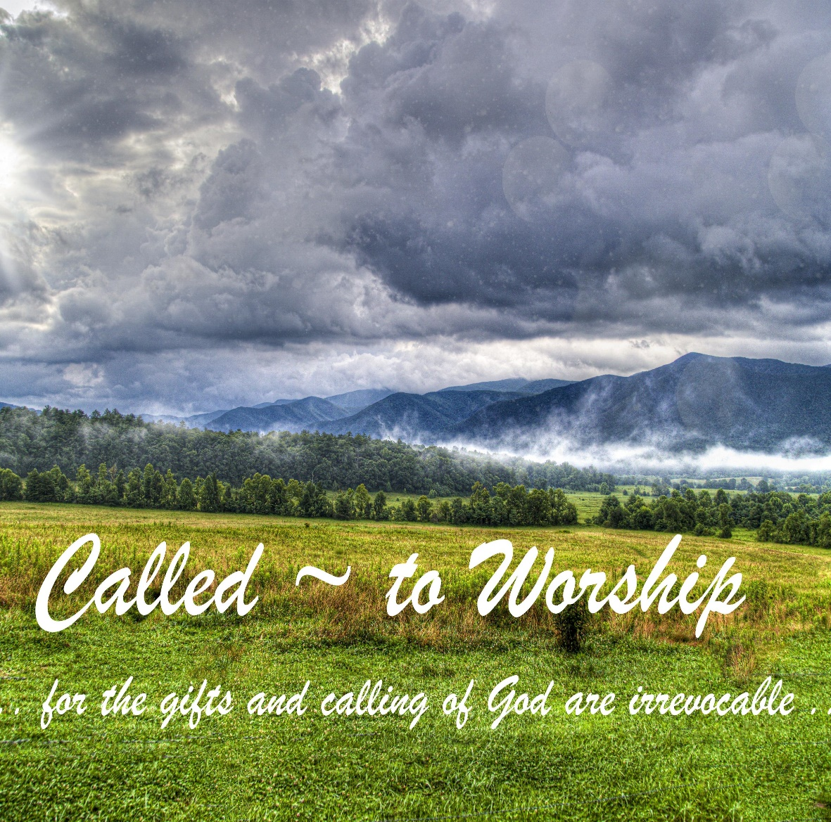

Eagle River Presbyterian Church

August 21, 2022

Weekly Walk

Sunday 10:00 am Worship

Last week’s In-Person Attendance --------- 32
Month to Date Income --------- $15,450.80
Month to Date Expenses --------- $14,188.09
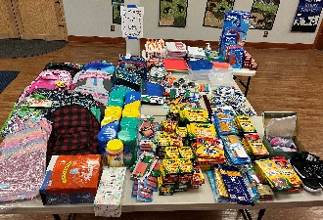
A big thank you to everyone for their generous donations of school supplies for Fire Lake Elementary!

We will be having a garage sale on Saturday, Sept. 17. You can bring your donations beginning Sunday, Sept. 11. All proceeds will benefit Christian Education at ERPC.

Next Sunday after worship, there will be an “End of Summer” celebration. Please plan to stay and eat. The fellowship committee will be providing all food – no sign-up needed!

Here are some ways you can keep up with your financial stewardship:
1) If you’re worshipping with us in person, you may leave your gift in one of the offering plates as you leave the sanctuary this morning. The plates are on the table to the right of the main door.
2) Donate online with a credit card by clicking the link from our website: www.erpresbyterian.org.
3) Visit your local bank or your bank’s website and set up a recurring electronic payment. Your bank may require the church’s account number. Please call the office for that information.
4) Checks can also be mailed to PO Box 771337 Eagle River, AK 99577

Weekly Walk

Sunday 10:00 am Worship

Last week’s In-Person Attendance --------- 32
Month to Date Income --------- $15,450.80
Month to Date Expenses --------- $14,188.09
A big thank you to everyone for their generous donations of school supplies for Fire Lake Elementary!

We will be having a garage sale on Saturday, Sept. 17. You can bring your donations beginning Sunday, Sept. 11. All proceeds will benefit Christian Education at ERPC.

Next Sunday after worship, there will be an “End of Summer” celebration. Please plan to stay and eat. The fellowship committee will be providing all food – no sign-up needed!

Here are some ways you can keep up with your financial stewardship:
1) If you’re worshipping with us in person, you may leave your gift in one of the offering plates as you leave the sanctuary this morning. The plates are on the table to the right of the main door.
2) Donate online with a credit card by clicking the link from our website: www.erpresbyterian.org.
3) Visit your local bank or your bank’s website and set up a recurring electronic payment. Your bank may require the church’s account number. Please call the office for that information.
4) Checks can also be mailed to PO Box 771337 Eagle River, AK 99577

