GATHERING TO WORSHIP
Please take a moment during the Prelude to silence your cell phones and quietly prepare yourself for worship.

PRELUDE
WELCOME
*CALL TO WORSHIP
Leader: Eternal God,
People: we worship and adore you.
Leader: You are the power within all things. Eternal God,
People: we worship and adore you.
Leader: You are the wisdom beyond all minds. Eternal God,
People: we worship and adore you.
Leader: You are the love revealed in the cross. Eternal God,
People: we worship and adore you. Amen.

*PRAYER OF INVOCATION
Startle us, O God, with your truth, and open our minds to your Spirit, that we may be one with Christ our Lord, and serve as faithful disciples, through Jesus Christ. Amen.

*HYMN “Praise, My Soul, the King of Heaven ” Hymnal 620

RECEIVING FORGIVENESS FROM
GOD AND EACH OTHER

*CALL TO CONFESSION

*PRAYER OF CONFESSION: Spoken and Silent (After the corporate Prayer of Confession, please take a few moments of silence to individually confess our sins to God.)
Holy and merciful God, in your presence we confess our failure to be what you created us to be. You alone know how often we have sinned in wandering from your ways, in wasting your gifts, in forgetting your love. By your loving mercy, help us to live in your light and abide in your ways, for the sake of Jesus Christ our Savior.
*DECLARATION OF FORGIVENESS
Leader: Anyone who is in Christ is a new creation. The old life has gone; a new life has begun. Know that you are forgiven
and be at peace.
People: Thanks be to God!

CHILDREN’S MESSAGE

HEARING THE WORD

PSALM OF THE DAY Psalm 51 Pew Bible p.405

SCRIPTURE Luke 15:1-10 Pew Bible p.740
1 Timothy 1:12-17 Pew Bible p.839

MESSAGE RE:boot Rev. Piper Cartland

RESPONDING TO THE WORD

SHARING OUR JOYS AND CONCERNS

PASTORAL PRAYER, followed by The Lord’s Prayer (we say sin)
MINUTES FOR MINISTRY

OFFERING OURSELVES TO GOD
* “Praise God from Whom All Blessings Flow” Hymnal 606

GOING INTO THE WORLD

*HYMN “To God be the Glory” Hymnal 634

*CHARGE AND BENEDICTION
POSTLUDE

*Those who are able please stand.

WELCOME! It is a joy to worship together in person. So that we may do so safely, here are the basic tenets for our COVID-19 Mitigation Plan: If the level of community transmission is substantial or high, the session recommends mask wear and social distancing by all congregants. If the level is low or moderate, mask wear and social distancing will be optional for vaccinated and recommended for unvaccinated and immunocompromised. The level of community transmission is posted by the entrance. Tithes/offerings may be placed in the offering plates at the back of the sanctuary.

LARGE PRINT HYMNALS with a black cover, are on the small bookcase in the rear of the sanctuary. If you use one, please put it back after worship.

ASSISTIVE LISTENING DEVICES available on request. Please request one from the Sound Tech at the sound desk.
There are cards in the pews for visitors to fill out and for anyone who needs to update their information. Please place the cards in the offering plates as needed. If you are visiting today, the worship service is our gift to you. Please contribute to the offering or not, as God leads. We delight in welcoming you, and we are glad that you’re here!
Children up to kindergarten age are welcome in the nursery. There are clipboards with coloring pages in the narthex if your children wish to stay in the sanctuary.

Thank you to John and Patti Malecha for sponsoring the communion table flowers this month.

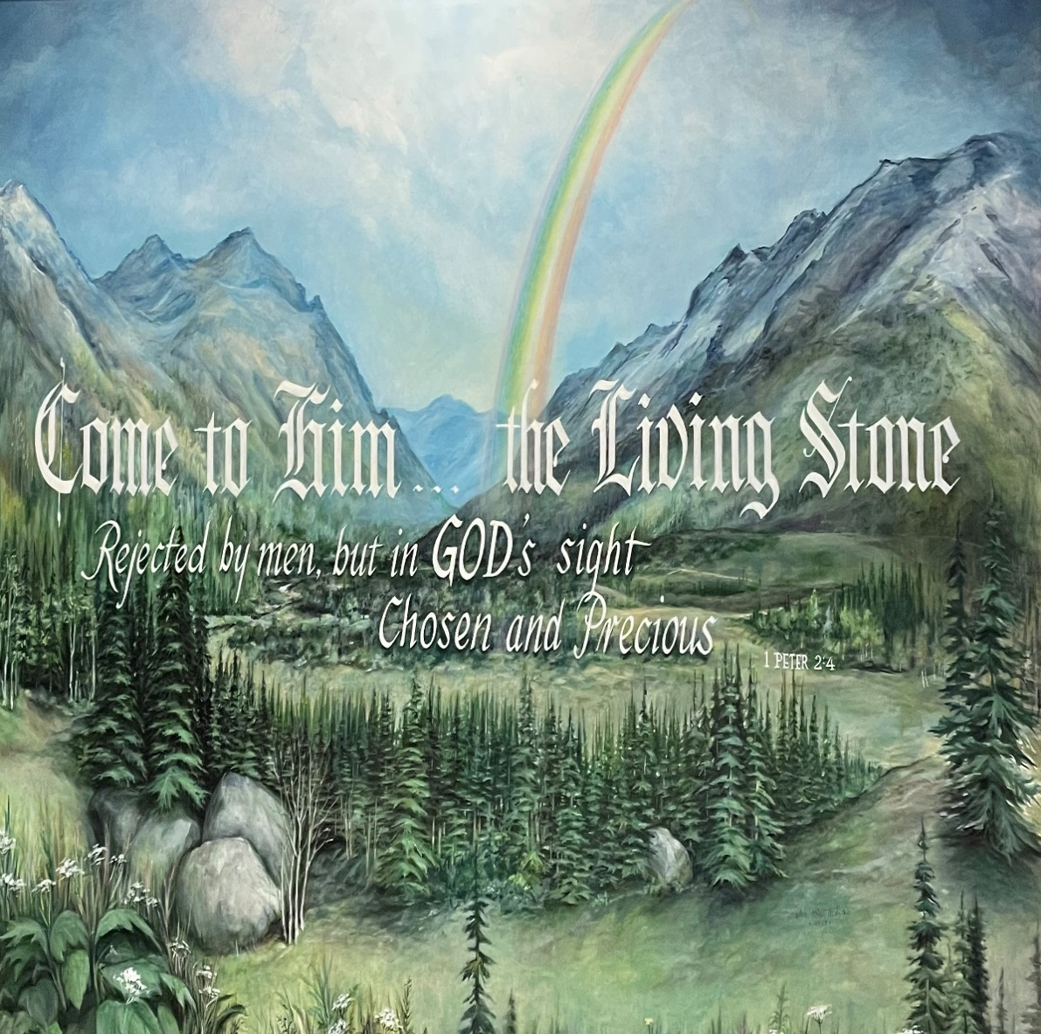

Eagle River Presbyterian Church

September 11, 2022

Weekly Walk

Sunday 10:00 am Worship
Sunday 10:15 am Sunday school harvesting garden
Sunday 11:15 am Sunday school parents’ meeting
Saturday 8am-1pm Garage sale

Last week’s In-Person Attendance --------- 26
Month to Date Income --------- $5,650.80
Month to Date Expenses --------- $14,281.85 (Including quarterly building insurance payment of $5,291.75)
Our Garage Sale supporting Christian Education at ERPC is this Saturday, September 17, 8:00 am – 1 pm. Volunteers and donations are needed! Set-up will begin at 7 am. Items can be brought in during office hours all week.

Next Sunday, September 18, will be a special worship service as we give thanks to God for the completion of the earthquake reconstruction. Please join us in person or online as we re-dedicate our building and ourselves to God’s service.

Next Sunday afternoon at 4 pm will be a celebration of life service for Ethel Dougherty in the sanctuary. We will be providing a punch and cookie reception afterward; if you would like to bake cookies for the reception, please drop them off in the kitchen next weekend.

Ways you can keep up with your financial stewardship:
1) If you’re worshipping with us in person, you may leave your gift in one of the offering plates as you leave the sanctuary this morning. The plates are on the table to the right of the main door.
2) Visit your local bank or your bank’s website and set up a recurring electronic payment. Your bank may require the church’s account number. Please call the office for that information.
3) Donate online with a credit card by clicking the link from our website: www.erpresbyterian.org
4) Checks can also be mailed to PO Box 771337 Eagle River, AK 99577
Weekly Walk

Sunday 10:00 am Worship
Sunday 10:15 am Sunday school harvesting garden
Sunday 11:15 am Sunday school parents’ meeting
Saturday 8am-1pm Garage sale

Last week’s In-Person Attendance --------- 26
Month to Date Income --------- $5,650.80
Month to Date Expenses --------- $14,281.85 (Including quarterly building insurance payment of $5,291.75)
Our Garage Sale supporting Christian Education at ERPC is this Saturday, September 17, 8:00 am – 1 pm. Volunteers and donations are needed! Set-up will begin at 7 am. Items can be brought in during office hours all week.

Next Sunday, September 18, will be a special worship service as we give thanks to God for the completion of the earthquake reconstruction. Please join us in person or online as we re-dedicate our building and ourselves to God’s service.

Next Sunday afternoon at 4 pm will be a celebration of life service for Ethel Dougherty in the sanctuary. We will be providing a punch and cookie reception afterward; if you would like to bake cookies for the reception, please drop them off in the kitchen next weekend.

Ways you can keep up with your financial stewardship:
1) If you’re worshipping with us in person, you may leave your gift in one of the offering plates as you leave the sanctuary this morning. The plates are on the table to the right of the main door.
2) Visit your local bank or your bank’s website and set up a recurring electronic payment. Your bank may require the church’s account number. Please call the office for that information.
3) Donate online with a credit card by clicking the link from our website: www.erpresbyterian.org
4) Checks can also be mailed to PO Box 771337 Eagle River, AK 99577

