GATHERING TO WORSHIP
Please take a moment during the Prelude to silence your cell phones and quietly prepare yourself for worship.

PRELUDE
WELCOME
*CALL TO WORSHIP
Leader: Enter the gates of the Lord with thanksgiving and the courts of God with praise; Give thanks and bless God’s holy name!
People: For the Lord is good; God’s love is eternal, and God’s faithfulness has no end.

*PRAYER OF INVOCATION
Leader: God of the universe, the heavens contain your glory. Yet you have come to be with us in Jesus Christ, and by the power of the Holy Spirit you are present with us now in the risen Christ.
People: We rededicate this building to your honor and glory. We thank you for all the gifts represented in this building, the craft and art of many hands, contributions of money and material, labors of love and commitment.
Leader: Bless the work of our hands, O God, that this place may offer your welcome
to many and diverse people, that all who seek you here may know your presence in their lives.
People: By your grace and according to your will, may the gospel of Jesus Christ be truly proclaimed and the sacraments rightly administered, that the body of Christ may be nurtured here and strengthened for Christ’s service in the world. In Jesus’ name we pray. Amen.

*HYMN “Holy, Holy, Holy ” Hymnal 1

RECEIVING FORGIVENESS FROM
GOD AND EACH OTHER
*CALL TO CONFESSION

*PRAYER OF CONFESSION: Spoken and Silent (After the corporate Prayer of Confession, please take a few moments of silence to individually confess our sins to God.)
Gracious God, our sins are too heavy to carry, too real to hide, and too deep to undo.
Forgive what our lips tremble to name, what our hearts can no longer bear, and what has become for us a consuming fire of judgment. Set us free from a past that we cannot change; open to us a future in which we can be changed; and grant us grace
to grow more and more in your likeness and image; through Jesus Christ, the light of the world.
*DECLARATION OF FORGIVENESS
Leader: Hear the good news! Do not fear, says the Lord, for I have redeemed you.
I have called you by name; you are mine. God is doing a new thing; now it springs forth! By the grace of Jesus Christ, we are forgiven!
People: Amen.

CHILDREN’S MESSAGE

HEARING THE WORD

PSALM OF THE DAY Psalm 100 Pew Bible p.427

* HYMN “I Love to Tell the Story ” Hymnal 1

PRAYER FOR ILLUMINATION

SCRIPTURE Deut 6:1-12, 7:7-9 Pew Bible p.130
Luke 6:46-49 Pew Bible p.730
Ephesians 2:14-22 Pew Bible p.828

MESSAGE A Strong Foundation Rev. Piper Cartland

* HYMN “My Hope is Built On Nothing Less ” Hymnal 353

AFFIRMATION OF FAITH
Leader: Almighty God, we rededicate this place to your worship, that in prayer and praise, in Word and Sacrament, we may know your will and experience your peace and power in our lives. Let this place be a refuge for those who suffer or grieve, a fortress for those besieged by temptation, a beacon to light the way in darkness.
People: Let us enter your gates with thanksgiving and come into your courts with praise.
Leader: Trusting in Jesus Christ, we rededicate this building in the name of the Father, and of the Son, and of the Holy Spirit. Amen.

RESPONDING TO THE WORD

SHARING OUR JOYS AND CONCERNS

PASTORAL PRAYER, followed by The Lord’s Prayer (we say sin)
MINUTES FOR MINISTRY

OFFERING OURSELVES TO GOD
*DOXOLOGY “Praise God from Whom All Blessings Flow” Hymnal 606

GOING INTO THE WORLD

*HYMN “The Church’s One Foundation” Hymnal 321

*CHARGE AND BENEDICTION
POSTLUDE

*Those who are able please stand.

WELCOME! It is a joy to worship together in person. So that we may do so safely, here are the basic tenets for our COVID-19 Mitigation Plan: If the level of community transmission is substantial or high, the session recommends mask wear and social distancing by all congregants. If the level is low or moderate, mask wear and social distancing will be optional for vaccinated and recommended for unvaccinated and immunocompromised. The level of community transmission is posted by the entrance. Tithes/offerings may be placed in the offering plates at the back of the sanctuary.

LARGE PRINT HYMNALS with a black cover, are on the small bookcase in the rear of the sanctuary. If you use one, please put it back after worship.

ASSISTIVE LISTENING DEVICES available on request. Please request one from the Sound Tech at the sound desk.
There are cards in the pews for visitors to fill out and for anyone who needs to update their information. Please place the cards in the offering plates as needed. If you are visiting today, the worship service is our gift to you. Please contribute to the offering or not, as God leads. We delight in welcoming you, and we are glad that you’re here!
Children up to kindergarten age are welcome in the nursery. There are clipboards with coloring pages in the narthex if your children wish to stay in the sanctuary.

Thank you to John and Patti Malecha for sponsoring the communion table flowers this month.

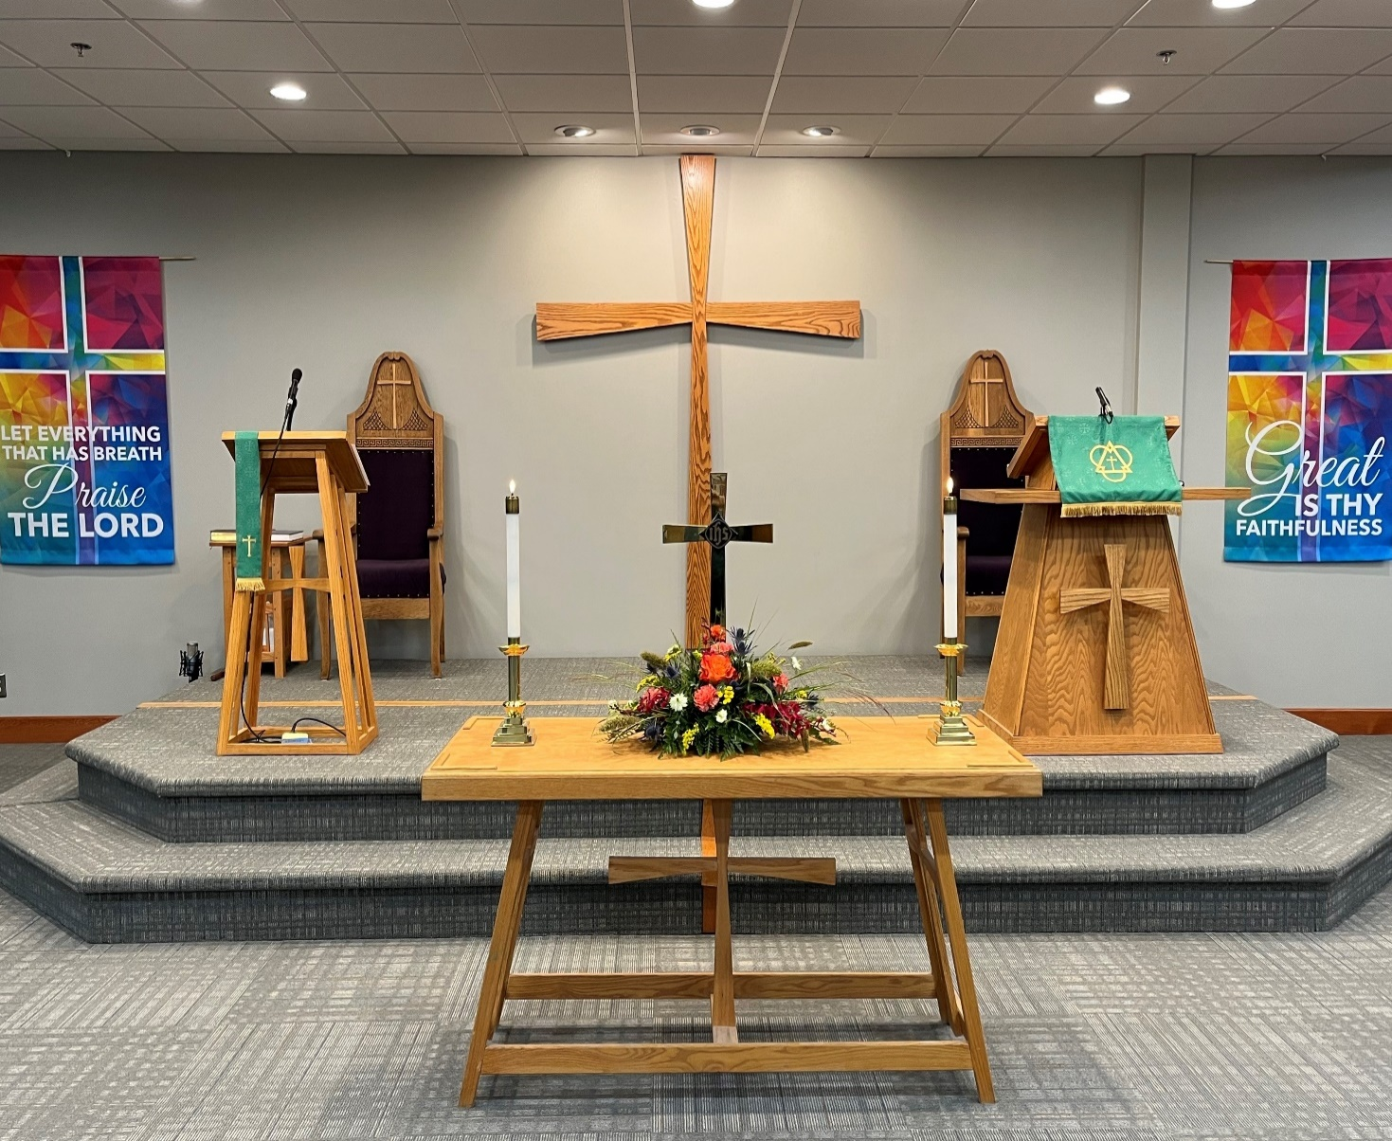

Eagle River Presbyterian Church

September 18, 2022

Weekly Walk

Sunday 10:00 am Worship
Sunday 4:00 pm Memorial Service
Saturday 11:30 am-2 pm Fall Tea @ Trinity PC

Last week’s In-Person Attendance ---------43
Month to Date Income --------- $7,475.80
Month to Date Expenses --------- $18,108.79 (including quarterly building insurance payment of $5,291.75)
Thank you to all who donated and came out to support the Garage Sale for Christian Education yesterday! Another way to support Christian Education is to teach Sunday school. We have the curriculum and can email or give you a copy of the lesson. Please consider spending an hour or two this semester with the wonderful young people in our congregation!

Today is the Memorial Service for Ethel Dougherty at 4:00 pm. We are still accepting donations of cookies for the reception afterward.

This Saturday, Sept. 24, Trinity Presbyterian Church and the Yukon Presbyterian Women are co-hosting a Fall Tea, including lunch, entertainment and a silent auction. Please see the flyer on the bulletin board by the door for details.

Next Sunday, September 25, immediately following worship we will have our fall Congregational Meeting. The purpose of the meeting is to vote on Rev. Cartland’s 2023 terms of call, and to transact other business as appropriate. The meeting will be conducted in person, but we’ll provide a Zoom link as well - we need a quorum for this meeting, so we would appreciate as many attendees as possible! An agenda is available in the back of the Sanctuary and on our website.

Ways you can keep up with your financial stewardship:
1) If you’re worshipping with us in person, you may leave your gift in one of the offering plates as you leave the sanctuary this morning. The plates are on the table to the right of the main door.
2) Donate online with a credit card by clicking the link from our website: www.erpresbyterian.org.
3) Visit your local bank or your bank’s website and set up a recurring electronic payment.
4) Checks can also be mailed to PO Box 771337 Eagle River, AK 99577
Weekly Walk

Sunday 10:00 am Worship
Sunday 4:00 pm Memorial Service
Saturday 11:30 am-2 pm Fall Tea @ Trinity PC

Last week’s In-Person Attendance ---------43
Month to Date Income --------- $7,475.80
Month to Date Expenses --------- $18,108.79 (including quarterly building insurance payment of $5,291.75)
Thank you to all who donated and came out to support the Garage Sale for Christian Education yesterday! Another way to support Christian Education is to teach Sunday school. We have the curriculum and can email or give you a copy of the lesson. Please consider spending an hour or two this semester with the wonderful young people in our congregation!

Today is the Memorial Service for Ethel Dougherty at 4:00 pm. We are still accepting donations of cookies for the reception afterward.

This Saturday, Sept. 24, Trinity Presbyterian Church and the Yukon Presbyterian Women are co-hosting a Fall Tea, including lunch, entertainment and a silent auction. Please see the flyer on the bulletin board by the door for details.

Next Sunday, September 25, immediately following worship we will have our fall Congregational Meeting. The purpose of the meeting is to vote on Rev. Cartland’s 2023 terms of call, and to transact other business as appropriate. The meeting will be conducted in person, but we’ll provide a Zoom link as well - we need a quorum for this meeting, so we would appreciate as many attendees as possible! An agenda is available in the back of the Sanctuary and on our website.

Ways you can keep up with your financial stewardship:
1) If you’re worshipping with us in person, you may leave your gift in one of the offering plates as you leave the sanctuary this morning. The plates are on the table to the right of the main door.
2) Donate online with a credit card by clicking the link from our website: www.erpresbyterian.org.
3) Visit your local bank or your bank’s website and set up a recurring electronic payment.
4) Checks can also be mailed to PO Box 771337 Eagle River, AK 99577

