GATHERING TO WORSHIP
Please take a moment during the Prelude to silence your cell phones and quietly prepare yourself for worship.

PRELUDE
WELCOME
*CALL TO WORSHIP
Leader: Happy are those who delight in the Word of God. They are like trees planted by streams of water, and they will flourish.
People: Let us worship God!

*PRAYER OF INVOCATION
Extravagant God, you pour out blessings upon us and lead us on the path of true life. Help us to choose your way again and again, that we might revel in your love
and reflect it to all we meet. In the name of Jesus we pray. Amen.

*HYMN “Sing Praise to God Who Reigns Above” Hymnal 645

RECEIVING FORGIVENESS FROM
GOD AND EACH OTHER

*CALL TO CONFESSION

*PRAYER OF CONFESSION: Spoken and Silent (After the corporate Prayer of Confession, please take a few moments of silence to individually confess our sins to God.)
Holy God, we confess that we fail to put our trust in you completely. Instead, we calculate our gains and losses, hoarding the things that do not lead to abundant life. Forgive us, and help us to treasure only you, that we may follow you faithfully and discover the blessings only you can give. Amen.

*DECLARATION OF FORGIVENESS
Leader: Beloved, your sins are forgiven. Therefore be at peace to follow the good road, for the Lord watches over the way of the righteous.
People: Thanks be to God!

CHILDREN’S MESSAGE

HEARING THE WORD

PSALM OF THE DAY Psalm 1 Pew Bible p.383

SCRIPTURES Deuteronomy 30:15-20 Pew Bible p.147
Luke 14:25-33 Pew Bible p.739
Philemon 1-25 Pew Bible p.845

MESSAGE RE:boot ~ RE:concile Relationships Rev. Piper Cartland

*AFFIRMATION OF FAITH - Nicene Creed Hymnal p.34

RESPONDING TO THE WORD

SHARING OUR JOYS AND CONCERNS

PASTORAL PRAYER
MINUTES FOR MINISTRY

OFFERING OURSELVES TO GOD
*DOXOLOGY “Praise God from Whom All Blessings Flow” Hymnal 606

CELEBRATING THE LORD’S SUPPER

*HYMN “Beneath the Cross of Jesus” Hymnal 216

INVITATION TO THE TABLE

GREAT PRAYER OF THANKSGIVING AND THE LORD’S PRAYER (we say sin)
Pastor: The Lord be with you.
People: And also with you.
Pastor: Lift up your hearts.
People: We lift them to the Lord.
Pastor: Let us give thanks to the Lord our God.
People: It is right to give our thanks and praise.

WORDS OF INSTITUTION
COMMUNION OF THE PEOPLE
PRAYER

GOING INTO THE WORLD

*HYMN “Go, My Children, With My Blessing” Hymnal 547

*CHARGE AND BENEDICTION
POSTLUDE

*Those who are able please stand

WELCOME! It is a joy to worship together in person. So that we may do so safely, here are the basic tenets for our COVID-19 Mitigation Plan: If the level of community transmission is substantial or high, the session recommends mask wear and social distancing by all congregants. If the level is low or moderate, mask wear and social distancing will be optional for vaccinated and recommended for unvaccinated and
immunocompromised. The level of community transmission is posted by the entrance. Tithes/offerings may be placed in the offering plates at the back of the sanctuary.

LARGE PRINT HYMNALS, with a black cover, are on the small bookcase in the rear of the sanctuary. If you use one, please put it back after worship.

ASSISTIVE LISTENING DEVICES available on request. Please request one from the Sound Tech at the sound desk.
There are cards are in the pews for visitors to fill out and for anyone who needs to update their information. Please place the cards in the offering plates as needed. If you are visiting today, the worship service is our gift to you. Please contribute to the offering, or not, as God leads. We delight in welcoming you, and we are glad that you’re here!
Children up to kindergarten age are welcome in the nursery. There are clipboards with coloring pages in the narthex if your children wish to stay in the sanctuary.

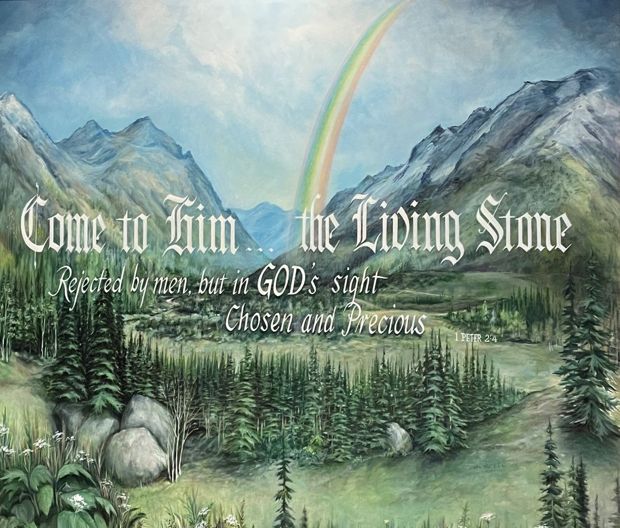

Eagle River Presbyterian Church
September 4, 2022

Weekly Walk

Sunday 10:00 am Worship
Monday Labor Day Office Closed

Last week’s In-Person Attendance --------- 46
August Month End Income --------- $19,426.80
August Month End Expenses --------- $16,516.69

Garden help is needed! Brent is out of town for the next few weeks, so help is needed to harvest vegetables twice a week, before the largest Food Pantry distributions. Please contact the office for details. Thank you!

Next Sunday, Sept. 11, will be the start of Sunday school. Whitney and Steph will help the children harvest potatoes and carrots from the garden. Please dress to get dirty! There will also be a brief meeting for Sunday school parents right after worship.
Next Sunday, everyone can begin bringing in donations for the garage sale which will be held on Saturday, Sept. 17. Please, no old electronics or tires.

Ways you can keep up with your financial stewardship:
1) If you’re worshipping with us in person, you may leave your gift in one of the offering plates as you leave the sanctuary this morning. The plates are on the table to the right of the main door.
2) Donate online with a credit card by clicking the link from our website: www.erpresbyterian.org.
3) Visit your local bank or your bank’s website and set up a recurring electronic payment.
4) Checks can also be mailed to PO Box 771337 Eagle River, AK 99577

Weekly Walk

Sunday 10:00 am Worship
Monday Labor Day Office Closed

Last week’s In-Person Attendance --------- 46
August Month End Income --------- $19,426.80
August Month End Expenses --------- $16,516.69

Garden help is needed! Brent is out of town for the next few weeks, so help is needed to harvest vegetables twice a week, before the largest Food Pantry distributions. Please contact the office for details. Thank you!

Next Sunday, Sept. 11, will be the start of Sunday school. Whitney and Steph will help the children harvest potatoes and carrots from the garden. Please dress to get dirty! There will also be a brief meeting for Sunday school parents right after worship.
Next Sunday, everyone can begin bringing in donations for the garage sale which will be held on Saturday, Sept. 17. Please, no old electronics or tires.

Ways you can keep up with your financial stewardship:
1) If you’re worshipping with us in person, you may leave your gift in one of the offering plates as you leave the sanctuary this morning. The plates are on the table to the right of the main door.
2) Donate online with a credit card by clicking the link from our website: www.erpresbyterian.org.
3) Visit your local bank or your bank’s website and set up a recurring electronic payment.
4) Checks can also be mailed to PO Box 771337 Eagle River, AK 99577

