If we live, we live for the Lord; and if we die, we die for the Lord. So, whether we live or die, we belong to the Lord.

Romans 14:8

Service of Witness to the Resurrection

Ethel Mae Dougherty
October 9, 1939 – August 28, 2022

Prelude

Call to Worship

Opening Prayer

Hymn How Great Thou Art

Scripture Isaiah 40:1-11
2 Corinthians 4:16-5:1
Homily

Prayers of Thanksgiving and Intercession

Hymn Jesus Loves Me

Time of Memories

Scripture John 14:1-6, 25-27

Hymn Amazing Grace

Prayer of Blessing

Benediction

Postlude

Officiant: Rev. Piper Cartland
Organist: Larry Baumgartner

The family invites you to remain after the service for a time of fellowship and sharing.

Sayings

You better get busy, cause if you miss the bus you’re walking to school

Get Max off the couch

SANDRA LYNN!!

If you don’t finish your Mush, you’re going to have it for lunch and again for dinner

Are you feeling OK?….. Are you sure?

Smile

Where is my Kiss?

Oh golly Miss Molly

What time is it there?

When are you coming to the Islands?

(At Church) Hold my hand, we’re going to say the Lord’s Prayer

Hit a home run for Grandma

I Love You Sweetheart, nightee night

Oh, You’ll survive

Remember you have birthdays coming up

Let’s hold hands and say Grace

I Love you all

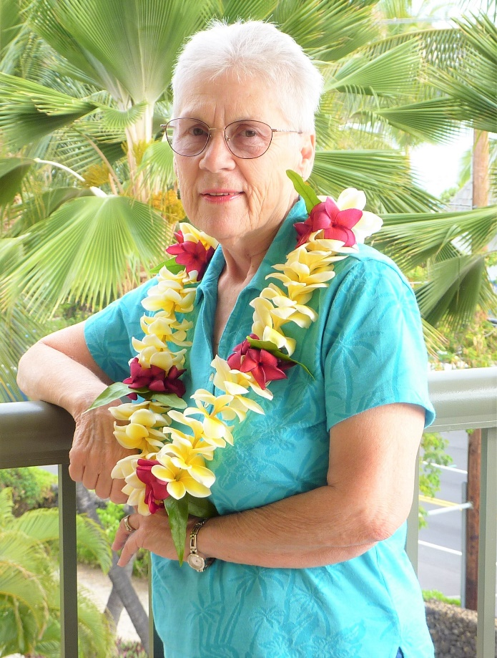

Ethel Mae Dougherty
October 9, 1939 – August 28, 2022

MLW
Ethel Mae Dougherty, 82, went to be with her Lord on August 28, 2022 at her home in Wasilla, AK. Ethel was born on October 9, 1939 in the San Joaquin County of California. She was the 2nd daughter of Albert and Velma Memory of East Wenatchee, WA. Her family originally lived in Lodi, California, but due to the fact that her father was absent for a considerable time due to being in the Merchant Marines, Mother and daughters relocated to live with different relatives several times during her young life. The family finally relocated to the North Seattle area of Washington State where she attended grade school and Junior High, then finally moved to Edmonds, WA where she graduated from Edmonds High School in 1956.

Ethel met the love of her life accidentally while on a day of skiing at Snoqualmie Pass, WA with her good friend Jane Dougherty. While skiing she saw Jane had stopped to talk to somebody and she skied over to see who it might be and fell right in front of Jane’s brother Bill, hence the oft repeated statement that she fell for the love of her life while skiing. They were married on September 7, 1957 and were only 10 days short of 65 wonderful years of living and being together while raising and being proud of their four children.

Ethel lived a life of dedication to being the best Wife, Mother, Grandmother, and Great Grandmother possible as well as providing aid to others, as at one time being a driver for Seniors and disabled persons, and also a volunteer for the Red Cross, participating in the aid provided during a major flooding in New Orleans for which she received official recognition. She enjoyed sewing, woodworking, knitting, crafts of all sorts and canning foods from her garden. She taught herself the basics of piano playing and urged her children to take up music also. Ethel loved taking long drives and camping to see new and interesting locations both near and far from her home. A temporary job relocation in 1990 to Alaska for husband Bill turned into a
MLW
Ethel Mae Dougherty, 82, went to be with her Lord on August 28, 2022 at her home in Wasilla, AK. Ethel was born on October 9, 1939 in the San Joaquin County of California. She was the 2nd daughter of Albert and Velma Memory of East Wenatchee, WA. Her family originally lived in Lodi, California, but due to the fact that her father was absent for a considerable time due to being in the Merchant Marines, Mother and daughters relocated to live with different relatives several times during her young life. The family finally relocated to the North Seattle area of Washington State where she attended grade school and Junior High, then finally moved to Edmonds, WA where she graduated from Edmonds High School in 1956.

Ethel met the love of her life accidentally while on a day of skiing at Snoqualmie Pass, WA with her good friend Jane Dougherty. While skiing she saw Jane had stopped to talk to somebody and she skied over to see who it might be and fell right in front of Jane’s brother Bill, hence the oft repeated statement that she fell for the love of her life while skiing. They were married on September 7, 1957 and were only 10 days short of 65 wonderful years of living and being together while raising and being proud of their four children.

Ethel lived a life of dedication to being the best Wife, Mother, Grandmother, and Great Grandmother possible as well as providing aid to others, as at one time being a driver for Seniors and disabled persons, and also a volunteer for the Red Cross, participating in the aid provided during a major flooding in New Orleans for which she received official recognition. She enjoyed sewing, woodworking, knitting, crafts of all sorts and canning foods from her garden. She taught herself the basics of piano playing and urged her children to take up music also. Ethel loved taking long drives and camping to see new and interesting locations both near and far from her home. A temporary job relocation in 1990 to Alaska for husband Bill turned into a permanent home when Ethel upon Bill’s retirement stated “you can move back to the lower 48 but I’m staying here”. She especially liked winter vacation trips to Hawaii and finally became a “Snowbird” in 2015 where they would spend 5 months of winter in Kona HI and 7 months in Chugiak/Wasilla, AK each year.

Ethel is proceeded in death by her parents Albert and Velma Memory of East Wenatchee, WA, her sister Shirley Davis of East Wenatchee, WA and her own eldest son John Dougherty of Anchorage, AK.

Ethel is survived by her husband William Dougherty of Wasilla, AK. Daughter Sandra Brown (Husband Billy) of Rogers, AR. Granddaughter Ashley Richards (Husband Garrett) (Great Granddaughter Mackenzie) of Bella Vista, AR. Son James Dougherty (Wife Deborah) (Granddaughter Megan) of Selah, WA. Son Nicholas Dougherty of Wasilla, AK. Daughter in law Therese Dougherty Christensen of Yakima, WA. Grandson Phillip Dougherty (Wife Shannon) (Great Grandsons Nolan and Carson) of Hayden, ID. Grandson Ryan Dougherty of Yakima, WA and several Nieces and Nephews.

Ethel is greatly loved and will be missed by all who love her, but we know her joy is complete now as she is in the presence of her God and Savior.

permanent home when Ethel upon Bill’s retirement stated “you
can move back to the lower 48 but I’m staying here”. She especially liked winter vacation trips to Hawaii and finally became a “Snowbird” in 2015 where they would spend 5 months of winter in Kona HI and 7 months in Chugiak/Wasilla, AK each year.

Ethel is proceeded in death by her parents Albert and Velma Memory of East Wenatchee, WA, her sister Shirley Davis of East Wenatchee, WA and her own eldest son John Dougherty of Anchorage, AK.

Ethel is survived by her husband William Dougherty of Wasilla, AK. Daughter Sandra Brown (Husband Billy) of Rogers, AR. Granddaughter Ashley Richards (Husband Garrett) (Great Granddaughter Mackenzie) of Bella Vista, AR. Son James Dougherty (Wife Deborah) (Granddaughter Megan) of Selah, WA. Son Nicholas Dougherty of Wasilla, AK. Daughter in law Therese Dougherty Christensen of Yakima, WA. Grandson Phillip Dougherty (Wife Shannon) (Great Grandsons Nolan and Carson) of Hayden, ID. Grandson Ryan Dougherty of Yakima, WA and several Nieces and Nephews.

Ethel is greatly loved and will be missed by all who love her, but we know her joy is complete now as she is in the presence of her God and Savior.

